Outline: Antitrust Law
  - Prasad Krishnamurthy (Spring 2026)
  - Joel Reinecke
Table of Contents
I. Introduction to Antitrust Law 1
A. Purpose of Antitrust (C1) 1
B. Antitrust Economics (C1) 1
1. Competitive Market 1
2. Demand/Supply 2
3. Market Power 4
C. Anticompetitive Conduct (C2) 5
D. Structure of U.S. Antitrust Law (C2) 7
II. Concerted Action Among Competitors (Restraints of Trade) 9
A. Emergence of the Rule of Reason (C3-4) 9
1. Early Common Law 9
2. Early § 1 Cases 10
3. Development of the Rule of Reason 11
4. Development of Per Se Illegality 12
5. Modern Antitrust Analysis 15
B. Per Se Analysis (C4-5) 17
1. Price Fixing 17
2. Market Division 18
3. Group Boycotts 19
4. Joint Ventures 20
C. Abbreviated Rule of Reason (C6) 22
D. Full Rule of Reason (C7) 24
III. Distinguishing Concerted from Unilateral Action 26
A. Intra-enterprise conspiracy doctrine 26
B. Economics of collusion 27
C. Law of inferring agreement 28
1. Inferred express and tacit agreements 28
2. Agreement and summary procedures 29
3. Identify who agreed 32
4. Collective facilitating practices 33
5. Unilateral facilitating practices 36
IV. Politics of the Sherman Act 37
A. Section 1 37
B. Section 2 38
V. Exclusionary Conduct (Monopolization) 38
A. Power + Conduct Framework 41
B. Market definition 43
C. Non-price exclusion 44
D. Refusals to deal 48
E. Predatory pricing 50
F. Predatory bidding 52
G. Attempted monopolization 53
H. Remedies 53
I. Tying 56
J. Exclusive dealing 62
K. Conditional Pricing Practices 66
L. Anti-Steering/Most-Favored Nation Clauses 68
M. Exclusion Continuum 70
N. Concerted Refusals to Deal 71
VI. Anticompetitive Distribution Practices 75
A. Single-Brand Restraints 75
1. Vertical within-brand restraints 75
2. Exclusive distributorships 79
VII. Mergers and Acquisitions 80
A. Emergence and Erosion of the Structural Paradigm 82
B. Horizontal Merger Analysis Under the DOJ/FTC Guidelines 87
1. Market Definition 91
2. Market Participants 95
3. Market Concentration 95
4. P’s theory of harm 96
a) Coordinated Competitive Effects 96
b) Unilateral Competitive Effects 100
5. Vertical Mergers and Conglomerate Mergers 105
C. D’s rebuttals to P’s prima facie case 113
1. Entry and repositioning 113
2. Procompetitive efficiencies 116
3. Failing Firms 117
D. Remedies 117
VIII. The Structure of Enforcement 118
A. Private Rights of Action 118
1. Statute of limitations 118
2. Judgments & Defenses 118
3. Antitrust injury 119
B. Standing 119
C. Damages 123
D. Antitrust Federalism 124
E. The First Amendment 127
F. Exemptions 129

Introduction to Antitrust Law

Purpose of Antitrust (C1)
3 Historical Purposes of Antitrust:
- Control unchecked economic power
- Protect individual freedom: bad for the country if independent business owners are turned into “mere servants” of a corporation without any voice in shaping business policy (Trans-MO)
- Ensure economic fairness and equality
Narrowed Modern Purpose of Antitrust (challenged by the left and the right): Antitrust prevents the anticompetitive acquisition, exercise, or maintenance of market power

Antitrust Economics (C1)
Neoclassical Economics Basics:
- Competitive markets bring social benefits
- Market power imposes social costs

Antitrust Economics Normative Claims:
- Competition is good
- Market power is bad

Competitive Market
Rationale: Study competitive markets to identify assumptions that generate ideal conditions so that deviations from the ideal are more easily detected.
Assumptions:
- Consumers and producers are price takers (antitrust primarily deals with failures of this assumption by attacking “market power”)
- Consumers know their own preferences
- Consumers know the attributes of all goods and services
- Consumers choose as they deem best
- Producers maximize profits
- Markets are “complete” (i.e., no externalities)
Outcome: Prices adjust to equate supply and demand
Implications:
- Planning: Given there exists a socially optimal price/quantity, central planners could fail to choose it
- Decentralization: supply and demand equilibrate naturally
- Efficiency: producers will sell more if they keep prices low, which they can only do profitably if they keep production costs low
- Maximum total surplus: goods are only produced if the benefit to consumers exceeds the cost to producers.

Demand/Supply
Demand:
- Individual demand: how much quantity is demanded at a given price
  - Total Benefit: total amount consumers would pay for a certain quantity of goods
    - Marginal Benefit: benefit to consumers from the next unit of a good
      - Diminishing marginal benefit: value of each additional unit tends to decrease

  - Consumer Surplus: value consumers received in excess of what they paid
    - Normative value: economics considers consumer surplus to be good
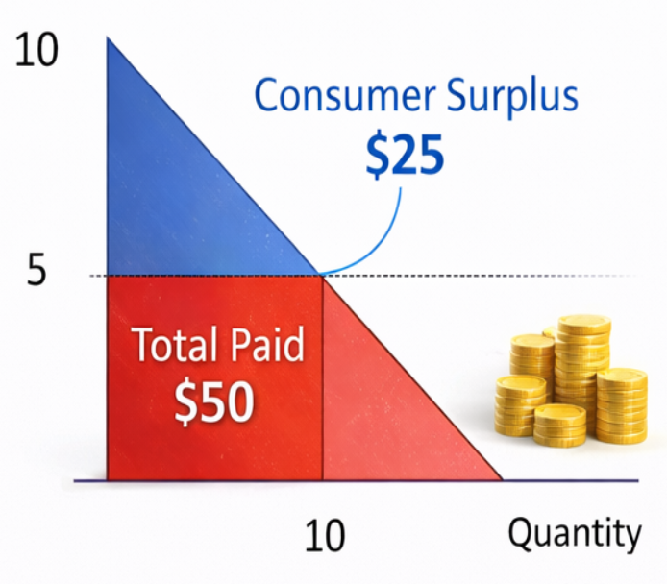
- Market Demand: sum of individual demand curves
- Elasticity of demand: how much quantity demanded changes in response to a change in price
  - Basic formula: $\left(\% change in quantity demanded\right)/(\% change in price)$
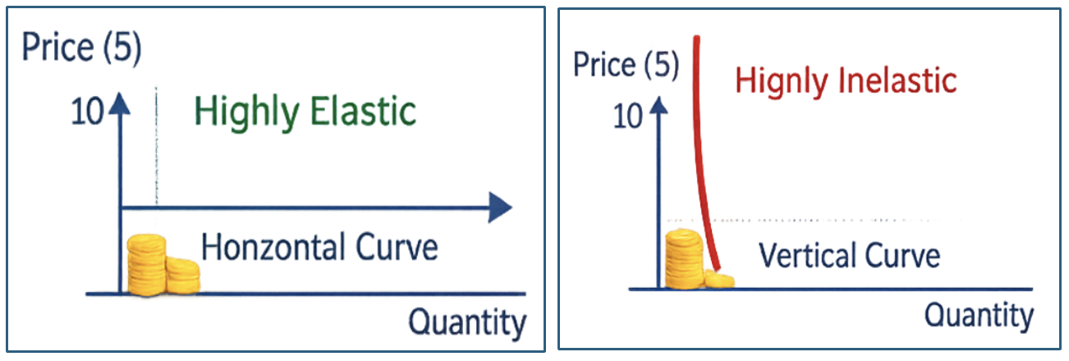
Supply:
- Firm supply:
  - Total Benefit: total amount firms would expend to produce a certain quantity of goods
    - Marginal benefit: benefit to firms from the next unit of a good
  - Total Variable Cost: total amount firms did expend to produce a certain quantity of goods (excluding fixed costs)
    - Marginal Cost: cost to firms to supply the next unit of a good
      - Increasing marginal cost: cost of each additional unit tends to increase
  - Producer Surplus: value producers received in excess of their variable costs
    - Marginal Profit: benefit net of costs to firms to supply the next unit of a good
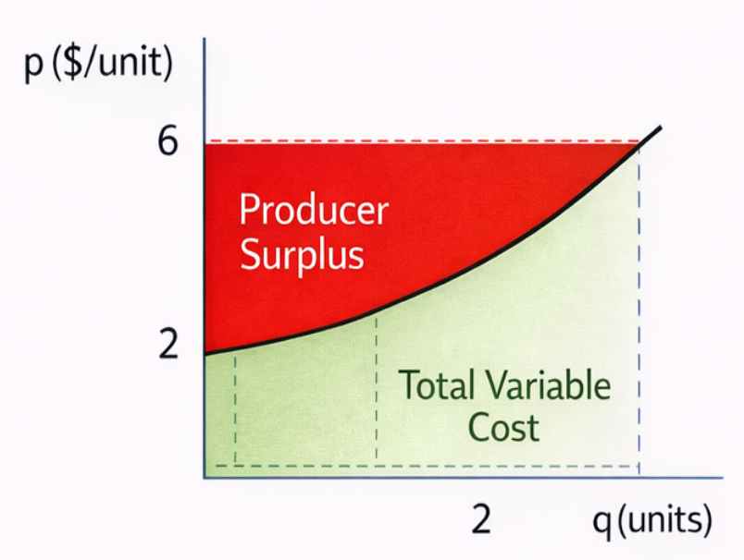
- Market supply: sum of firm supply curves
- Elasticity of supply: how much quantity supplied changes in response to a change in price
Total Surplus: sum of consumer and producer surplus (which economics aims to maximize)
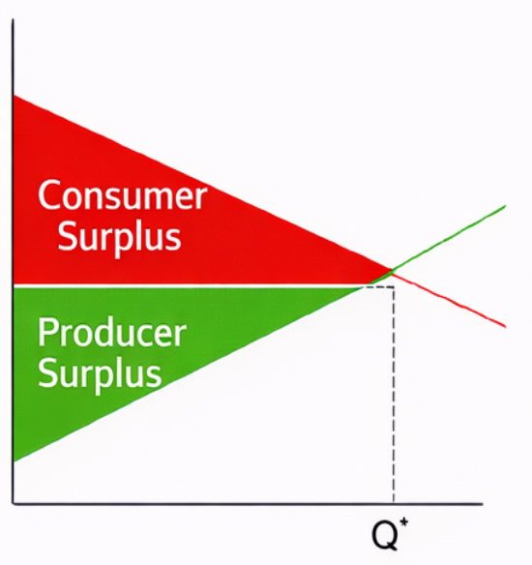
General Mechanics:
- Consumers keep buying as long as marginal benefit > price
- Firms keep producing as long as marginal cost < price
- The competitive equilibrium that maximizes total surplus is the quantity where price = marginal benefit = marginal cost (see Q* in the total surplus graph above).
  - No gains from trade/pareto efficient: no consumer is willing to buy another unit and no firm is willing to produce another unit
- Note that pursuing noneconomic values might sacrifice the benefits of efficient markets

Market Power
Limitations of the competitive model and the law that addresses them in connection with antitrust:
- Market Power (regulation and antitrust law): firms have power to set prices
  - Returns from market power go disproportionately to the wealthy, exacerbating inequality
- Public Goods: non-rival (my experience doesn’t affect yours) and non-excludable (free-rider problem, difficult to prevent use)
- Externalities (environmental law): cost/benefit that affects third parties not directly involved in a transaction
- Incomplete Information (consumer law): lack of full knowledge of details relevant to a decision
- Psychology (behavioral economics): relaxing assumptions about perfect rationality
Philosophical debate: Smith vs. Marx
- Smith and antitrust doctrine: the market system can be saved
- Marx: market failures are intrinsic to capital, we need an entirely new system
Economic consequences of market power:
- Because firms set their own price, some consumers may be priced out of the market
- Usually results in higher prices and lower output
- Allows firms to transfer wealth from consumers to producers
- Deadweight loss: loss of pareto efficiency and gains from trade
- In addition to price, note that these effects apply to quality, variety, and innovation
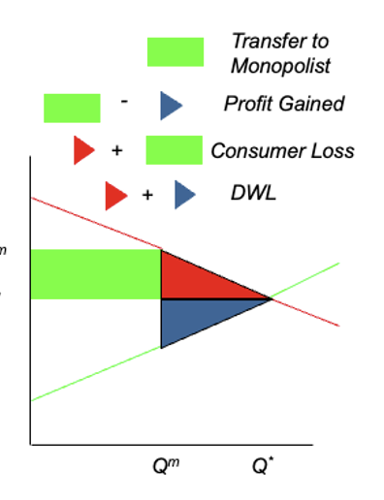
Antitrust law’s combats market power by litigating and regulating (1) the number of buyers and sellers and (2) the conditions of market entry

Anticompetitive Conduct (C2)
There are 2 types of antitrust injury:
- Collusive harm: coordinated action by competitors to emulate a monopolist and limit some dimension of competition that affects customers or suppliers
  - Direct harm on customers or suppliers: first-order effects are higher prices/other limitations of competition (“transaction-party harm”)
  - Example mechanisms: price fixing, division of markets
- Exclusionary harm: Unilateral or coordinated action to harm a competitor that likely affects the excluding firms’ customers or suppliers
  - Indirect harm on customers or suppliers: first-order effect is that competitors are impaired/cut off from accessing valuable inputs and markets, second-order effects are higher prices/other limitations of competition
  - Example mechanisms: some boycotts, exclusive dealing/tying
End results of antitrust injury (same for collusive and exclusionary harm):
- Reduced output
- Maintained or raised price
- Determine quality or other product features or characteristics
- Determine level of innovation

Policy rationale: in furtherance of neoclassical economics and competitive markets, competitors must compete, not make agreements at the expense of consumers and suppliers (however, there are some exceptional agreements deemed to benefit consumers/suppliers are permitted)
- Under antitrust law, harms to competitors are not valid causes of action (Gloucester)
- However, the cascading harms that are suffered by upstream suppliers and downstream consumers are valid causes of action.
Caselaw:
Case of the Ancient School (1410)
- Holding: harms to competitors aren’t actionable without the violation of a legal right
  - Decision to open a school and offer cheaper fees were valid business moves, so any resulting harm would not support a valid legal claim
- Facts: students left one school for another school that had cheaper fees and a well-liked teacher
Brunswick Corp. v. Pueblo Bowl-O-Mat (1977) (P must show antitrust injury)
- Holding: lost profits are not cognizable damages under antitrust law
  - Lost profits don’t follow from the anticompetitive part of the conduct
    - Suing over an increase in competition is antithetical to the purposes of antitrust law
    - Antitrust laws were enacted for “the protection of competition not competitors.”
- Facts:
  - A bowling alley operator’s (Brunswick) parent company acquires bowling alleys that Pueblo, another bowling alley operator, claims would have failed.
  - Pueblo alleges violation of Clayton Act: the merger of the bowling alleys lowered its profits compared to a world in which Brunswick hadn’t intervened.
- Prof. Note: plaintiffs must allege exclusionary or collusive harm
  - Pueblo could argue that the merger diminished competition because Brunswick is blocking them from getting equipment (exclusionary harm)
United States v. Andreas (2000)
- Holding: defendant conspiracy leaders should have received longer sentences
  - Clear collusion: agreements on price that were not accidental (satisfy civil meaning of intent)
- Facts:
  - Lysine (animal feed additive) manufacturers formed a cartel, met secretly and colluded to set price, quantity, and allocate market share for over a decade
  - Ensured cooperation/prevented cheating by agreeing to have company A purchase company B’s unsold allocations if company A sold more than their agreed allocation
    - Example of how illegal promises are enforced without contract law – punish uncooperative colluders with exclusionary conduct (they go together)
- Prof. Note: Successful collusion requires exclusion
JTC Petroleum v. Piasa Motor Fuels (1999)
- Holding: strong evidence that applicators inflicted exclusionary harm by facilitating a conspiracy between producers to not sell asphalt to applicator competitor
  - Applicators have a strong incentive to collude: application is a standardized service
  - Producers have a strong incentive to collude: asphalt has a very local market because it’s difficult to transport (heavy and deteriorates)
    - There are only 3 local producers that are already producing at capacity, lowering price wouldn’t result in more sales/profits (demand is inelastic)
  - Cheating is easy to discover: the cheater will be the lowest bidder and win the applicator contract
  - Evidence of market power among local producers: local producer prices for asphalt were high
- Facts:
  - Applicators (road contractors) attempt to start a cartel, but JTC (competing applicator) refuses.
  - Applicators agree to pay asphalt producers extra if the producers refuse to sell to JTC.
Apple acquisition of Dark Sky (2020)
- Facts: After acquiring Dark Sky, Apple withheld Dark Sky from Android OS and withheld Dark Sky’s API from rival weather apps
  - Neither the transaction nor subsequent conduct were subject to significant antitrust scrutiny
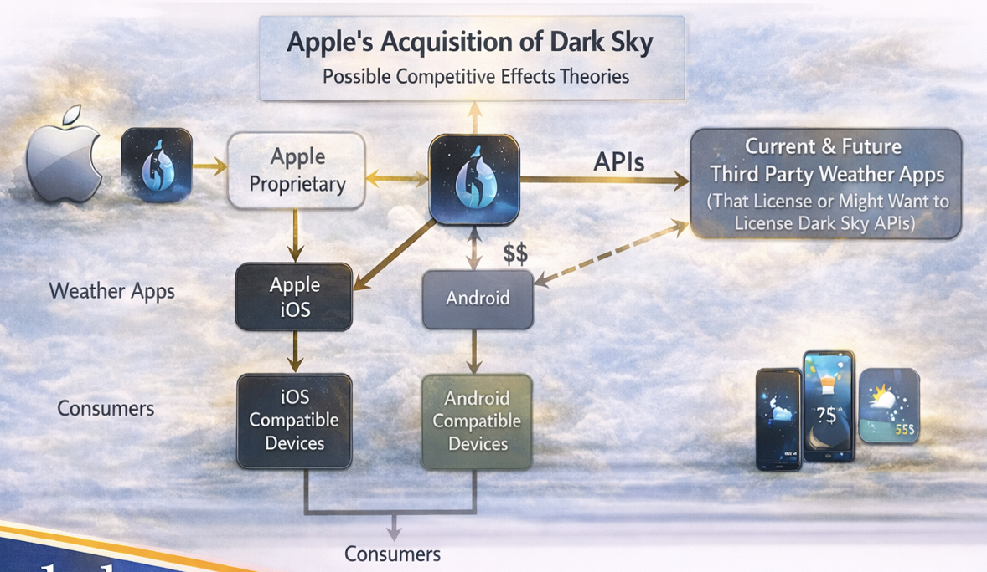

Structure of U.S. Antitrust Law (C2)
Public v. Private Enforcers:
- Public: DOJ, FTC, States
- Private: Competitors, Suppliers, Consumers
DOJ:
- Acts enforced: Sherman and Clayton Acts
- Administrative structure: Antitrust Division headed by Assistant Attorney General (nominated by the President and confirmed by the Senate)
- Brings suits in federal court:
  - Civil suits: can obtain equitable relief or collect treble damages (when it sues as a purchaser of goods and services)
  - Criminal suits: sole authority to prosecute antitrust crimes (must commence within five years of the offense)
- Issues enforcement guidelines, “business review letters,” and advice to regulatory commissions and legislative committees
FTC:
- Acts enforced: Clayton Act and Section 5 of the FTC Act (which encompasses the Sherman Act)
- Administrative structure: Headed by 5 Commissioners (no more than 3 from the same political party) (nominated by the President and confirmed by the Senate) that serve 7-year terms
  - Bureau of Competition (assisted by Bureau of Economics) is responsible for antitrust cases
- Issues enforcement guidelines, advisory opinions, and advice to regulatory commissions and legislative committees
  - Has the authority to use a compulsory process to study industry trends
States:
- Acts enforced: Clayton Act Sections 4 and 16 (damages or injunctive relief for violations of federal antitrust law), statutes that mirror the language of the Sherman Act and Section 5 of the FTC Act
  - State courts often rely on federal antitrust jurisprudence to interpret state statutes
Remedies:
- Criminal: imprisonment, fines (corporate and individual), asset forfeitures, injunctive relief
  - Can only be brought by DOJ under the Sherman Act, typically reserved for cartels
  - Standard: criminal intent (reasonable knowledge of harmful effect)
- Civil: damages, injunctive relief (conduct prohibitions, divestiture or other structural relief), attorney’s fees
  - Standard: voluntary, purposeful action (not forced or accidental)
Acts:
- Sherman Act (1890): created general rules to permit positive system of enforcement executed by public authorities with specific content articulated by the courts
- Clayton Act (1914): created more specific commands that leave courts/enforcement agencies with less discretion

S1/S2/C3 Summary:
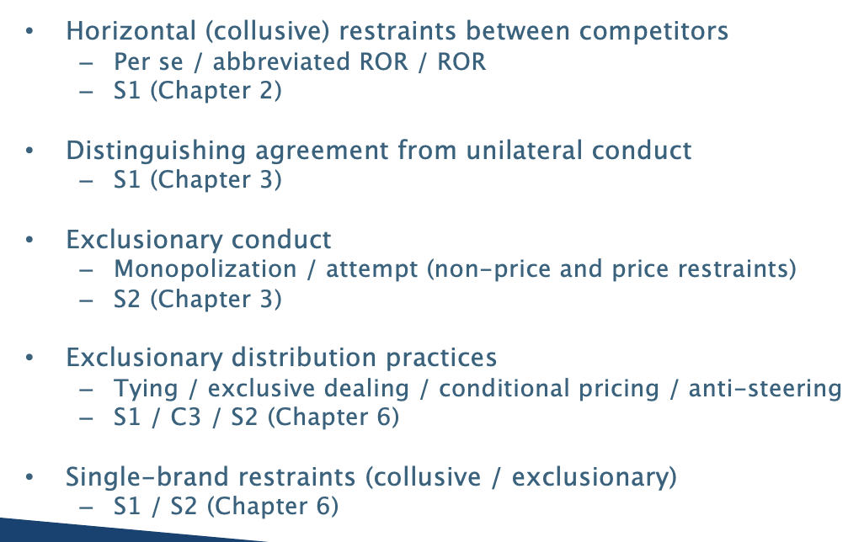

Concerted Action Among Competitors (Restraints of Trade)
Sherman Act § 1 (1890): “Every contract, combination in the form of a trust or otherwise, or conspiracy, in restraint of trade or commerce among the several States, or with foreign nations, is declared illegal.”
- Contract, combination, or conspiracy (CCC): Governs agreements (explicit or tacit) between parties (doesn’t apply to single-firm behavior)
- Restraint of trade (ROT): defined by the common law, enables courts to change interpretation
- Jurisdictional hooks: “among the several States” = interstate commerce, “with foreign nations” = international cartels
General approach: look at evidence of harm, look at justifications
- Per se illegal: there was almost definitely harm (often proved through direct evidence) without any legally cognizable justification
- Abbreviated rule of reason/quick look: there was almost definitely harm, but there is a legally cognizable justification – however, the restraint is “overly broad”
- Full rule of reason: unclear if there is harm and, if there was harm, there is a very good justification – a full investigation is required to evaluate

Emergence of the Rule of Reason (C3-4)
Rule of Reason: Provides the interpretive framework for Sherman Act § 1
- Initial burden: P has burden to make the prima facie case that there was (a) CCC, (b) ROT, and (c) antitrust injury.
- If P satisfies initial burden: D has burden to provide some procompetitive justification for ROT
- If D satisfies burden: P has burden to show that the anticompetitive effects outweigh the procompetitive justification
Per se illegality: agreements without a legally recognized procompetitive justification
- P must still satisfy its initial burden under the Rule of Reason (CCC, ROT, and antitrust injury) – an additional showing of market power is sometimes required

Early Common Law
Pre-Sherman common law definition of an enforceable restraint of trade:
- the restraint is ancillary (i.e., supporting) to some lawful agreement
- the restraint is reasonable with respect to time, scope, locality, AND
- the restraint is reasonable with respect to the parties and public interest.
Caselaw:
Dyer’s Case (1415)
- Holding: A covenant not to engage in a lawful trade or calling is void (unenforceable) per se
  - Burden on community: a person who can’t engage in a trade will rely on the church parish to support them
- Facts: Dyer agreed not to practice trade in hometown
- Prof. Note: ruling refined by Mitchel v. Reynolds (see below)
Case of the Ancient School (1410) (see above)
- Holding: an existing business has no action in tort against a new business that takes its customers
- Facts: students left one school for another school that had cheaper fees and a well-liked teacher
- Prof Note: holding applies even if it is a big company stealing from a small company
Mitchel v. Reynolds (1711)
- Holding: contracts in restraint of trade are enforceable if (1) the restraint is ancillary to some lawful agreement, (2) the restraint is reasonable with respect to time, scope, locality, and (3) the restraint is reasonable with respect to the parties and public interest.
- Prof. Note: emphasis on unreasonable restraints of trade
  - examples with ancillary agreement to restrain trade include sale of a business (agreement to not immediately open competitor nearby), employment/apprenticeship contracts (agreement not to leave immediately), partnership agreements

Early § 1 Cases
Central legal question: what is a “restraint of trade” based on the history of the Sherman Act?
- Court wants to develop a doctrine that condemns conduct and respects the common law without requiring difficult factual determinations
- Defendants will argue that a literal meaning of section 1 would outlaw contracts, pointing out that the ROT is (1) ancillary to a lawful purpose or (2) reasonable under the common law
- Plaintiffs will argue that the statute says “every” CCC. If this is rejected, P will argue that the ROT is the (1) purpose of the agreement (i.e., not ancillary), (2) lacks a lawful purpose, and (3) is unreasonable under the common law
Caselaw:
U.S. v. Trans-MO Freight Ass’n (1897) (per se illegal – reasonable prices / destructive competition)
- Holding: “every” contract in restraint of trade is illegal
  - D unsuccessfully argues that
    - Association and rates are necessary to cover fixed costs
    - Rates are reasonable
    - And members still had the ability to lower rates
  - However, the Court is skeptical about determining reasonable rates
- Facts: 18 railroads create an association to set rates
- Dissent: section 1 only condemns unreasonable ROT, interpreting “every” literally is unworkable, would outlaw contracts
- Prof. Note: the dissent’s view is what was ultimately adopted by modern antitrust – see Standard Oil
U.S. v. Joint-Traffic Ass’n (1898)
- Holding:
- Facts:
U.S. v. Addyston Pipe & Steel Co. (1898)
- Holding: common law condemned cartel that had no purpose other than to restrain trade
  - 2 categories of restraints:
    - Absolutely prohibited agreements: no purpose other than to restrain trade
      - Condemned absolutely at common law
    - Ancillary restraints: restrain trade at the time of enforcement, but at the time of agreement can facilitate the underlying, legitimate transaction and promotes trade
      - Should be assessed for their reasonableness
  - The cartel represented an absolutely prohibited agreement
- Facts: cast-iron pipe manufacturers formed cartel to rig bids on municipal contracts.
- Prof. Note: narrow approach of only considering reasonableness of “ancillary” ROT not adopted, Standard Oil court elected to broaden consideration of reasonableness to all ROT

Development of the Rule of Reason
Basic History: the reasonability standard was introduced by Standard Oil, while the judicial test (rule of reason) was established by CBT
Formulation of Rule of Reason after CBT: does the ROT “merely regulate” and “perhaps thereby promote” competition, or does it “suppress or even destroy” competition?
- Court must consider the nature/scope/effect of the restraint
- Other relevant factors include facts peculiar to the business, condition before and after the restraint, history of the restraint, and reason for adopting the restraint
Caselaw:
Standard Oil v. U.S. (1911) (reasonability is the standard for all Section 1 violations)
- Holding: only unreasonable restraints of trade are illegal under the Sherman Act (rule of reason)
Chicago Bd. of Trade v. U.S. (1918) (classic rule of reason case)
- Holding: Board of Trade’s rule was reasonable under the rule of reason
  - Lower court erred:
    - Didn’t consider the purpose of the call rule
    - Excluded evidence on the effect of the rule
  - Outlined judicial test: does the ROT “merely regulate” and “perhaps thereby promote” competition, or does it “suppress or even destroy” competition?
    - Court must consider the nature/scope/effect of the restraint
    - Other relevant factors include facts peculiar to the business, condition before and after the restraint, history of the restraint, and reason for adopting the restraint
  - Applied test:
    - Nature of restraint: time restriction made it in interest of sellers to attend the call
    - Scope of restraint: applied to a small part of daily grain shipped and daily sales
    - Effect of restraint: no appreciable effect on prices or volume
  - Worried that warehouses would exercise market power, CBT setting prices improves competition
- Facts: restriction on the after-hours price in the “to arrive market” for grain
  - To arrive market: parties transact about grain that arrives the next morning (between the spot and futures markets)
  - Agreement: at the end of the day’s spot market trading, arrive price is fixed for each transaction (further negotiations are prohibited)
- Prof. Note: didn’t overrule Trans-MO, but gave defendants a path forward

Development of Per Se Illegality
Requirements for a per se § 1 violation after Socony: illegal per se = lacks a “cognizable” or “plausible” procompetitive justification
A CCC formed with the “purpose and effect” of fixing price is illegal per se (highly likely to give rise to anticompetitive effects):
- Purpose (intent) and effect are sufficient for a violation
- Purpose (intent) and power are sufficient for a violation even if there is no effect
- Purpose (intent) without power is sufficient (but dicta from Socony fn 59 – these cases usually not worth pursuing because there is no harm)
After Topco, agreements are only per se illegal when courts have “considerable experience” with their general type – see the list of per se illegal acts below.

Additional notes:
- “Per se illegal” is a conclusion, not a method of analysis
- A court must always analyze a restraint: if the restraint is of a type that is highly likely to be anticompetitive because of its (1) nature, (2) scope, and (3) the court’s past experience with it, and (4) there are no obvious procompetitive benefits of the kind that courts have recognized in the past or that stem from the economic circumstances of the case, then the court will conclude that the restraint is per se illegal
- This conclusion can often be done without elaborate factual findings (Andreas)

Policy Note (Northern Pacific): don’t require effect to declare price fixing per se illegal (power is sufficient) because we want to empower enforcers to charge defendants before the cartel has a chance to actually fix prices

Acts deemed per se illegal (D can’t provide legally cognizable procompetitive justification):
- Price fixing/“reasonable prices”:
  - U.S. v. Trenton Potteries (1927, fixed prices for bathroom fixtures)
  - U.S. v. Trans-MO Freight (1897, can’t argue reasonable prices and destructive competition)
  - U.S. v. Socony-Vacuum Oil (1940, can’t argue destructive competition and reasonable method of stabilizing prices)
- Minimum price fixing/price floor:
  - Goldfarb v. Virginia State Bar (1975, minimum fee schedule by bar association)
- Maximum price fixing/price ceiling: courts don’t trust Ds to do this
  - Arizona v. Maricopa County Medical Society (1982, agreement between doctors/insurers on maximum prices charged by doctors)
- Suggested prices: courts believe this won’t have beneficial consequences on average
  - Plymouth Dealers Assn. v. U.S. (1960, auto dealers using common list prices, courts don’t trust Ds to do this)
- Quantity fixing: analogous to controlling price
  - Hartford-Empire Co. v. U.S. (1945, limitation of production of glass products)
- Market division (geographic/product/customer): no reason for firms to do this other than protect themselves – tends to hurt consumers
  - Palmer v. BRG of Georgia (1990, division of Georgia bar review course market)
- Agreement to limit credit: firms should compete for credit card customers
  - Catalano, Inc. v. Target Sales, Inc. (1980, beer distributors agree to eliminate free short-term credit)
- Competition is destructive: whole point of antitrust is to promote competition
  - NSPE v. U.S. (1978)
- Non-Profit status
  - NCAA v. Board of Regents (1984, NCAA prohibits teams from negotiating their own network deals)
- Upholding amateurism in sport
  - NCAA v. Board of Regents (1984, NCAA prohibits teams from negotiating their own network deals)
Historical Debate: Justice Burger vs. Justice Marshall
- Burger: the court cannot escape weighing competitive effects, so it should try to do its best
  - Supports the rule of reason
- Marshall: the court isn’t good at weighing competitive effects, so it should avoid doing so
  - Supports per se liability
- Burger’s perspective won, leading to the expansion the rule of reason/stop of the expansion of the rule of reason
Caselaw:
U.S. v. Trenton Potteries (1927) (reasonableness of price not cognizable)
- Holding: reasonableness of the prices set under a ROT is not material
  - Agreements that create power over prices may be held to be unreasonable or unlawful in themselves under the Sherman Act
  - Uniform price fixing is prohibited: the “reasonableness” of particular prices is not a defense
- Facts:
  - Ds control 82% of vitreous pottery (bathroom fixtures) in the U.S.
  - Ds fixed prices and limited sales, argued that the prices they set were reasonable
- Prof. Note: made two types of cases: one where you consider reasonableness (CBT), one where there aren’t cognizable legal defenses that the fixed price is reasonable (Trenton)
Appalachian Coals v. U.S. (1933)
- Holding:
  - Distinguished from Trenton Potteries: D had no power to affect market prices because most of the coal was to be sold outside Appalachia
- Facts:
U.S. v. Socony-Vacuum Oil (1940) (can’t justify price fixing by claiming that competition is destructive or claiming “stability”)
- Holding: CCC with the purpose and effect of raising prices is per se illegal
  - Provided requirements for a § 1 violation:
    - Purpose (intent) and effect are sufficient for a violation
    - Purpose (intent) and power are sufficient for a violation even if there is no effect
    - Purpose (intent) without power is sufficient (but dicta)
  - Here, the CCC was completed with the purpose and effect of raising prices
- Facts:
  - In the Depression, government trying to raise prices with price floors under National Industrial Recovery Act (NIRA)
  - NIRA held unconstitutional, but oil companies continued to coordinate (agreed to buy from independent oil distributors to stabilize price at high levels)
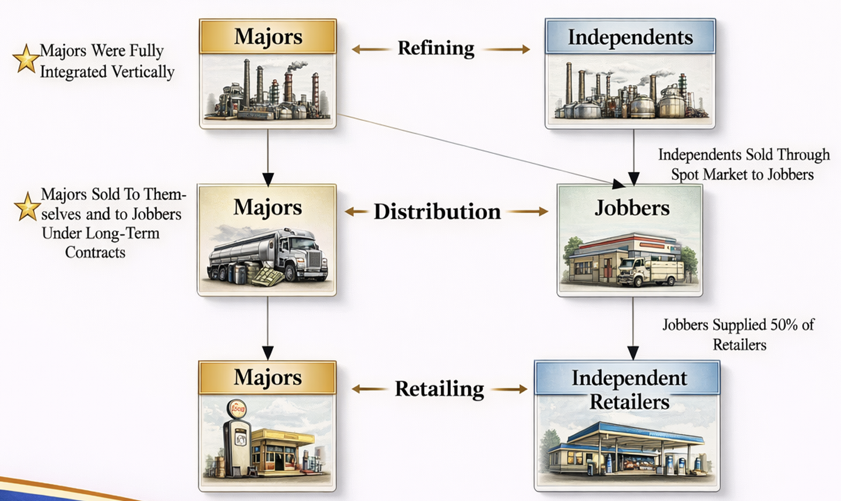
- Prof. Note: by expanding what is considered per se illegal, this case narrowed the law of agreement by incentivizing businesses to hide their agreements

Modern Antitrust Analysis
Professional Associations:
- Professional associations can set requirements for members: it is helpful to certify quality
- This interest in certifying quality can outweigh interest in having a higher supply of professionals
- Distinction from valid professional association and NSPE: the ban in NSPE is too broad, is not the least restrictive means to accomplish a valid, lawful purpose (like certifying professionals)
Caselaw:
National Society of Professional Engineers v. U.S. (1978)
- Holding: a professional association cannot broadly ban competitive pricing
  - CBT: illegality depends on competitive effects
  - Trenton Potteries: do not permit an inquiry into the reasonableness of prices
  - Trans-MO: there are not special characteristics of an industry that suggest monopolistic arrangements will better promote trade than competition
  - Complementary categories of antitrust analysis:
    - Socony: illegal per se, no elaborate study is required to determine illegality – maybe the case here, unclear
    - CBT: under ROR analysis, the fee ban is too broad and serves as a ban on competitive bidding (not the least restrictive approach to promote quality)
      - Arguing that competition is unreasonable is not a valid defense
- Facts:
  - Engineers who want to bid on a job can’t talk about fees per NSPE’s code of ethics
    - Can only talk about fees after a client has selected an engineer for a project
  - Engineers argue that work will be inferior and endanger public safety without this agreement
- Prof. Note: treat this case like it was per se illegal given the competitive pricing ban, but it isn’t clear from the opinion that this is the holding
  - That being said, there is reason to think this could be decided under the abbreviated rule of reason case now even without direct harm: overly broad restrictions suggest high likelihood of anticompetitive effects
Broadcast Music v. CBS (1979)
- Holding: blanket license is not per se illegal
  - Per se rule isn’t appropriate here: strongest argument is gains from trade
    - Efficiencies: bundling like this creates efficiencies that wouldn’t exist otherwise (independent transactions with each artist are impossible)
    - By enabling a new type of transaction, blanket licenses enhance competition
  - Other (less compelling) arguments that per se rule is inappropriate:
    - Effectuating a copyright:
    - History of consent decree: courts haven’t found this conduct illegal in the past, hesitate to find it per se illegal now
    - Negative effect of a per se finding: would cast industry into disarray
- Dissent: not offering the per-composition and per-use licenses (when they are feasible to offer) is anticompetitive, unlawful under ROR, limits options available to consumers
- Facts:
  - ASCAP and BMI are associations of artists that offer nonexclusive blanket licenses for artists’ music for limited periods – licensee can use music they want during period
  - CBS wants compositions available on a per-use rate
- Prof. Notes:
  - If BMI and ASCAP agreed on a price of a blanket license, then there would be a CCC (the agreement) and ROT (price-fixing), so likely per se illegal (would be an easy case)
  - If BMI and ASCAP agreed on type of license, there would be a CCC (the agreement) and ROT (sufficient market power that agreement is anticompetitive), per se illegal
  - If individual composers agree to adopt uniform licensing fee schedule for compositions, whether it is per se illegal likely depends on whether artists have market power (if they do, then the case is analogous to SCTLA)
  - Case is an example of how the ROR requires the court to supervise contracts and prices (as they feared)

Per Se Analysis (C4-5)
Cases on the boundary of per se illegality: overlap of potentially illegal agreements with otherwise legitimate business activities
- Topco (grocery brand)
- BRG (non-compete in licensing contract)
- NSPE / IN Dentists / CDA (professional associations)
- NCAA (competitive league)
- Dagher (joint venture)
Considerations on the boundary of per se illegality:
- Is the restriction too broad relative to any lawful purpose? Topco, NSPE
- Would prohibition prevent equivalent market organization by low-cost, substitute means?
  - Topco: probably not, co-op can still operate without geographic restrictions and stores can achieve geographic spacing without cooperation
  - BMI: certainly in the short term, blanket license may be unavailable if per se illegal
- Is there direct or indirect evidence of anticompetitive harm or market power?
  - NSPE and BRG: evidence of price increases
  - Topco: evidence suggests that competitive harm was unlikely

Price Fixing
Caselaw:
Catalano v. Target Sales (1980)
- Holding: agreement limiting credit is per se illegal
  - D’s Barrier to removal arg: limiting credit raises the price, can’t say that raises the price enables entry, antitrust is specifically meant to limit this type of conduct
  - D’s price transparency arg: transparency helps competitors more than customers, secret price cutting is a way to steal customers
- Facts: Agreement between beer wholesalers D that (1) payment must be made in advance or upon delivery and (2) retailers will not be provided credit.
  - D argues that (1) allows wholesalers who can’t accommodate credit to compete with those that can and (2) improves price transparency for consumers.
- Prof. Note: not a defense to reduce competition on some dimension of price to make the main price more transparent
  - This is an easy case

Market Division
3 types of market division/allocation: geographic, customer, and product
- Effect: limits both price and non-price competition
Caselaw:
Timken Roller Bearing v. U.S. (1951)
- Holding: dividing markets geographically is per se illegal
  - We expect companies to compete over territory
- Facts: territorial division of world markets for antifriction bearings, where prices were fixed in each competitor’s territory and entry was discouraged.
- Prof. Note: this is an easy case
U.S. v. Topco (1972)
- Holding: bylaws are a per se illegal horizontal division of territories
  - Not sympathetic with idea that bylaws help small chains compete against big chains
  - Horizontal division of territories is a classic example of a per se violation
- Facts: small grocery cooperatives (owned by workers) D, bylaws establish territorial licenses to help stores avoid competing in the same geographical market (like Safeway spaces out its stores).
  - The Topco cooperatives procure and distribute products under the Topco brand.
  - Topco has 6% of grocery market.
- Prof. Note: know how to argue both sides
  - Topco’s best defenses: (1) bylaws help small firms compete against big chains; (2) 6% market share suggests there will be little anti-competitive effect
  - Government response to Topco’s defenses: (1) apply Timken, this is collusion; (2) Holmes’ bad man argument (if decided the other way, a “bad” actor could buy a little bit of Topco product could justify a division of markets)
  - This is a hard case
Palmer v. BRG of Georgia (1990)
- Holding: agreement not to compete in competitor’s market was per se illegal
  - Apply Socony: agreement formed with the purpose and effect of raising the price of the Georgia bar review course (see large price increase)
  - Apply Topco/Timken: agreements to allocate territory to minimize competition are illegal
- Facts: agreement to divide market for bar review materials in Georgia between HBJ and BRG. HBJ gives BRG an exclusive license to offer its materials and courses in GA. BRG agrees not to compete outside GA. Price of BRG course increases from $150 to over $400.
- Prof. Note: know how to argue both sides, this is case is harder than it seems
  - BRG’s best defenses: (1) the same price increase would have occurred if HBJ left GA without an agreement; (2) not competing is ancillary, like agreeing not to open a store next to one you just sold is ancillary; (3) consumers are better off if BRG doesn’t enter other markets because HBJ’s materials are better
  - Palmer’s best response to BRG’s defenses: see the court’s reasoning
  - Think about how the length of a license affects judgment: if noncompete is aligned with the length of the license, then this is more justifiable than a noncompete agreement that extends further

Group Boycotts
Collusive group boycotts: Agreement among competitors to coerce a lower price from supplier or a higher price from purchaser
- Conduct involves coercive demands but is economically no different than price fixing
- Examples:
  - Boycotting firms collectively refuse to purchase unless suppliers agree to sell at a depressed price
  - Boycotting firms collectively refuse to sell unless customers pay a higher price
Difference between collusive and exclusionary effects:

Caselaw:
FTC v. SCTLA (1990) (collusive group boycott, direct effect)
- SCOTUS Holding: SCTLA boycott is illegal per se
  - Agreed with FTC in the holding and ALJ in the rejection of counterarguments
  - On Noerr: you can petition, but actions here amounted to coercion (withdrew services to get a higher wage instead of just asking for higher wage), which isn’t protected
  - On Claiborne: the boycott yields an economic benefit to the lawyers, not the case in Claiborne
    - Prof. Note: lawyers could argue that like P in Claiborne, they are effectuating the 6th Amendment right to counsel for their clients
  - On O’Brien: Don’t want to have to weigh First Amendment issues in every case (weak argument by Court)
- Circuit Holding: remands to determine whether SCTLA had market power
  - There is an element of expression that needs to be protected under the First Amendment (O’Brien, protected burning of draft card on courthouse steps) so
  - Per se is not appropriate (rule of reason is necessary)
- FTC Holding: SCTLA conduct was coercive, concerted refusal to deal with the purpose and effect of raising prices and thus illegal per se (lawyers can’t do this)
- ALJ Holding: complaint dismissed, boycott had beneficial effects (given DC didn’t complain)
  - ALJ rejects arguments that (1) there is public interest in better legal representation, (2) any group can petition the legislature per Noerr, and (3) this is an example of protected political action per Claiborne (black consumers boycott white-owned businesses not participating in civil rights, protected under the first amendment)
- Facts: Criminal Justice Act lawyers (independent contractors) collectively refuse to accept new assignments, bill passes increasing their fees, FTC files complaint (illegal agreement to refuse assignments). Since lawyers weren’t state employees, the Norris-LaGuardia Act didn’t exempt them as employees engaged in a labor dispute.
- Prof Note: each court takes a different approach for how to deal with cases like this
  - Tough case, but a group refusing to do a service unless they receive a particular fee is an agreement between competitors to fix a price and is per se illegal.
Catalano: wholesalers agree not to extend credit to retailers (collusive group boycott, direct effect)
JTC Petroleum: asphalt producers boycotted applicators competing with the cartel (exclusionary group boycott, indirect effect)

Joint Ventures
Joint venture: two competitors agree to collaborate on a project like R&D, Production, or Distribution
- Typically get rule of reason treatment
- For a joint venture to get a blessing from an agency, there must be some argument about synergies and efficiencies that provide a procompetitive justification
- Examples from cases: CBT, BMI, Topco
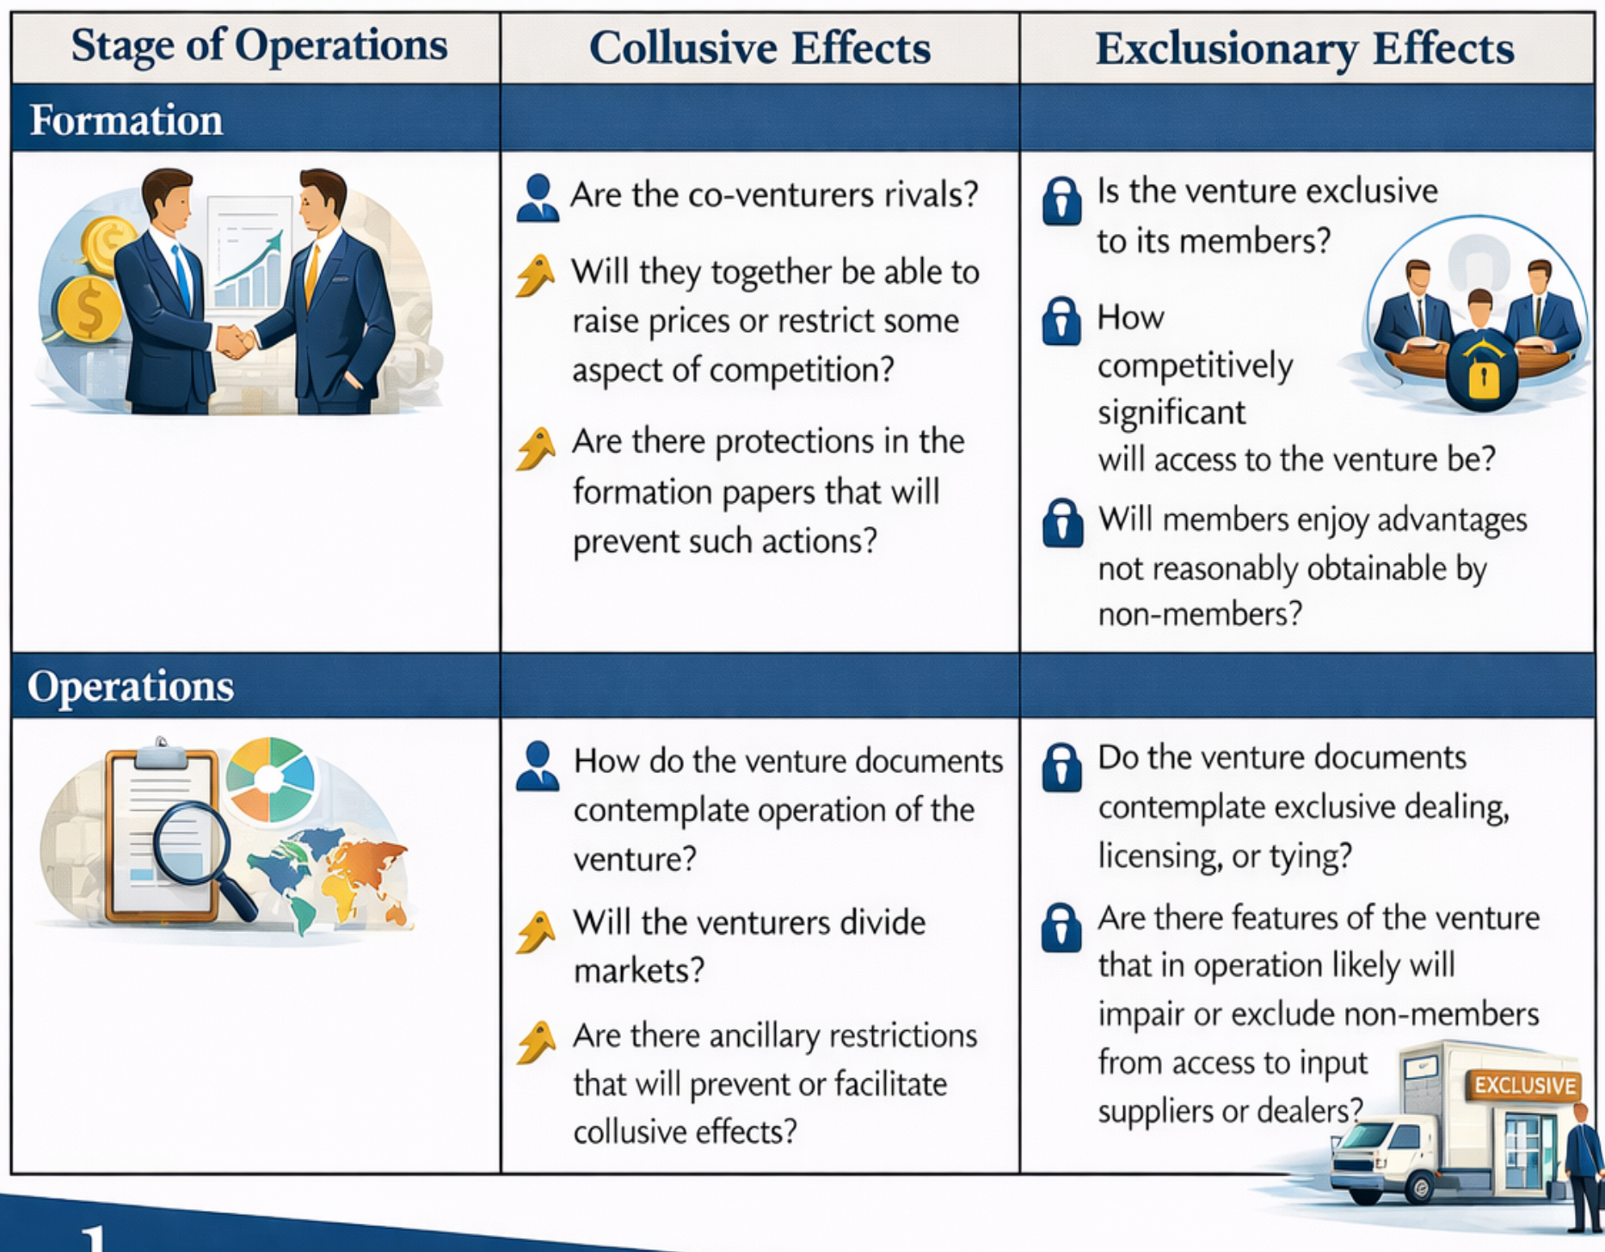
Caselaw:
Texaco v. Dagher (2006)
- Holding: the per se rule is inapplicable
  - Has many of the provisions and attributes of a joint venture, effectively dismissed
- Facts: joint venture (Equilon) formed between gas companies Texaco and Shell to refine and sell gas, set joint prices but sell under separate brands
  - Venture could be dissolved at any time by mutual consent or, after an initial term of five years, unilaterally with two years notice
- Prof. Note: how would this have gone under rule of reason? Factors to consider (good for P):
  - Considerations about the fixed price:
    - The joint pricing idea was conceived before the formation of the venture (even though it wasn’t contained in the main joint venture agreements)
    - Pricing allowed Equilon to raise prices in areas when crude oil prices were low and stable
    - The efficiencies were independent of the agreement to set price, so price didn’t need to be set together
  - Dissolution plan incentivized sticking with the venture for a long time
  - Altogether, this suggests that this joint venture went too far and let the gas companies set the same price

Abbreviated Rule of Reason (C6)
Abbreviated Rule of Reason: no bright line rule – per CA Dental, what is required is an “enquiry meet for the case”, looking to the “circumstances, details, and logic” of the restraint
- The P must usually show either direct evidence of anticompetitive effects (NCAA, IN Dentists) or a high likelihood of such effects (e.g., NSPE)
- Courts will ask whether the restraint is too broad relative to a lawful purpose (e.g., NCAA, CA Dental)
- If D is unable to rebut the P’s case by providing a strong procompetitive justification to shift the burden back, then P wins even though the restraint was not per se illegal
General idea: a court can find a restraint to be illegal under Section 1 if the defendant’s procompetitive justifications are strong enough that per se treatment is not warranted, but not strong enough to shift the burden of production back to the plaintiff.

Direct v. Indirect evidence of harm:
- Direct evidence of harm: increased price, reduced quantity, reduced quality, reduced variety, worse terms of credit, lessened innovation, evidence of exclusion
- Circumstantial/indirect evidence of harm: look at circumstances that suggest an inference that participants are harmed (market definition, market shares, inference of market power)
  - High market shares in relevant product and geographic market
  - High barriers to entry and other evidence why high market shares are indicative of market power
  - Argument that the restraint, in light of this market power, will have an anticompetitive effect

Caselaw:
NCAA v. Board of Regents of Oklahoma (1984) (abbreviated ROR can be applied)
- Holding: NCAA plan is not per se illegal, but is nevertheless an illegal restraint of trade under Section 1
  - Direct evidence:
    - Teams harmed: price teams could get for their TV rights was suppressed
    - Consumers harmed: amount of college football on TV was reduced under the NCAA’s plan
  - NCAA arguments and Court’s response
    - Accepted: NCAA organizes competition between teams, so their general oversight of the league is procompetitive
    - Rejected: Judiciary lacks experience to opine on the competition (Topco)
    - Rejected: NCAA was just preserving competition
    - Rejected: NCAA was a non-profit, different rules applied
    - Rejected: NCAA didn’t have market power – Court’s response:
      - (1) market power has never been required (dicta)
      - (2) here, market power is present – college football is a distinct market (even though NCAA tried to argue any leisure activity was the relevant market)
  - NCAA’s procompetitive justifications and the Court’s response:
    - Rejected: Facilitates commerce that wouldn’t be possible otherwise (BMI)
      - Court: schools can (and did) contract individually with networks, unlike musicians in BMI
    - Rejected, but closer: limiting the amount of college football on TV makes live football more attractive
    - Rejected, but closer: allowing teams to contract individually would allow a small number of schools to get all the money and attention, disrupt the competitive balance
    - Accepted in principle, but not a justification for the restraint: purpose of football programs is to allow students to engage in athletic activity as part of their education
- Facts: agreement between network and NCAA limited teams’ TV appearances and had a negotiated fee schedule that NCAA “recommended” schools follow
  - Schools attempted to contract with another network to show more games
FTC v. Indiana Federation of Dentists (1986)
- Holding: the Commission’s findings are sufficient to establish a section 1 violation per the abbreviated rule of reason
  - Not per se illegal: IFD is a professional association which is allowed to make polices about patient care (some deference to the association’s judgment)
  - Direct evidence: x-rays not being provided to insurers, can’t verify whether care is needed at all, no good procompetitive justification
- Facts: IFD refuses to supply x-rays to insurers, preventing the insurers from verifying the cost and quality of care provided by the physician (no different than denying consumers access to their own x-rays)
- Prof. Note: not as clear a case as NCAA, there is not uncontroverted evidence of price and quantity fixing like in NCAA, but there is direct evidence of harm through the effect on inputs
CA Dental Association v. FTC (1999) (abbreviated ROR shouldn’t be applied)
- Holding: failed to shift the burden to D to provide procompetitive evidence
  - Procompetitive justification: D has good reason to limit ads (prevent inferior services)
  - Effect could go either way: restrictions could hurt consumers or not, no obvious anticompetitive effect was shown – not obvious enough to permit quick-look
- Dissent: evidence substantiates restraint limited truthful and nondeceptive advertising
  - Sufficient consideration of the specific restraint, likely competitive effects, procompetitive justifications, and evidence of market power
- Facts: dentist’s association D prohibited advertising of across-the-board discounts (“15% off all services”) and unsubstantiated quality claims (“family friendly care”)
- Prof. Note: this case is on the boundary line of full and abbreviated rule of reason
  - Dissent shows how close the case is, argues there was a sufficient showing to warrant the burden shift to D
  - Defense bar: quick look requires actual evidence of anticompetitive effects
  - Plaintiff’s bar: quick look doesn’t require evidence if the likelihood of anticompetitive conduct is high (NSPE)

Full Rule of Reason (C7)
Full Rule of Reason (burden shifting framework):
- (1) A P must make out a prima facie case showing (a) an agreement (b) in restraint of trade that either (c) has anticompetitive effects or a high likelihood of anticompetitive effects (the D can try to rebut this case)
  - If the restraint of trade is particularly pernicious, then courts will be more likely to consider the high likelihood of anticompetitive effects
- (2) If the P is successful, the burden shifts to the D to provide a procompetitive justification, which can include evidence of procompetitive effects or an argument for or evidence of a high likelihood of such effects (P can rebut)
- (3) If the D is successful, the burden then shifts back to the P to show anticompetitive effects of the restraint outweigh any procompetitive benefits or that the restriction is not reasonably necessary to achieve the procompetitive benefits (less restrictive alternative)

Relevant considerations/factors (Chicago Board of Trade): use these factors to assemble a narrative about whether the challenged restraint is likely to have an adverse effect on competition
- Does the restraint “merely regulate and perhaps thereby promotes” competition or “suppress or even destroy competition”
- Courts must examine the nature, scope, and effect of the restraint
- Other relevant factors:
  - Facts peculiar to the business
  - Condition before/after the restraint
  - History of the restraint
  - Reasons for adopting the restraint

Direct vs. Indirect evidence of harm:
- Direct evidence of harm: increased price, reduced quantity, reduced quality, reduced variety, worse terms of credit, lessened innovation, evidence of exclusion
- Circumstantial/indirect evidence of harm: look at circumstances that suggest an inference that participants are harmed (market definition, market shares, inference of market power)
  - High market shares in relevant product and geographic market
  - High barriers to entry and other evidence why high market shares are indicative of market power
  - Argument that the restraint, in light of this market power, will have an anticompetitive effect

Caselaw:
NCAA v. Alston (2021) (modern, defendant friendly three step formulation of ROR)
- Holding: uphold NCAA rules limiting athletic scholarships and compensation related to athletic performance; enjoin NCAA rules limiting education-related benefits
  - Posits 3-step process to evaluate restraints under full rule of reason (although exact language doesn’t control in practice):
    - (1) P shows prima facie case that there was a “substantial anticompetitive effect”: change from “likely” to “substantial,” lots of room for judicial discretion
    - (2) Burden shifts to D to show “procompetitive rationale”: judges can also read this as “procompetitive evidence,” which is a higher standard that requires facts
    - (3) Burden shifts back to P to show that procompetitive efficiencies can be achieved in a less restrictive and less anticompetitive way: judges can interpret as restraint is “on balance” anticompetitive
  - Anticompetitive effect: students being paid less than they would be in a competitive market
  - Main holding: there is a difference between college and professional sports (prohibition is too broad)
    - NCAA should be allowed to preserve amateurism because it offers consumers an alternative to professional sports, court agrees, allows payment through education-related benefits
    - NCAA should not be allowed to pay based on athletic performance – that looks too similar to professional sports to be excluded by the amateurism argument
  - NCAA arguments:
    - Should be quick look to exonerate: court rejects, NCAA has substantial market share (need low market share for this to even be a discussion)
    - NCAA is a non-profit: doesn’t matter, still have anticompetitive harm
  - Court didn’t require NCAA to adopt the least restrictive means possible to achieve its ends – just needed to be less restrictive
  - Court notes that markets are better than the judiciary in enhancing consumer welfare, encourages judicial restraint (wary to “set sail on a sea of doubt”)
- Facts: student athletes challenged NCAA restrictions on athlete compensation, which effectively reduce student-athlete compensation (compared to world without rules)
- Prof. Note: lots of defense bar antitrust critiques here:
  - Provides a formulation of a narrow rule of reason doctrine
  - Courts shouldn’t second guess industry participants, nor should they micromanage
    - Courts should similarly avoid making injunctions because doing so would require them to micromanage

Distinguishing Concerted from Unilateral Action

Intra-enterprise conspiracy doctrine
Who can contract, combine, or conspire under section 1 of the Sherman Act as a matter of law? yes = potentially subject to liability
- Single entities and their agents: yes
- Corporations collaborating in a joint venture: yes (American Needle)
- Corporations with some common ownership: sometimes
  - Novatel: 51% ownership is sufficient for no
- Persons within a single (legal) business enterprise: no
- Parent corporation and wholly-owned subsidiary: no (Copperweld)
- Subsidiaries wholly owned by the same parent: no (Advanced Healthcare)
Caselaw:
Copperweld Corp. v. Independent Tube Corp (1984)
- Holding: a parent corporation and a wholly-owned subsidiary cannot, as a matter of law, conspire under section 1
  - Internal coordination within one economic unit is unilateral conduct, not section 1 violation
  - FRCP Rule 12(b)(6): Defendant will prevail on a motion to dismiss for failure to state a claim on which relief can be granted
- Facts: Copperweld D alleged to have conspired with its wholly-owned subsidiary to exclude another firm

Advanced Healthcare Serv. v. Radford (1984): Copperweld precludes liability for conspiracy between two wholly owned subsidiaries of the same parent corporation

Novatel Comm. v. Cellular Tel. Supply (1986): 51 percent ownership sufficient for full control so entities incapable of conspiring under Copperweld

American Needle v. National Football League (2010)
- Holding: joint ventures are not exempt from conspiracy law (remands for consideration under ROR)
  - Rejected by the court, this is an agreement between competitors (NFL teams are “independent centers of decision making”): NFL Properties argues that it is a single entity for the purpose of antitrust per Copperweld
    - Basis of NFL’s argument: NFL Properties was joint venture outside the scope of section 1 like in Texaco
- Facts: NFL forms NFL Properties (joint venture) to develop, license and market NFL-owned property. American Needle’s license (independent contractor) to make NFL apparel is not renewed, sues under section 1.
- Prof Note: NFL gets lots of protection for its activities since it organizes competition, hence remand

Economics of collusion
Problem of proving conspiracy: most of the time, evidence is hidden, you must often rely on circumstantial evidence. The economics of collusion helps construct a narrative that suggests conspiracy.
- Cartel Problems and their solutions (see Andreas and JTC Petroleum):
  - Reach consensus on price / quantity / quality / markets: meetings and discussions
  - Deter cheating
    - Detection: share information
    - Punishment: violence (OUS) or making business more difficult for competitors (US)
  - Prevent new competition from non-participants and entrants
Factors that facilitate and frustrate cartel formation:

Law of inferring agreement

Inferred express and tacit agreements
Rule: express agreements to fix prices are illegal.
- Goal: in the absence of direct evidence, what circumstantial evidence is necessary to infer an agreement?
Note on tacit agreements: tacit agreements to fix price are legal
- Such agreements involve firms that are strategically interdependent (respond to other firm’s activity strategically) and may engage in “conscious parallelism”
- Conscious parallelism is insufficient to prove conspiracy (Rule 50 and Monsanto), defeat D’s motion for summary judgment (Rule 56 and Matsushita), and defeat D’s motion to dismiss for failure to state a claim (Rule 12(b)(6) and Twombly)
- Gas station example: one station raises prices, the other follows, no agreement, not illegal
Types of circumstantial evidence:
Type 1: indications of express collusion (stronger, needed to win) (intuition: rules out not communicating)
- Improbable uniformity
- Frequent and unusual communication (something more than normal operations)
- Sharp break from past behavior
- History of collusion
Type 2: Industry is conducive to collusion, i.e., collusion makes sense and would work in the industry (weaker, can’t win with only Type 2) (intuition: consistent with communication)
- Industry features
- History of coordination
- Adoption of facilitating practices
- Actions that only make sense if done jointly
Caselaw:
Interstate Circuit v. United States (1939)
- Holding: sufficient circumstantial evidence to infer an express horizontal agreement under a preponderance standard at trial
  - Court considered Type 1 and Type 2 factors:
    - Type 1: all distributors agreed to exceptions for some cities (e.g., Galveston) – how do you exclude Galveston without talking?
    - Type 2: Each distributor got the same offer from the theater and knew it (distributors were all listed on the letterhead in the offer provided by the theater)
    - Type 2 (potentially Type 1 based on profitability): Drastic change from prior practices – only in an industry prone to coordination would you see these changes
    - Type 2: independently implementing the conspiracy offer is not profitable - they would have been undercut and lost business
  - Dicta in support of very broad approach to conspiracy: “subsequent-run exhibits was not a prerequisite for an unlawful exhibit” – court is saying that even if they find that the distributors didn’t talk, this is still illegal, they that their actions were anticompetitive (narrowed in Twombly)
- Facts: Hub (movie theater) and spoke (Hollywood movie distributors) conspiracy to offer first run movies for 40 cents, second for 25, and no double features (to prevent showing runs together as a workaround to the agreement)
  - Distributors only communicated with the theater and adopted the same agreement with the theater in parallel – no direct evidence of conspiracy between distributors
- Prof. Note: two interpretations:
  - (1) Narrow: this is an example of where there is enough evidence to infer that an actual agreement occurred between the distributors from circumstantial evidence
  - (2) Broad: dicta says that there is enough evidence to convict even without proof of agreement between the studios – each agreement with the studio made understanding other studios were making the same agreement

Theatre Enterprises v. Paramount (1954)
- Holding: parallel conduct isn’t sufficient proof of an agreement
  - Parallel conduct is not dispositive: could be that all distributors just thought that the theatre wasn’t good enough
- Facts: Theatre wanted access to first-run films, all major film distributors refused, Theatre sued.

Agreement and summary procedures
Standards of proof: in general, mere allegation of parallel conduct and assertion of conspiracy will not suffice – need evidence of Type 1 and Type 2 plus factors
Trial (Monsanto): need Type 1 plus factor evidence to survive a motion for judgment as a matter of law: “there must be evidence that tends to exclude the possibility of independent action by the parties” (preponderance standard)
Summary judgment (Matsushita): Monsanto standard applies at summary judgment: must show evidence of Type 1 plus factors that tend to “exclude the possibility of independent action” to survive motion for summary judgment (preponderance standard)
- Lower courts are divided about whether to also require Type 2 plus factors at this stage
- Preponderance standard: if parallel conduct is just as likely as collusion, then P should not survive a motion for summary judgment.
- Need to have some strength to Type 1 factors: must tell a story about an industry prone to collusion that could only come about through express communication (rule out parallel conduct)
Complaint (Twombly): need to allege at least Type 2 and some evidence that is suggestive of Type 1 plus factors to survive a motion to dismiss at the pleading stage (plausibility standard)
- Plausibility standard per Posner: the complaint must establish a “nonnegligble probability” that the claim is valid, but the probability need not be as great as “preponderance of the evidence” connotes.
- Need Type 2 plus factors and evidence suggestive of a Type 1 plus factor

Why procedure matters: if an agreement is found, many cases will be per se illegal, so the procedural standards are the main barrier to finding liability

Algorithmic price fixing (Real Page):
- Algorithmic price fixing: can facilitate collusion in markets that aren’t conducive to coordination (e.g., rental market, usually comprised of independently owned properties)
- There is an agreement between a platform and a firms, but not between firms (which is required for a violation of Section 1 – compensate by proving plus factors)
  - Key distinction: there are vertical agreements here between competitors and other firms, but no horizontal agreements between competitors and competitors (which would be per se illegal)
- Note that the scheme works even without an agreement between the firms, presents a problem for antitrust law (although recall the Interstate Circuit dicta that says you don’t have to prove agreement for action to be illegal)

Caselaw:
Monsanto v. Spray-Rite (1984) (trial)
- Holding: to survive a motion for judgment as a matter of law (Rule 50(a)), you need at least a Type 1 plus factor
  - Standard of proof at trial is that “there must be evidence that tends to exclude the possibility of independent action by the parties” (otherwise lose as a judgment as a matter of law)

Matsushita v. Zenith (1986) (summary judgment)
- Holding: must meet the Monsanto standard to survive a motion for summary judgment (Rule 56(a))
  - Type 1 plus factor requirement: P must have some evidence that tends to exclude the possibility of independent action
- Prof. Note: most courts extend standard broadly to all section 1 cases, require Type 1 and Type 2 plus factors to move forward (great case for defendants)

Bell Atlantic v. Twombly (2007)
- Holding: allegations of parallel conduct are insufficient to survive Rule 12(b)(6) motion, must meet Monsanto standard
  - It is just as likely that this is independent action as collusion: D’s story is equally plausible as P’s story, doesn’t meet the preponderance standard
  - Parallel conduct is not dispositive of agreement or collusion:
    - Resisting entry is individually rational: ILECs don’t want competition from CLECs
    - History of not competing made collusive parallel conduct less likely (CEO quote)
  - Judicial resources and case management: discovery is expensive, move to plausibility standard (reasonable expectation), raise bar from the Conley “no set of facts” standard
- Facts: AT&T split up into Incumbent Local Exchange Carriers (ILECs) in 1984, regulated by the Telecom Act of 1996.
  - Under the Act, ILECs required to allow Competitive Local Exchange Carriers (CLECs) to use certain parts of infrastructure.
  - ILECs were basically regional monopolies, tried to prevent entry of CLECs by providing inferior network connection and overbilling.
  - CEO quote: competing in territory of another ILEC is wrong.
- Prof. Note: did the court follow their own standard? Many Type 2 plus factors (Prof. expects this would be enough for most courts)
  - Type 2 plus factors: this improbably uniform behavior was not what Congress intended (really strong point); history of collusion; industry communication; industry background; cooperation raises antitrust risk
  - P just alleged public facts: basic idea is that if we let complaints like this go forward, we would allow burdensome cases to go forward

In re Text Messaging 1 (2010) (application of Twombly standard at pleadings)
- Holding: sufficient plus factors plead to survive motion to dismiss
  - Type 1 plus factors:
    - History of coordination through leadership counsel, “cooptition” instead of “competition,” plans consolidated following meetings
    - Rising prices as costs are falling
    - As pricing had been varied, there had been an increase in price
  - Type 2: concentrated industry with four competitors
- Facts: fixed pricing in “price per use” text messaging plans.

In re Text Messaging 2 (2015) (application of Matsushita standard at summary judgment)
- Holding: insufficient evidence to survive a motion for summary judgment
  - Parallel conduct is just as likely as collusion, so D wins at summary judgment
    - Type 2 plus factor: Few firms
    - Rising prices as costs fell: people were moving away from per use plans, only users left were low volume users, they were particularly insensitive to price
    - Email evidence: saying that a firm will raise price if another does first isn’t collusive in an antitrust sense (even though they used the word “collusive”) – this is rational behavior in a market
    - Price change after meetings: doesn’t look that bad
- Facts: fixed pricing in “price per use” text messaging plans.
In re Real Page, Inc. Rental Software Antitrust Litigation (2023)
- Holding: sufficient facts pled to avoid motion to dismiss the complaint for multifamily home Ps (complaint of student-housing Ps dismissed for other reasons)
  - Plus factors:
    - Strong factor: it doesn’t make sense to give up proprietary information and pricing independence unless you think other properties are doing the same
    - Uniformity of D’s actions and parallel conduct: Ds are signing up for Real Page, prices are rising in areas where Real Page use is increasing
    - Real Page is coordinating in ways that facilitate communication (algorithm encodes price information from rivals into a single price, notifies firms who has signed up for Real Page in their market)
    - There is a common motive to conspire: landlords want to make more money
    - Real Page requires justification for Ds not following price recommendations
    - High barriers to entry for competition: hard to build an apartment building
    - Inelastic demand: it is costly to move, so renters are likely to stay despite rising prices
  - Student-housing complaint didn’t provide as much proof of harm as multifamily housing complaint
- Facts: renters file case against Real Page alleging property owners and managers use Real Page algorithm price recommendations to set prices above competitive levels.
  - Real Page requires property owners/managers to follow their price recommendations 70-80% of the time

Identify who agreed
Rule:
- Use circumstantial and direct evidence to create an account of why a particular D is part of an agreement
- The main way to avoid being part of a conspiracy is to stay quiet and call the cops
  - Note that this may be hard in some industries where collusion is necessary to some degree
Caselaw:
U.S. v. Foley (1979) (boundary of conspiracy)
- Holding: evidence at trial was sufficient for jury to convict each D at trial
  - Foley: clearly part of the agreement:
    - he mailed the increase announcement to all realtors, hosted the dinner, and pressured the other realtor to raise rates over the phone
  - Carruthers: very likely part of the agreement:
    - Most listings at 7%
    - Called another realtor on three occasions to pressure him to raise rate with threats
    - Called other realtors to complain about 6% listings
  - Shannon & Luchs: might be part of the agreement:
    - Stated that they shouldn’t discuss a rate increase at the dinner
    - Stated that they would go to 7% at the beginning of the year, actually did
    - Told another realtor they didn’t need help
- Facts: Foley hosts dinner for local realtors and announces that his firm is increasing its commission rate from 6% to 7%. Each D raises to 7% over the next months.
- Prof. Note: to avoid liability for agreement, Ds should have stayed quiet and informed the antitrust authorities
  - Firms can be cautious to do this because collusion is necessary to some degree in some fields

Collective facilitating practices
Facilitating practices: practices that firms adopt to make collusion more likely
When firms adopt practices that may facilitate collusion, consider their relevance as
- (1) a plus factor: facilitating practices could be evidence of price-fixing or another prohibited agreement that is illegal pe se
- (2) an unreasonable restraint of trade: if there is an agreement to adopt the practice, the practice can be condemned on its own under the rule of reason
  - This would be treated as an independent violation of Sherman Act Section 1

Example facilitating practice: anything that helps firms arrive at an agreement
- Information exchange (helps cartels check cheating and maintain agreements) (most common)
- Most favored nation clauses: firms are required to give all customers a discount if one customer is given a discount (discourages discounts across the board)
- Competitor price matching: promise to match any price of a competitor (firms won’t get much benefit from lowering price, will keep prices higher)

Exceptions for information sharing: courts are more likely to approve information sharing if firms
- Have little market power
- Share information concerning past transactions (as opposed to current or future)
- Avoid exchanging information about prices or key cost elements
- Share aggregate rather than individualized information
- Share information with customers and suppliers

Conclusions from cases:
- Facilitating practices may have anticompetitive effects
  - Exchange of sales information (Williamson)
  - Price verification (Container)
  - Industry conducive to collusion (Type 2 plus factor)
- Modern courts are likely to require proof of anticompetitive effects to prove the facilitating practices are a violation of section 1
  - Williamson: proof was plausible
  - Container: evidence was weaker, but still possible

Caselaw:
American Column & Lumber (1921) (illegal information sharing, compare to Maple Flooring)
- Holding: price sharing agreement was a violation of section 1
- Facts:
  - Members’ market share: 33%
  - Types of information disseminated by the Association (monthly or weekly): current price lists; output data; inventory data; data for each sales, including quantity, price, and buyer
  - Form in which data was disseminated: company by company
  - Distribution of data: to Association members only
  - Commentary on trends: reports to members proposed future output and pricing levels
  - Meetings: members met monthly or weekly by area for “discussion of all subjects of interest”
  - Effects Evidence: Information exchanges raised prices

Maple Flooring (1925) (legal information sharing, compare to American Column & Lumber)
- Holding: information sharing didn’t violate the Sherman Act
  - Provided aggregate, anonymized data with no attempt to forecast/propose future output/prices
  - Courts thought this was an information exchange to help firms optimize output
- Facts:
  - Members’ market share: 70%
  - Types of information disseminated by the Association (monthly or weekly): past sales (no current prices); output data; inventory data; no data on purchasers
  - Form in which data was disseminated: aggregated on Association-wide basis (specific sellers not identified)
  - Distribution of data: made available to the public
  - Commentary on trends: no effort to propose future output or pricing levels
  - Meetings: members met regularly, but no record evidence that meetings were occasions to fix prices
  - Effects Evidence: No evidence that information exchanges raised prices
  - Freight book: provided rates on shipment of flooring to over 5000 destinations in the U.S. – no evidence that it was used to fix prices

Williamson Oil v. Philip Morris (2003)
- Holding: grant D’s motion for summary judgment under Rule 56
  - D’s behavior/plus factors are just as consistent with parallel conduct as agreement
    - Firms could have just accepted the consultant’s service to keep tabs on each other at a cheaper rate than they could otherwise, equivalent to paying an ante at a poker table to get access to the game
    - Ds exchanged sales data, but not price data
- Facts:
  - Limited set of facts: Cigarette oligopoly of 5 with 97% market share
    - Discount brands enter (Williamson), premium brand price cut (Marlboro Friday), price points reduced from 10 to 2
    - Signaled end of price war through trade press
    - One firm increases premium and discount brand price, others follow – 11 parallel increases from 1995-2000
  - Additional facts (facilitating practices): cigarette manufacturers exchange sales data through a common consultant that tracks shipments from manufacturers to wholesalers and reports to each firm on competitor shipments
    - Philip Morris initially collects sales data on competitors through consultant, but shares the system with competitors, who agree to contribute their sales info
- Prof. Note: under limited set of facts, would P survive
  - Rule 56 motion for summary judgment? No, these facts are just as consistent with parallel behavior as with agreement (doesn’t meet the preponderance standard)
  - Rule 12(b)(6) motion to dismiss? Could go either way, although most courts would let the case go forward
    - Don’t dismiss: reducing number of price points to two indicates a more complex series of unraveling changes that differ from simple parallel price increases
    - Dismiss: this is just parallel conduct, no showing of a Type 1 plus factor
    - Note that most courts would say that the full set of facts would be sufficient to show some explicit agreement between the firms at the pleadings stage
      - Grant Ps opportunity to get docs to show some explicit agreement between the firms
  - If analyzing the data sharing agreement alone:
    - Likely not per se illegal: not sharing prices, just sales
    - However, likely anticompetitive effects: firms look like they’re better at solving their oligopoly problem, likely meets pleading standard from Twombly

U.S. v. Container Corp. of America (1969)
- Majority Holding: facilitating practice is per se illegal under section 1
  - The industry is conducive to oligopoly
  - The facilitating practice stabilizes prices, which is illegal per se under Socony
- Concurrence: practice is illegal under the rule of reason
  - Since this is not an agreement on price, it should be analyzed under the rule of reason
- Dissent: the practice is not illegal
  - There is no proof that the practice restrained price competition
  - The frequency of price cuts, downward price trend, and absence of uniformity do not suggest anticompetitive effects
- Facts: Ds account for 90% of corrugated container shipments in SE US and compete mainly on price.
  - Ds request competitors for information on most recent price charged or quoted to customers
  - Prices have tended downwards with excess capacity
- Prof. Note: current law stands somewhere between the concurrence and the dissent

Unilateral facilitating practices
Unilateral facilitating practice: actions taken by a single firm without agreement with other parties that produces anticompetitive harm (basically one firm trying to initiate parallel conduct)
- The Sherman Act doesn’t address these practices well:
  - Section 1 doesn’t apply: there is no agreement
  - Section 2 rarely applies: requires exclusionary action, which isn’t present in many cases
  - Section 5 of FTC Act rarely applies: courts have limited application of the unfair and deceptive acts and practices to claims where there is an agreement – even when it does apply, remedies are limited to enjoining parties from partaking in activity
- In general, these practices have been left alone by courts
Examples:
- Information disclosure (price, sales, or cost information)
- Price matching for customers and competitors

Caselaw:
U.S. v. American Airlines (1984)
- Holding: unilateral facilitating practice in violation of Section 2
  - This is a unilateral invitation to collude (no section 1 violation since no agreement)
  - Section 2 violation: court finds that there was an intent to monopolize that had a dangerous probability of success
- Facts: president of D airline asks president of another airline to raise fares on DFW route in a recorded conversation, which is presented to the government
- Prof. Note: this Section 2 claim could not be brought in many situations, although it happened to be effective here

Politics of the Sherman Act

Section 1
The continuum of political theories about Section 1:
Libertarian: don’t impinge upon people’s ability to make agreements with each other
- Founded on rights, not economics
- Counterargument: externalities, people not included in a contract are affected by the contract, some effects are quite harmful and should be regulated (e.g., pollution)
- Libertarian response: in the context of antitrust, selling at a higher price doesn’t create an externality because people can choose whether or not to deal at the higher price
Populist right: unclear what they believe, writings of Josh Hawley are the best source
Center right: don’t eliminate Section 1, but keep it simple
- To win a case, a P must prove actual effects, not likely effects
Center left: this is where the current approach to Section 1 lands
Progressive left (New Brandeis): an expanded version of the center left that increases the burden of proof for defendants
Marxian left: allow consolidation of firms, labor can only consolidate if firms do first

Section 2
The continuum of political theories about Section 2:
Libertarian: monopoly is legal as long as the monopolist doesn’t do something that is otherwise illegal (punish with criminal/tort law, no need for the Sherman Act)
Populist right: unclear what they believe, writings of Josh Hawley are the best source
Center right: exclusion should be limited to conduct actuated solely by a desire to prevent competition (Judge Bork)
- If there is a tiny bit of evidence that a practice is justified, and the plaintiff doesn’t have clear evidence that the practice is harmful, there is no violation
Center left: exclusion should be broader than conduct actuated solely by a desire to prevent competition (Judge Learned Hand)
- Conduct can be exclusionary even if it is motivated by a valid business justification
No-fault monopolization: the existence of monopoly power should be unlawful
- Broadest statement in U.S. discourse, even Khan didn’t go that far
Marxian left: permit monopoly to facilitate proletarian organization and consolidation in opposition

Exclusionary Conduct (Monopolization)
Section 2 of the Sherman Act: “Every person who shall monopolize, or attempt to monopolize, or combine or conspire with any other person or persons, to monopolize any part of the trade or commerce among the several States, or with foreign nations, shall be deemed guilty of a felony.”
Three offenses: primarily single-firm conduct
- Monopolization
- Attempted monopolization
- Conspiracy to monopolize: also a section 1 issue
Sports analogy:
- Section 1 includes the rules for players
- Section 2: dominant players play by different (more restrictive) rules

Elements of the monopolization offense (see Grinnell):
- (1) Monopoly power: possession of monopoly power in the relevant market, i.e., the substantial power to do wrong
- (2) Exclusionary or anticompetitive conduct: willful acquisition or maintenance of monopoly power as distinguished from growth or development as a consequence of a superior product, business acumen, or historical accident
  - Focus on the harm to rivals, which matters because of the effects on parties downstream (Section 2 indirectly protects consumers)
  - Unilateral conduct:
    - Refusals to deal with competitors, suppliers, or distributors/customers (Section 2)
    - Predatory pricing (Section 2): dominant firm sets prices low to drive competition out of the market, raise prices above competitive levels in the future
  - Concerted conduct:
    - Tying (Sections 1 and 2): if you buy a product, you must by a service
    - Exclusive dealing (Sections 1 and 2): telling transacting party they can’t deal with rivals

Similar burden shifting framework as under Section 1:
- (1) P’s prima facie case:
  - Power: Define a relevant product and geographic market and establish that D has substantial market power in this market through direct or circumstantial evidence (or both)
  - Conduct: Show D has acquired, maintained, or enhanced this market power through exclusionary (anticompetitive) conduct
- (2) Burden of production then shifts to D to give a procompetitive justification or provide procompetitive evidence for the conduct
- (3) Burden shifts back to P to show that the anticompetitive harm outweighs any procompetitive benefits

Conduct hierarchy under Section 2:
- (1) Violation of another area of law while you have market power
  - Crimes: criminal conduct while you have market power is a clear violation of Section 2
    - E.g., arson, theft, extortion, fraud, embezzlement
  - Torts: intentional torts done by a company with market power are clear violations of Section 2
    - E.g., tortious interference, fraudulent misrepresentation, trade libel
- (2) Conduct that is neither a crime nor tort
  - Exclusionary restraints of trade under Section 1: if a firm has monopoly power, it’s reasonable to infer they violated Section 2
    - E.g., exclusive dealing (Lorain), tying
  - Otherwise legal conduct done with monopoly power (liability is rare here)
    - Unilateral refusals to deal with competitors, suppliers, customers, conditional pricing practices, predatory pricing, capacity expansion (Alcoa)

Differences between U.S. and EU:
- EU: monopoly pricing is illegal
  - Dominant firm will price too high and create losses
  - Surplus from monopoly can be weaponized by the monopoly against potential competitors
  - Entry into some markets is hard, unreasonable to expect competitors to challenge some monopolists
- U.S.: monopoly pricing is legal
  - Monopoly pricing encourages entry (as long as there is no exclusion)
  - Administrability issue: court has to decide a fair price
Caselaw:
Lorain Journal v. U.S. (1951) (applies the Grinnell standard of power + conduct)
- Holding: finding of attempted monopolization upheld
  - Market power:
    - News market: >90% of families subscribe to the journal
    - Advertisement market: journal accounts for 100% of newspaper advertisement
  - Exclusionary conduct: refuse to deal with advertisers who choose to also advertise on the radio station, harming the competing radio station
  - D’s defenses:
    - (1) Right to choose who to deal with (libertarian): deciding not to deal with advertisers who also deal with the radio station is within their rights
      - Court rejects, effect of this practice is to exclude a competitor from the market
    - (2) Trying to protect local advertisers by only patronize those who serve the local market
      - Court rejects: Section 2 doesn’t do trade protection
- Facts: Lorain Journal had a “substantial monopoly” of news and advertising in Lorain
  - Lorain Journal threated to end ad contracts with advertisers who advertise with new radio station.
  - Merchants testify that they had to stop advertising or abandoned plans to advertise with radio station
- Prof. Note: everyone agrees that this case was decided correctly – consider the following hypos:
  - (1) Exclusive dealing: Lorain Journal insists in its contracts with all advertisers that they commit not to advertise with other newspapers or radio stations that serve Lorain
    - Exclusionary: Arguably worse than the actual situation in Lorain since it excludes more broadly than the pointed exclusion of WEOL
  - (2) Higher price: Lorain Journal charges a higher price for advertisers that advertise with competitors, constant price for those who only advertise with Lorain Journal
    - Exclusionary: no different than exclusionary contracts, there exists some high price for which this is absolutely exclusionary (can perhaps justify a small price hike)
  - (3) Loyalty program: charge lower price for advertisers who only advertise with Lorain journal, constant price for other advertisers
    - Likely not exclusion: responding to competitor’s entry by lowering prices, prosecuting would chill competition
  - (4) Price drop: Lorain Journal aggressively drops its prices for all advertisers after radio station enters
    - Court will not find to be exclusionary: while this is predatory pricing, courts aren’t sympathetic

Power + Conduct Framework
The power + conduct framework: every violation of Section 2 has two elements:
- (1) Market power
  - Proof ideally comes from direct evidence; circumstantial evidence can fill in gaps
    - Direct: power over quantity (NCAA and limitations on quantity of college football)
    - Circumstantial evidence:
      - market shares (product, geography): 90% is enough, 64% is doubtful, 40% isn’t enough
      - barriers to entry or expansion
- (2) Exclusionary conduct
Caselaw:
Standard Oil v. U.S. (1911) (sets 90% share as sufficient for monopoly power)
- Holding: defendant violated Section 2
  - Market power: D had 90% share of U.S. petroleum refining
  - Exclusionary conduct: D charged with price cutting, bribery, and commercial espionage
  - Statements by the court:
    - Section 2 is concerned with the same ends as Section 1, but reaches acts not covered by Section 1
    - Sherman Act does not explicitly prohibit monopoly

U.S. v. U.S. Steel (1920) (sets 40% share as insufficient for monopoly power)
- Holding: no section 2 violation because no monopoly power
  - Market share had fallen from 95% to 40% for various steel products
  - Emphasizes that exclusionary conduct is a necessary element

U.S. v. Alcoa (1945) (helpful market power benchmarks based on market shares)
- Holding: Alcoa’s conduct violates Section 2
  - Court considers 3 market shares based on different interpretations of Alcoa’s structure:
    - Alcoa’s structure
      - (2) Alcoa transfers virgin ingot to its refinery
      - (1) Sells virgin ingot
    - (3) Imports
    - (4) Secondary market
  - 33% = (1) / ((1) + (3) + (4)) (not enough for monopoly power)
    - Excludes portion Alcoa made but used for its own production, which Hand includes because it is spare capacity that can affect price
  - 64% = ((1) + (2)) / ((1) + (2) + (3) + (4)) (doubtful this is enough for monopoly power)
  - 90% = ((1) + (2)) / ((1) + (2) + (3)) (absurd if no monopoly power here)
    - Exclude the secondary market: Alcoa controls this market, what it sells in the primary market will eventually compete with it in the secondary market
    - Hand chooses this market definition somewhat arbitrarily (legal realism)
  - Based on the choice of 90%, there is monopoly power
  - Exclusionary conduct: expansion of capacity ahead of competitors
- Facts: Alcoa, the sole virgin aluminum ingot producer in the U.S. responsible for between 70% and 90% of virgin ingot for sale in the U.S.
  - Alcoa purchases some of the virgin ingot and fabricates it, although secondary ingot is not accepted for some uses and is usually available at a discount relative to virgin
  - Alcoa has continuously expanded production capacity
- Prof. Note:
  - What survives from this case:
    - Power + conduct is the standard (although P now has burden to show both, rather than P show monopoly and D have burden to show it didn’t monopolize)
    - Unilateral conduct is not illegal under section 1, but can be under section 2
    - Despite contradicting the holding, defendants often rely on the quote “the successful competitor, having been urged to compete, must not be turned upon when he wins”
  - What does not survive:
    - Industrial consolidations are inherently undesirable
    - Help small business
    - Broad interpretation of exclusion extending to the preemptive expansion of capacity
  - Valid analogy to predatory pricing

Market definition
Test for monopoly (market) power: Monopoly power is the power to control prices or exclude competition
Market definition: commodities reasonably interchangeable for the D’s commodity by consumers for the same purpose
- Consider use, price, characteristics, adaptability, and quality
- Also look at cross-elasticity of demand: how much does quantity of product X change when you change the price of product Y

General analytical flow to determine if D has market power:
- What is the market?
  - What are the substitutes for the good (i.e., what goods are reasonably interchangeable)?
    - What are the cross-price elasticities?

Cellophane fallacy: a high cross-price elasticity could indicate that a firm is already exercising market power
- Could just be the case that prices are so high that non-substitutes appear as substitutes (e.g., if flights are expensive enough, driving might look attractive)
Overcoming the fallacy:
- Examine the own-price elasticity of demand or cross-price elasticity of demand at the competitive price
- Look for evidence that a firm can profitably raise the price of the good above the competitive level
Main point: always ask yourself whether the elasticity is high because the firm is already pricing at monopoly levels
Caselaw:
U.S. v. E. I. Du Pont De Nemours (1956)
- Holding: DuPont didn’t have market power in the relevant market
  - Relevant market is any commodity reasonably interchangeable by consumers for the same purpose as cellophane
  - Court finds that the relevant market is “flexible packaging material”
    - At minimum, it is what Dupont is selling: cellophane
    - Identify products that are interchangeable in terms of:
      - Use: packaging various food items, cellophane didn’t have highest share for any
      - Price: similar prices, but not identical
      - Characteristics (not as important as use): papers much different from cellophane that were put to the same use
      - Adaptability: for different uses, what different goods can be used
      - Quality: higher vs. lower (can compare within and across quality)
      - Cross-elasticity of demand: what are the goods that are substitutes for cellophane
- Facts: DuPont produces 75% of cellophane in U.S. and 20% of “flexible packaging material”
- Prof. Note: which market you pick often determines the case
  - Each of the techniques used to identify substitutes here are fair to use today

Non-price exclusion
Approaches to analyzing exclusionary conduct:
- Traditional approach (Alcoa/Grinnell): analyze market power and exclusionary conduct separately
- Integrated approach (Aspen Skiing): evaluation of power, conduct, and effects are interrelated – don’t artificially separate them
  - Evidence of conduct and effects can inform the question of market power
  - Evidence of market power and anticompetitive effects can inform the question of whether conduct is exclusionary

Analytical framework for analyzing exclusionary conduct under integrated approach from Aspen Skiing:
- (1) Consider impact on consumers and whether conduct has impaired competition in an “unnecessarily restrictive way”
- (2) If a firm has been “attempting to exclude rivals on some basis other than efficiency,” it is fair to characterize its behavior as predatory.
- (3) Consider D’s procompetitive or efficiency (business) justifications.

Test for anticompetitive conduct (nice formulation from Microsoft):
- (1) P must make a prima facie showing of conduct having anticompetitive effect (rather than intent)
- (2) D must offer procompetitive justification
- (3) If D is successful, then P must demonstrate that anticompetitive harm outweighs procompetitive benefits

Caselaw:
Aspen Skiing v. Aspen Highlands (1985) (duty to deal)
- Holding: there is sufficient evidence of monopolization for P to survive JMOL
  - Court doesn’t decide the issue on essential facilities doctrine (unlike the appellate court): multi-area ticket was an essential facility that D had duty to jointly market
  - D: JMOL because even a firm with monopoly power has no duty to cooperate with a competitor
    - Court: doesn’t answer directly, note that a duty to deal with competitors can exist in some circumstances, including
      - History of prior cooperation and an unjustified break from that cooperation
      - Cooperation (all area ticket) seemed like a norm in more competitive markets
      - (implicit) lack of cooperation is worse for consumers
    - None of these circumstances alone justify duty to deal, but a combination may (although it is rare)
  - Framework for exclusionary conduct under an integrated approach:
    - (1) Consider impact on consumers and whether conduct has impaired competition in an “unnecessarily restrictive way”
      - Here, consumers seem to be hurt by the change, other areas offer the ticket
    - (2) If a firm has been “attempting to exclude rivals on some basis other than efficiency,” it is fair to characterize its behavior as predatory.
      - Clear harm to P: status has declined, market share has declined, it is going out of business, it is not a multi-day destination, not competing with other areas
    - D doesn’t have any procompetitive or efficiency (business) justifications
  - Here, there is a duty to deal (although this is the outer bounds per Trinko)
- Facts: D (Aspen Skiing) owns 3 ski facilities on 3 Aspen mountains, while P (Aspen Highlands) owns facilities on the 4th
  - Since 1962, D and P offer an All-Aspen 6 or 7 day ticket
  - In 1978, D offers P 12.5% fixed revenue share, which P rejects after negotiations, ending the All-Aspen ticket.
  - D offers 6 day, 3 area pass and discontinues 3 day, 3 area pass while P offers 3 day pass at Highlands and 3 vouchers for use at D’s facilities
  - D refuses to sell P lift tickets and refuses to accept vouchers, although D eventually accepts P’s traveler’s checks and money orders
  - P’s market share declines steadily, alleges Section 2 monopolization
- Prof. Note:
  - Important: Trinko limits duty to deal in Aspen to its facts and situations where a firm (1) gains market power, (2) breaks from past practice, and (3) sacrifices present profits
  - Know how to argue from perspective of D:
    - Broader market definition: Market should be expanded to include all places people travel to ski
    - Impossible standard to follow: D would be sued under Section 1 for coordinating with competitors and Section 2 for not coordinating with rivals
    - D isn’t at fault for dissolution of coordination: coordination could have continued if P accepted the 12.5% fixed revenue split, but they refused instead
      - Counterargument: fixed revenue sharing doesn’t give companies incentive to compete for skiers
    - National campaign for 3 area 6 day ticket was procompetitive: if there was coordination, there wouldn’t be the same incentive to advertise nationally
      - Helps further justify “lowball” fixed share offer: D is bringing business to Aspen and growing the pie, P is not
  - Not an argument from D: the mountains are complements – we want collaboration between producers of complements

U.S. v. Microsoft (2001) (monopolization broth)
- Holding:
  - Market power in the product and geographic market:
    - Worldwide market for Intel compatible PC operating systems (MS had 95% share)
    - Excluded products:
      - Mac OS: must buy a $1k computer to access the OS, too expensive to be a substitute
        - For Mac OS, you decide on an OS then buy a computer; for Windows, you decide on a computer and buy an OS, different process
      - OS’s for non-PC devices (handheld computers, etc.): not reasonable substitute for OS on desktop computer
      - Middleware (Netscape Navigator, Java): browsers/java aren’t what consumers buy instead of Windows when purchasing a computer
        - D response: the whole theory of the case is that MS was trying to harm these competitors
        - Court: these competitors are nascent threats, excluding them in an unreasonable way is still a violation of antitrust law
    - D: competition in Silicon Valley is a sequence of winner take all contests. Shares don’t indicate whether competition is happening, direct effects are necessary to show here (and there aren’t any)
      - Court: the share is sticky and indicative of substantial market power (barriers to entry, network effects, large fixed cost with low marginal cost, sunk costs (ineffective OS has no value despite large investments), customer switching costs
  - Theory of harm: Windows is a platform that connects software to users (like Lorain)
    - Software developers use APIs to write software for Windows users, Netscape threatens to capture developers from Microsoft and the money they bring by exposing its own APIs that lets developers write software for the browser
    - Microsoft wants to exclude Netscape from the market and promote IE
  - Anticompetitive conduct test:
    - P makes a prima facie showing of conduct having an anticompetitive effect: none of these actions make much sense unless Microsoft is trying to protect its market share
      - License restrictions on Original Equipment Manufacturers (OEMs): Microsoft demanded that OEMs remove desktop icons and alter the initial boot sequence
      - Integrating IE and Windows: exclude IE from add/remove utility, override user’s choice of default browser, combine browser and other code in same file
      - Agreements with internet access providers: give IE to IAPs for free, exclusive contracts where IAPs could only promote IE
      - Deals with Apple and Intel: threaten to stop development of Office for Mac unless IE promoted over all other browsers; threatens to support non-Intel microprocessors if Intel continues developing cross-platform JVM
      - Java: Microsoft makes its own JVM, deals with independent software vendors to make its JVM the default, misleads developers to think that code written for Microsoft’s JVM will work on other machines
- Facts: P makes 4 claims, we focus #3: monopolization of PC OS market under section 2
  - Windows sells OS to consumers, provides API to enable software developers to make applications for Windows systems.
- Prof. Note: D could have made the argument that there is competition for the main browser spot on each computer, their efforts are just an attempt to secure that main spot
  - Adding additional browsers to the system will hurt computer performance
  - Customers could be confused by browser options

U.S. v. Google (2024) (still being litigated, reviewed district court decision)
- Holding:
  - Court reviews the relevant product market
  - Section 2 analysis: 2 markets (search advertisers and consumers), Google has market power in both
    - Consumers: general search services
      - Competitors: Google, Bing, Yahoo, DuckDuckGo
      - Product: general search (not all web queries, just those that originate from a general search site; excludes Amazon)
        - Identified using the Cellophane approach to reasonable substitutes
      - Reasoning: using ads as a proxy for price, Google shows tons of ads to consumers without considering whether they might leave for a competitor
    - Advertisers: general search text ads market
      - General market: advertiser pays Google for hyperlink ads in search results (advertisers must choose a search engine to advertise on)
      - Reasoning: measure whether Google has control over prices directly using ad auction data
  - Exclusionary conduct: other search engines excluded by Google’s arrangements
    - Prof note: this is vulnerable on appeal, Google can argue there is competition for defaults, paying for the first look like CPG firms pay for store shelf space
- Facts: Google allegedly used its dominance in the search market to exclude rivals
  - E.g., contracts with Apple to be the default search engine on all devices for $20B
- Prof. Note: major concern about Google’s dominance is that it controls the information ecosystem of our world, which is an enormous power over prices and information that people get

Refusals to deal
Unilateral refusals to deal after Trinko: firms have a duty to deal limited to situations where a firm (1) gains market power, (2) breaks from past practice, and (3) sacrifices present profits (limited reading of Aspen Skiing) – however, courts typically accord companies great latitude when deciding whether to deal with competitors
- A narrower, less common interpretation is that antitrust liability for failure to deal is limited in cases where regulation (1) targets market power (“monopoly”) and (2) creates substantial duties to cooperate with competitors

Boundary between antitrust law and regulation: if a firm’s market power is too substantial, then Sherman Act Sections 1 and 2 aren’t enough to regulate market power, need direct regulation to layer on top of antitrust law.
- E.g., the Sherman Act is insufficient to regulate utilities like water and electricity
- On the boundary, antitrust law should defer to direct regulation (e.g., Trinko)

Essential Facilities Doctrine: associated with older line of cases finding Section 2 violations for refusals to deal
- (1) Control of essential facility
- (2) Inability of competitor to reasonably duplicate
- (3) Denial of use
- (4) Feasibility of access
Criticisms: (a) requiring competitors to share facilities undermines incentives to invest in facilities; (b) requires extensive and continuing court supervision (puts court in regulatory role rather than role of deciding cases)
Caselaw:
Verizon v. Trinko (2004) (limited duty to deal, no duty in regulation context)
- Holding: judgment as a matter of law, no exclusionary conduct
  - Entities regulated under the Telecom Act are not shielded from antitrust liability
  - Policy reasons for not imposing a duty on competitors to cooperate:
    - Incentives:
      - Incumbents are incentivized to engage in bad faith “cooperation” to hinder competitors as much as possible without violating the law
      - Firms will decrease investments in their infrastructure if they share with others
    - Administration:
      - False positives: getting enforcement wrong chills competition
      - Cost: it’s expensive for the court to act as a regulator and oversee deals with rivals
    - Collusion: duty to cooperate can incentivize collusion, which the Sherman Act is supposed to prevent through Section 1
  - Distinguishes case from Aspen Skiing (which it identifies as the outerbounds)
    - Voluntary dealing in Aspen, dealing forced by statute here
    - Cooperation in comparison markets in Aspen, no such comparison here
    - No business justification in Aspen, cooperation not in the ILEC’s self-interest here (just being forced to cooperate by statute)
- Facts: similar to Twombly – baby Bell (ILEC) required to share and interoperate technologically with competitors per Telecom Act, Verizon tried to do as bad a job at cooperating as possible, FTC identified behavior as exclusionary. P brought suit under Section 2.
- Prof. Note: when dealing with regulation, antitrust analysis must be “attuned to the particular structure and circumstances of the industry at issue” and show “awareness of the significance of regulation”
  - Benefits of antitrust enforcement are minimal:
    - Duties to cooperate under regulation are more demanding than under Sherman Act
  - Costs of antitrust enforcement are high:
    - False positives
    - Expensive for courts
    - Long-term regulatory burden for the courts
      - Counterargument: can’t FTC handle this burden?
  - Narrow reading of case: antitrust liability for exclusionary failure to deal with a competitor is limited in cases where regulation targets market power (“monopoly”) and creates a duty to cooperate with competitors
  - Broad reading of the case: antitrust liability is limited for any failure to deal with competitors (common reading by federal courts)
  - Essential facilities doctrine: invoked by lower courts but not SCOTUS in this opinion, currently not popular but could be relevant in Democrat administrations

U.S. v. Colgate (1919)
- Holding: there is no requirement to deal
- Prof. Note: not interpreted broadly, there are requirements to deal under certain conditions

Lorain Journal v. U.S. (refused to deal with advertisers who advertised with radio station, disallowed because of anticompetitive effect)

Aspen Skiing v. Aspen Highlands (refused to deal with/accept vouchers from Aspen Highlands, had a duty to deal given history of dealing and a lack of justification)

U.S. v. Microsoft (refused to deal with OEMs who didn’t agree to conditions)

Bell Atlantic v. Twombly (ILECs had duty to share and interoperate technologically with competitors)

Predatory pricing
What is predatory pricing? dominant firm lowers price to either (1) drive rivals out of the market or (2) induce rivals to raise prices (or both). After rivals exit and/or raise their prices, overall prices rise to anticompetitive levels.
Test for predatory pricing (Brooke Group): predatory pricing is unilateral conduct, so can only be reached under Section 2 of the Sherman Act (P basically always loses)
- (1) Power: proof of monopoly (substantial market) power
- (2) Conduct: (a) pricing below some measure of cost AND (2) “dangerous probability of recoupment”
Dangerous probability of recoupment:

Compare to non-price exclusion: this test is much more precise than the test for non-price exclusion offered in Aspen Skiing and Trinko
Reasons predatory pricing is mostly defunct: no P has won a sole predatory pricing case
- (1) The Chicago Critique (1970s)
  - (a) Predatory pricing is rarely successful
    - Losses for predator are certain (pricing below costs), while recoupment is uncertain (scheme to coerce competitors will likely fail before firm has to raise prices to avoid losing too much money)
  - (b) When courts get it wrong, they are chilling price cutting behavior (price cutting is what antitrust seeks to promote!)
    - Costs are frequently mismeasured and misinterpreted, so cost-based tests are more error prone
    - It’s hard to measure the opportunity cost of things with fixed costs (how do you apportion costs across time?)
- (2) Game theoretic approach (1980s)
  - In many settings “predation” (setting price below costs) is rational and can work
  - These theories do not make for easily-administered legal rules: they are based on bespoke cases with details that are not easily generalizable.
  - If anything, the approach offers an appeal that intent evidence should be taken seriously: if a company says they are engaging in predatory pricing, we should take them seriously

Caselaw:
Brooke Group v. Brown & Williamson (1993) (generates test that kills predatory pricing)
- Holding: no reasonable jury could have found a violation of the Sherman or Robinson Patman Acts
  - On the facts of the case, D could not reasonably recoup as a matter of law:
    - There was an oligopoly in the market, which would force D to bear the losses from dropping prices below cost but split the gains of a price hike between other market participants
    - Robinson Patman: there was not a reasonable probability of recoupment
    - Section 2: there was no dangerous probability of recoupment
  - Court applies the predatory pricing test:
    - (1) Price below cost: sufficient evidence to satisfy this element
    - (2) No reasonable prospect of recovering losses:
      - (a) Recoupment is unlikely given the market’s oligopoly structure, see above
        - P’s response: there were really only two firms in the low-quality generic cigarette market (P and D), D’s predatory pricing could disadvantage or exclude P from the market
        - P’s response: D said they intended to slow the generics market, pricing strategy is one way to do that. Why not believe them (game theoretic reasoning)?
      - (b) Generic market expansion: if predatory pricing worked, the market should contract, but it expanded, showing an increase in demand
        - P’s response: the market for generics could have grown even faster, which D’s own documents suggest was expected
        - P’s response: more intent evidence, D’s documents showed they thought they had slowed the market’s growth
      - (c) List prices: allegations of price cutting and a consequent increase are based on list prices, which include discounts and don’t reflect the actual price paid (not “actually informative”)
        - P’s response: as long as the list price is correlated with actual prices, they are informative
      - (d) Parallel pricing: initiating parallel price increases from a drop in prices is too difficult to pull off – it’s unclear how the competitors will interpret the drop
        - P’s response: this is the tobacco industry, which has a long history of parallel price increases. There is evidence that they did this here.
- Facts: Price war between generic cigarette manufacturers Liggett (P) (which introduced its “black and white” generic cigarette) and BW (D). By late 80s, evidence of parallel conduct and stability in prices. P claims D predatorily entered the generic market with low prices to force P to raise generic prices and alleges a violation of the Robinson Patman Act (similar to Sherman Act Section 2).
- Prof. Note: this case shows the Court is really tough on the dangerous probability standard
  - P has a bunch of obvious counterarguments to each point of the Court’s reasoning, but the Court ignores
  - Takeaway: P will almost always lose a predatory pricing argument

Predatory bidding
What is predatory bidding: the dominant firm submits high bids to buy up supply and prevent competitors from accessing inputs. Once competitors have been disciplined to not submit bids, dominant firm submits low bids to get inputs for cheap.
Test for predatory bidding (Weyerhaeuser): this is the same test as for predatory pricing (Brooke Group). Under Section 2, a plaintiff must prove:
- (1) Power: monopsony power in (a) a product (input) market AND (b) geographic market
- (2) Conduct: (a) below cost pricing in output market AND (b) dangerous probability of recoupment in output market
Criticism: D doesn’t have to take a loss on a high bid/expensive purchase if they can turn around and sell the output for more than they bought it.
- However, this condition is hard to satisfy, so courts continue to use it.

Caselaw:
Weyerhaeuser v. Ross-Simmons Hardware (2007) (predatory bidding analyzed under same standard as Brooke Group)
- Holding:
  - The company submitted the high bids because they wanted to exclude rivals from the market by purchasing all of the inputs.
  - They planned to lower bids after competitor was disciplined.
- Facts: manufacturing company submitted high bids for logs.

Attempted monopolization
Attempted monopolization test (Spectrum Sports v. McQuillan): the plaintiff must demonstrate
- (1) Exclusionary conduct
- (2) Specific intent to monopolize: show D intended the harm or had knowledge of the reasonable likelihood of the harm (harm was not accidental nor coerced)
  - Can be inferred from (1)
- (3) Dangerous probability of success (achieving monopoly power)
  - Cannot be wholly inferred from (1) and (2)
  - Requires proof of likely harm in a relevant product and geographic market

Dangerous probability of success: the further the event is in the future, the more uncertain it is that recoupment will occur

Practical note: attempted monopolization will likely be alleged in all Section 2 cases, the intent element makes the attempt approach more promising than the need to show actual harm

Caselaw:
Spectrum Sports v. McQuillan (1993) (clarifies attempted monopolization test)
- Holding: specific intent can be inferred from exclusionary conduct, but not dangerous probability of success
  - P: argues that they infer specific intent and dangerous probability of success from exclusionary conduct
    - Court disagrees, but says that all three should be considered together under an integrated approach as a matter of inference
- Facts: D owns manufacturing and distribution rights to input to rubber horseshoes (sorbothane). D tells P that they must sell athletic distributorship to keep exclusive distribution rights for horseshoes. P refuses to stop selling athletic shoes and P’s distributorship is terminated. P sues alleging attempted monopolization under Section 2.

United States v. Am. Airlines, Inc.: see in unilateral facilitating conduct section, court found a violation of S2 for attempted monopolization

Remedies
Section 2 remedies: 3 types of remedies
- (1) Injunctive relief:
  - (a) Conduct remedies: prevent a firm from engaging in some activity
    - Typical remedy (much more common than divestiture)
    - Remedies often require oversight from the courts, which costs the courts money and time
    - Other examples: modify exclusionary contract terms, compulsory licensing
  - (b) Structural remedies: dismantle the firm in some way
    - Divestitures: monopoly power acquired through acquisition
    - Single-firm cases: last one in 1982 with breakup of AT&T
- (2) Damages:
  - (a) Treble damages: P is a rival firm that is harmed through exclusion (anticompetitive conduct), receive triple damages
  - (b) Costs
  - (c) Attorney’s fees

Conduct remedies:
- Conduct examples:
  - Court prohibited Microsoft from excluding Netscape or Java and from having exclusive contracts
  - Court required Google not to give special treatment to its search engine
- Judicial supervision examples:
  - Duties to deal with customers:
    - BMI: the nonexclusive blanket license was upheld because it enabled artists to receive money for their music that they wouldn’t have otherwise (CBS had duty to deal with customers through BMI to maintain music market)
  - Duties to deal with competitors:
    - Microsoft: Court had to oversee Microsoft to make sure they were complying with court orders
    - Aspen: court declines to require certain provisions of the all-area ticket to be included because the conduct requirement would require the court to oversee the process, which would be burdensome
    - Trinko: court claims it isn’t their role to oversee the telecoms, this is the responsibility of the regulatory commission
- Modify exclusionary contract terms:
  - Google: Google required to modify contract with Apple saying they were the default search engine
- Compulsory licensing (IP and antitrust)

Structural remedies: court has not enacted a major structural remedy since the breakup of AT&T in 1982
- Single-firm cases:
  - Standard Oil (1911)
  - American tobacco (1911)
  - Paramount (1946)
  - AT&T (1982)
  - Microsoft (rejected): court rejected P’s proposal to split Microsoft into a software and operating system company
  - Facebook (rejected): court rejected P’s proposal to force Facebook to divest from WhatsApp (P couldn’t show market power)
  - Google (rejected): court rejected P’s proposal to force Google to divest from Chrome and Android

Difference between EU and U.S. approaches to monopolization cases:
- EU: civil cases can involve fines
- U.S.: civil cases can’t involve fines, only criminal cases involve fines
  - U.S. approach: financial punishments for antitrust violations under civil law come through follow-on cases following the initial discovery of liability
  - Don’t award the initial case to have fines because doing so may result in windfall gains to competitors rather than promote competition

Caselaw:
U.S. v. Microsoft (D.C. Cir. 2001)
- Holding: admin dropped case
  - District court ordered divestiture into operating system business and applications business
    - Krugman critique: if you break up a seller of complements, the total price consumers pay will probably increase
  - Appellate court vacates the remedy because district court judge was behaving improperly
Google
- Holding:
  - What was Google required to do (1-3 are the main requirements):
    - (1) No exclusive distribution: Google can’t have a contract with Apple that requires Apple to feature competing search engines
    - (2) Make available to competitors certain search index and user-interaction data
    - (3) Offer competitors search and search ads “syndication” services (e.g., must provide results to AI companies)
    - (4) Disclose material changes to auction formats
  - What is Google not required to do:
    - (1) Divest Chrome or Android: too aggressive, most of Google’s success has come from it being a better product
    - (2) Stop payments for default positions: Google will likely have the default position if they don’t pay, why take $50 billion of revenue out of the ecosystem
      - Prof. Note: this neuters the opinion, while Google can’t specify exclusion they can still effectively exclude by buying up the space
    - (3) Offer choice screens for consumers: iPhone asks what search engine you prefer on setup
    - (4) Limit self-preferencing of its own products (e.g., search default on Chrome)
- Facts: Google’s conduct is highly analogous to Microsoft’s, but not so extreme. Microsoft told online providers that they had to use IE and not Netscape, Google was just paying for default position with Apple (which the court found to be exclusionary).

Tying
Tying (Jefferson Parish):
Per se illegal (Sherman Act Section 1 and Clayton Act Section 3):
- (1) Products are separate: is there a market where the tied product is “at least sometimes” sold separately
  - Not a functional test: test is not whether the products are used together
- (2) Market power in the tying product
- (3) Buyer is coerced or forced into accepting the tied product
- (4) More than a minimum amount of commerce affected in the tied product (this is always satisfied)

Rule of reason: If any of these conditions are not satisfied, then the rule of reason applies (O’Connor’s concurrence):
- P’s prima facie case that tying has anticompetitive effects, which will include:
  - (1) Separate products (coherent economic reason to treat tying and tied markets as distinct): is there a market where the tied product is “at least sometimes” sold separately (same as in per se)
  - (2) D has market power (or monopoly power under Section 2) in the tying market
  - (3) Coherent economic theory of exclusion in tied or tying market
- Burden shifts to D to provide a procompetitive justification for the tie
- Burden shifts back to P to show on balance the tie is anticompetitive

Additional notes:
- Same rule as reason as under Sherman Act Section 2, just with a lower market power showing requirement (30% market share is sufficient for tying, while 70% is required under Section 2/plausible attempted monopolization claim)
  - Note there is no per se test under Sherman Act Section 2
- Courts don’t like the per se rule for tying, so they often work hard to find one of (1)-(3) don’t apply (commonly products aren’t truly separate, there is no market power)
- Two paths to rule of reason:
  - Failed per se test: in practice, there will be no liability under rule of reason here because failing to meet one of (1), (2), or (3) under per se basically implies that (1), (2), or (3) isn’t met under RoR
  - Per se test not appropriate: see, e.g., Microsoft (dynamism and benefits to innovation from tying were large), apply rule of reason without being influenced by the result of a per se test
- Allege violations of all three sections (SA1/CA3 for per se and RoR, SA2 for RoR) if you think there is monopoly power

This is different than the per se rule for price fixing! There, all that was required was an agreement on the basis of price and a lack of procompetitive justification, here you must walk through the steps and meet higher evidentiary showing.

Courts tend to be very outcome driven: if a court doesn’t like the outcome of a test, it will often ignore the test and create a carveout where rule of reason is required (has created a Swiss cheese)
- Microsoft: clear per se violation (browser to OS), elected not to impose liability because of the dynamism of software platform markets
- Brantley v. NBC Universal (9th Cir. 2012): tying television programs with packages is clearly per se illegal, but court dismisses
- In re Cox Enters. (10th Cir. 2017): set-top cable boxes tied to cable services would be per se illegal under the JP test, court declined to apply the test
- Epic Games, Inc. v. Apple (9th Cir. 2023): Apple ties software sales platform to the iPhone, court declines to apply the JP test

Criticism of the per se test: the test is overinclusive (too broad), many complementary items are bought together as a single unit
- In practice, courts want the test to really be about whether there is exclusion in the tying or tied market.
- As a result, courts interpret each element of the test very narrowly to get to the rule of reason, then often find that the D wins.
Mechanics of tying: is the consumer being forced to make a purchase they wouldn’t make otherwise (unilateral conduct)?
- Seller refuses to sell product A (tying product) unless buyer also purchases product B (tied product)
- Vertical, across-brand restraint: both products are part of the same chain of products, A and B are complementary
- Concern: Potential exclusion of sellers of B
  - Seller is using power in the market for A to gain power in the market for B
  - If buyers cannot buy product B from other sellers, then the outcome resembles exclusive dealing in B

Applicable antitrust laws:
- Sherman Act Section 1 (if there is an agreement and restraint of trade)
  - In tying, there is an agreement between the buyer and the seller (seller agrees to buy the tied product if they buy the tying product)
- Sherman Act Section 2 (if seller has a monopoly in one of the markets)
- Clayton Act Section 3: applies explicitly to ties involving commodities
  - Unlawful to lease or sell commodities on the “condition” that a buyer can’t use the goods of a competitor (analogous to an agreement)
  - Tie is illegal if the effect is to “substantially lessen competition” or “tend to create a monopoly” (analogous to a restraint of trade)
Note: Sherman Act Section 1 and Clayton Act Section 3 are seen as virtually the same standard (with the exception that CA Section 3 only applies to goods while SA Section 1 applies to goods and services)

Economic reasons for tying:
Procompetitive: because of the benefits of tying, most commentators argue that tying should be governed by the rule of reason.
- (1) Prevent double markups: combination of two markups on two products (if sold separately) is worse than one markup on two products (if tied)
- (2) Attain cost economies (production and distribution): producing and distributing tied products together could lower the marginal cost for producing and distributing each
- (3) Assure (tying) product quality: e.g., IBM machines work best with IBM punch cards
- (4) Save consumer search costs: consumers can buy what they need at once instead of searching around for multiple goods
- (5) Innovation (new combination)
- (6) Enter a new market (marketing/learning by doing)
Anticompetitive: first 3 are the main ones
- (1) Limits consumer choice, forced to buy something they don’t want (per se test): e.g., requiring IBM machine users to use IBM punch cards limits their ability to shop for cheaper and better punch cards
  - Monopoly power: harm is to consumer
- (2) Attain or enhance market power in tied market (exclusionary): e.g., D sells a car (tying) that P is only permitted to get fixed by D (tied)
  - Exclusionary: harm is to competitor (e.g., other service providers excluded from the market)
- (3) Maintain or enhance market power in tying market (exclusionary): rare; e.g., Microsoft attempted to enhance market power in OS market (tying) by excluding Netscape from gaining ground in the browser market (tied)
  - Exclusionary: harm is to competitor
- (4) Evade rate regulation (monopoly): e.g., water utility can bundle services with water to hide hikes in the price of water (which is regulated to be fixed)
Ambiguous:
- (1) Price discrimination: firms can tie products together as a way of charging different prices

Are consumers better off after IBM and IS? Ambiguous, depends on who the consumer is
With tying:
- General pricing strategy in these circumstances:
  - D prices the machine lower to get the consumer in D’s ecosystem (low fixed cost)
  - D prices punch cards/salt higher once P is in D’s ecosystem (tying forces them to buy at higher prices) (high average variable cost)
- P who doesn’t use many punch cards or much salt is getting a good deal: they get a cheap machine and aren’t hurt much by the higher tied product price
- P who use many punch cards and much salt are getting a worse deal: the benefits of the cheap machine erode as more of the higher priced tied products are purchased
- In theoretical terms: cost to P converges to the high average total cost
Without tying:
- D will increase price of machines: no longer can rely on tied product for profits
- P who doesn’t use many cards will be worse off, P who uses many cards will be better off (converge to a lower average total cost)

Microsoft tying example:
- If tying OS to Office, trying to use market power in tying market to get market power in tied market (extend)
- If tying OS to browser, trying to use market power to preserve market power in tying market (prevent competitor browser from taking share in OS market) (entrench)
Logic of O’Connor’s opinion in Jefferson Parish: profit is the same whether D is a local monopolist or there is tying, so there must be some non-exclusionary reason for the tie
- In both cases, since the goods are complements and D has market power for at least one good, D will charge the amount that sets the total bundle price at the consumers’ maximum willingness to pay
- If the tie can’t increase profits, then the tie may be based on other (perhaps) procompetitive reasons
- Where logic breaks down:
  - Assume Microsoft ties Windows and Microsoft Office: Microsoft can gain sales of Office to users of mac and other non-Windows OS, which would increase profits (people who wouldn’t buy the tied product are now buying it, strict increase in quantity sold)

Caselaw:
IBM v. U.S. (1936)
- Holding: Leases violate Clayton Act Section 3
  - Court rejects IBM’s argument that its own cards must be used to prevent machine malfunction
  - Record suggests that other manufacturers of cards were able to meet the required quality
- Facts: IBM leases machines that punch, tabulate, and sort punch-hole cards. The machine leases provide that lessees must buy cards from IBM.

International Salt Co. v. U.S. (1947) (introduces the per se rule to tying)
- Holding: the tying arrangement is per se illegal
  - Restraint of trade is per se illegal (Jefferson Parish not yet passed, so modern test not used)
  - Contracts not saved by the fact that the lessee can buy from competitors if IS cannot match the price
  - Assurance of salt quality is not an adequate procompetitive justification
- Facts: International Salt leases salt dispensing machines and requires buyers to purchase salt tablets too. People want to buy salt elsewhere for cheaper.

Jefferson Parish Hospital v. Hyde (1984) (articulation of modern per se test)
- Holding: D’s arrangement with Roux is not an illegal tie per se
  - Tie: surgical services (tying) and anesthesiologists (tied)
  - Court articulates and applies the per se test:
    - Separate products: surgical services and anesthesiologists are not always purchased from the same vendor, so they are separate
    - Market power in the tying market: in the parish, the share of the surgical services market held by the hospital is about 30%, too low for there to be market power
      - Prof. Note: there could be market power here, consumers usually don’t choose to go to a hospital that’s not nearby
  - Since the hospital didn’t have market power, the arrangement is not per se illegal
- O’Connor Concurrence: dispense with per se illegality for ties, tying tends to have procompetitive justifications and should be analyzed under the rule of reason (reflection of what modern practitioners think)
  - Proposed test for tying under the rule of reason:
    - P’s prima facie case:
      - (1) D has market power in the tying market
      - (2) There is a substantial threat that seller should acquire market power in tied product market
      - (3) Coherent economic reason to treat tying and tied markets as distinct
    - D offers a procompetitive justification
  - Here, there is no reason to treat the tying and tied markets as distinct: surgical services and anesthesiologists will be offered together because hospitals won’t make more money by offering them separately
- Facts: Anesthesiologist (P) denied admission to medical staff of JPH (D) by JPH Board after P was approved by D’s staff. D had been under an exclusive contract for anesthesiology services with Roux & Associates. P claims D illegally tying surgical services with anesthesiology services.
- Prof. Note: if there was only one hospital, this tying arrangement would be per se illegal – the hospital would have market power, and the final element of the test (more than a minimum amount of commerce) would be met.
  - Under the facts of the case, P could still argue the tie is illegal under the rule of reason, but would be hard: for the monopolization claim, need to show power and conduct, but the court has already concluded that D didn’t have market power and there isn’t really evidence of harm to competition in the hospital or anesthesiologist markets

U.S. v. Microsoft (D.C. 2001) (hypothetical application of Jefferson Parish)
- Holding: per se test doesn’t apply in software platform markets in D.C. Circuit
  - Apply the Jefferson Parish test:
    - Separate products: yes, the products are sold separately
    - Market power in tying product: yes, Microsoft has a monopoly in operating systems (more than market power, this is monopoly power)
    - Buyers are forced to buy the tied product with the tying product: yes, users can’t remove Internet Explorer from the operating system
  - Even though this should be an easy case of per se liability, court says no: software platform markets are dynamic, shouldn’t use per se test in these circumstances because it may interfere with efficiencies.
- Facts: allegation of tying between Microsoft’s operating system and Internet Explorer. Theory that this harmed competition in the market for operating systems by preventing NetScape from having its browser on Windows machines.
- Prof. Note: this type of evasion is fairly typical in cases where tying is ubiquitous and the court is uncomfortable with the outcome of the test

Exclusive dealing
Exclusive Dealing:
Test: Exclusive dealing is analyzed under the rule of reason (no per se test) for Sherman Act Section 1 and Clayton Act Section 3 (Jefferson Parish, O’Connor concurrence)
- (1) P’s prima facie case: Exclusive dealing is illegal if it forecloses a substantial share (maybe ~25% or more, above 40% is safe) of a product and geographic market (Tampa Electric)
  - A “substantial share” is one where there is a substantial likelihood of anticompetitive harm (“probable effect of the contract on the relevant area of effective competition”)
  - Foreclosures are usually shown through circumstantial evidence of market shares through exclusive dealing contracts
  - P usually does not have to show direct evidence of anticompetitive effects, although some courts will require a showing of harm (e.g., Gilbarco)
- (2) Burden shifts to D to demonstrate procompetitive benefits or reasons why P’s evidence overstates the anticompetitive potential of the restraint
- (3) Burden shifts to P to show that the anticompetitive effects outweigh any procompetitive benefits
Sherman Act Section 2: test is the same with an additional requirement in P’s prima facie case to make a showing of monopoly power (D has >70% market share)
- Market power can be proved with very few facts (e.g., McWane: apply Cellophane test and show the large price difference)
Definition: exclusive dealing occurs when
- (1) A firm limits its customers/distributors or suppliers from dealing with its competitors
- (2) Vertical, across-brand restraint
- (3) Potential exclusion of rival sellers

Important factors: consider these together
- Foreclosure share (market definition)
- Exclusive contract features (length/termination)
- Switching costs (for exclusive suppliers/distributors)
- Other non-exclusive suppliers/distributors
- New suppliers/distributors
- Other entry/expansion barriers
- Anticompetitive intent
- Direct and/or circumstantial evidence of likely and/or actual harm
- Procompetitive justifications

Common defenses (McWane):
- Contracts were presumptively legal because they were nonbinding and short term (weighs heavily in D’s favor, but look at switching costs)
- Exclusive dealing didn’t harm competition, it just harmed a competitor (but look at intent of exclusive dealing and but-for world)

Anticompetitive effects of and potential justifications for exclusive dealing: McDonald’s franchise example. McDonald’s decides what kind of food the franchise will sell (won’t sell rivals’ food), so franchisee is in an exclusive dealing contract with McDonald’s.
Potential justifications:
- Reduce transaction costs: franchise owner has a fixed set of standardized requirements they must meet, which streamline operations and allow lower costs to be passed to consumers
- Create relationship specific investments: exclusive dealing creates trust between parties that can incentivize greater investment
- Prevent inter-brand freeriding: people won’t invest if they think returns will be taken by a third party (e.g., unknown muffin seller inside McDonald’s)
- Competition for exclusive contracts: there is competition between franchises (e.g., McDonald’s vs. Burger King)
- Capture market share on the basis of cost or quality advantages: improves ability to compete on the merits
- Initial investments only profitable if exclusive
Anticompetitive effects:
- Firms with substantial market share and suppliers/distributors who are essential to function in the market, exclusive relationships can bar competitors from the market
Takeaway: because there are so many conceivable benefits from exclusive dealing contracts, there is not a presumption that they are illegal per se, so the test is rule of reason from the start.
- P rarely wins unless there is no good procompetitive justification for the exclusive dealing

Caselaw:
Standard Oil v. United States (1949) (“Standard Stations”)
- Holding:
  - P must show “proof that competition has been foreclosed in a substantial share fo the line of commerce affected”
  - Distinguishes exclusive dealing from tying: exclusive dealing has recognized commercial benefits
  - Court condemns the exclusive dealing arrangements under Clayton Act Section 3 (6.7% foreclosure)
  - Contracts foreclosed independent distributors from buying from D’s rivals
- Facts: D accounts for 23% of all gasoline sales in the western U.S., where 6.8% of gas is sold through D’s own stations and 6.7% to independent dealers through exclusive contracts. Only 1.6% of retail outlets are “split-pump” (more than one supplier). Government challenges the exclusive contracts (D shouldn’t be allowed to tell independent distributors not to purchase gas from anyone else).
- Prof. Note: today, 6.7% foreclosure would not be enough to get a court to find a violation for exclusive dealing
  - Today, would need something closer to 25% of the market to be foreclosed
  - Distinction between tying and exclusive dealing not as clear today: most courts recognize benefits from tying like they did of exclusive dealing
  - Unclear if there was any actual harm here: competitors like Exxon could likely still access consumers through independent distributors or other channels, so the foreclosure here isn’t really having meaningful anticompetitive effects

Tampa Electric v. Nashville Coal (1961)
- Holding: the contract does not violate the Clayton Act
  - The exclusive dealing contract foreclosed less than 1% of coal supply in the southeastern region.
  - Doctrinal formulation: (1) define a product and geographic market in which D’s share is substantial and (2) show foreclosure is likely going to lead to anticompetitive effects
- Facts: electric utility (D) contracts with coal supplier (P) and agrees to a 20-year requirements contract before D constructs two coal-fired power plants. After the plants are completed, P informs D that it will not deliver any coal because the contracts are unenforceable under Clayton Act Section 3.
- Prof. Note: real reason that P challenged the contract was that the price of coal had risen, so the requirements contract was no longer favorable to them.
  - The contract excludes coal sellers from selling to D, which is such a small portion of the market that there isn’t a meaningful anticompetitive effect

McWane v. FTC (11th Cir. 2015)
- Holding:
  - Section 2 case, so P must show D had market power in a relevant product and geographic market
  - Market definition: domestic pipe fittings
    - Other product market for “open” pipe fittings: these pipe fittings were sold internationally (same fittings, just labeled for the international market)
    - Why aren’t domestic and open pipe fittings part of the same market?
      - Contracts were only for buying fittings produced in the U.S.
      - There was a large difference in price between the open ($2) and domestic ($5) fittings: since companies were still buying the $5 fittings, they must not be reasonable substitutes (otherwise companies would flip their contracts and buy the cheaper fitting)
  - Market power: clear monopoly power, D had 100% of the domestic market.
    - Court rejects D’s argument that P was able to enter the market and get a 10% share before exiting.
    - Court reject’s D’s argument that P had no expert testimony to support their argument for the geographic and product market: few facts are needed to prove market power
  - Exclusive dealing: the Full Support Program foreclosed P from entering the market
    - Even though P entered the market, they did so at a higher cost and with less success than they would have absent the exclusive dealing
    - D’s failed counterarguments:
      - Contracts were presumptively legal because they were nonbinding and short term: but switching costs for distributors were high (D cut switching distributors off from their products, forcing distributors to rely on P’s offerings, which weren’t able to supply the whole market)
      - There wasn’t harm to competition, just harm to a competitor: but we don’t know if P would have entered the market at a higher scale absent exclusive dealing
        - Clear intent evidence that D introduced exclusivity to prevent P from entering at scale with its own foundries
        - The way D should have competed with P is by developing better fittings, not by
      - Exclusivity is needed to have a domestic foundry: Court dismisses (prof. thinks it’s a good argument)
- Facts: 3 manufacturers account for 90% of pipe fittings in the U.S. D accounts for 100% of the domestic specification market. In 2009, Star entered the domestic-specification market, producing fittings with 3rd party foundries. D responded with the Full Support Program, which forced non-exclusive distributors to lose all accrued rebates and be cut off from purchases for 12 weeks.
  - Two distributors account for 60% of the distribution market. Internal evidence from D indicates it intended to prevent Star from achieving critical market mass to force Star to develop a full line of fittings before securing distribution. Despite these efforts, Star’s domestic-only market share grew to 10% over the next 2 years.
- Prof. Note: in 2008, there was a ton of stimulus money but a requirement that goods were purchased from the domestic market

Omega Environmental v. Gilbarco (9th Cir. 1997) (exclusion of party other than competitor)
- Holding: cutting off P and entering exclusive dealing contracts with other dealers is not anticompetitive
  - 38% foreclosure (70% of 55%) overstates the anticompetitive effects of the exclusive dealing: competitors can still sell directly to P and sell to P through distributors
    - No evident anticompetitive harm: evidence of past entry, increasing output, falling prices, and fluctuating market shares
    - Exclusive dealing is not a way these companies are maintaining an oligopoly
- Dissent: the majority was too lenient
  - Evidence that exclusivity helped avoid price competition
  - Accuses majority of elevating the standard of proof from probable harm to actual harm
- Facts: Gilbarco (D) is the leading manufacturer of petroleum dispensing equipment in the U.S. (55% share). Omega (P), a distributor (i.e., not one of D’s competitors), plans to provide one-stop shopping for multiple manufacturer’s product lines.
  - P buys two of D’s authorized distributors. D responds by terminating the two distributors and adopts exclusivity with all other distributors (70% of D’s share). P sues under Section 3 of the Clayton Act.
- Prof. Note:
  - Usually, exclusive dealing cases exclude a company’s competitor. Here, the distributor, which wants to be a one-stop shop where smaller gas stations can comparison shop gas dispensers, is the one excluded.
  - Case illustrates the difficulty of winning a modern exclusive dealing case
  - There is good reason to side with P here: it looks a lot like oligopoly (but court not sympathetic)
    - Exclusive distributors can help competitors tacitly collude
    - Once a customer (think a small gas station) has developed a relationship with a distributor, they might be reluctant to switch
    - P introduces competition to the market: encourage customers to comparison shop, result in lower prices
  - Tough case to win for P: not like McWane, where the evidence of anticompetitive intent and effect was very strong

Conditional Pricing Practices
Conditional pricing: firm offers price with a condition
Share/loyalty discounts (S1/C3/S2) (ZF Meritor)
- (1) Price-cost test: if price is the driving force behind the exclusion, then apply Brooke Group (predatory pricing)
- (2) If Brooke Group doesn’t apply, then assess whether the practice is exclusionary under Tampa Electric (exclusive dealing/substantial foreclosure)
- (3) Even if the price-cost test does not directly apply, a court must still decide what persuasive authority (if any) the price/cost test has under the Tampa Electric (substantial foreclosure) standard
Bundled discounts (S1/C3/S2)

Definitions and context:
Share/loyalty discounts (S1/C3/S2)
- If you purchase X% or more of goods from me then you get a Y% discount
  - Equivalently: if you purchase less than X% of goods from me, then you get a Y% penalty
- Extreme cases look like exclusive dealing and predatory pricing:
  - Exclusive dealing (Tampa Electric): X = 100, Y = large penalty
  - Predatory pricing (Brooke Group): X = 0, Y = large discount
- Enables firms to exclude competitors without pricing below cost: monopolist offers buyer the option to buy 100% of their goods from them for $10 or pay $11 otherwise. Another seller can supply 10% of goods for $9. The average cost of buying solely from the monopolist is lower than the average cost of buying from the monopolist and the other seller, so the other seller will be excluded from the transaction.
Bundled discounts (S1/C3/S2)
Caselaw:
ZF Meritor LLC v. Eaton Corp. (3rd Cir. 2012) (modern conditional pricing test)
- Holding: D’s conditional pricing was anticompetitive under Tampa Electric
  - Price-cost test can be used as a specific application of the rule of reason when:
    - (1) P alleges that price is the vehicle of exclusion OR
    - (2) Evidence suggest that price is the “clear driving force” behind exclusion
  - If not, then Tampa Electric applies and the test is whether the probable effect of the conduct was to substantially lessen competition
  - Here, price is not the clear driving force behind P’s exclusive dealing claim:
    - One of D’s goals in introducing the LTAs was to supply the market
    - Some aspects of collusion here weren’t price related: data book, long-term length of the contract, threat of withdrawing supply
  - Thus, apply Tampa Electric (prima facie case):
    - Anticompetitive effect: foreclosure is likely and can be effective
      - Nature of the market: (1) highly concentrated (economies of scale enable transmissions to be produced cheaply to meet market demand) with (2) entry barriers (making transmissions is technologically difficult) where (3) OEMs rely heavily on D
      - Anticompetitive conduct: LTAs foreclosed 90% of the market by forcing 90% of the market to transact with D
      - Non-price exclusion: took place through the data books
  - D’s procompetitive justifications:
    - LTAs were necessary to supply the market (Court rejects)
    - Price behavior was just aggressive competitive behavior (addressed in dissent)
  - Policy: concerned about exclusion through non-price restraints; want to promote entry into transmission market to give buyers more choices
- Dissent:
  - D’s low prices are precisely what caused the OEMs to enter into the LTAs
  - Pricing was above cost, which implies a high barrier to P success and demands Brooke-Group (price-cost test) to at least have persuasive effect
  - No evidence of coercion or that D would have refused to supply OEMs
  - Antitrust is supposed to protect competition, not competitors
  - Policy: worried about chilling price competition
- Facts: sole manufacturer of heavy-duty truck transmissions in North America (D) sells transmissions to four truck manufacturers. A competing transmission manufacturer (P) enters the market and grows its share of sales to 17%. D responds with new long-term agreements (>5 years) with each original equipment manufacturer (OEM).
  - LTAs:
    - Conditional pricing: OEM receives a rebate if it agrees to purchase a minimum percentage of its requirements from D.
    - Non-price: D required to be the standard offering in the OEM data book
    - Non-price: 2/4 LTAs require competitor’s products to be removed from data books.
    - Conditional pricing: OEMs are required to preferentially price D’s transmissions relative to competitor’s equivalent transmissions
    - Conditional pricing: Competitiveness clause allowed OEMs to purchase from D’s competitors if they make a price or quality offer that D could not match.
  - After the LTAs:
    - P experiences quality problems in its automatic transmission lines
    - D always prices below P but never below cost
    - P determines that LTAs limits its market share and dissolves its joint venture
    - P exits heavy-duty transmission market in 2007 after shares drop to 4%

Anti-Steering/Most-Favored Nation Clauses
Caselaw:
Ohio v. American (2018) (modern articulation of Rule of Reason for vertical restraints)
- Holding:
  - Provides framework for current rule of reason (same as Alston)
    - (1) P’s prima facie case: “the challenged restraint has a substantial anticompetitive effect that harms consumers in the relevant market”
      - In a case with vertical restraints, P must define the relevant market and provide indirect evidence of anticompetitive effects (direct evidence is insufficient)
      - Must show harm on both sides of a two-sided transaction platform market (merchants and consumers)
    - (2) Burden shifts to D, who must “show a procompetitive rationale for the restraint”
    - (3) Burden shifts back to P to “demonstrate that the procompetitive efficiencies could be reasonably achieved through less anticompetitive means”
  - Here, P didn’t provide indirect evidence of anticompetitive effects, nor did they show that consumers were harmed (ignored one side of the transaction market)
    - P provided direct evidence: anti-steering leads to higher fees; court responded:
      - Higher fees also reflect value for consumers (card uses revenue to give perks to consumers)
      - All card fees have gone up while transaction volume has also increased
      - There is robust card competition and differentiation
- Dissent: Breyer takes issue with each prong of the updated rule of reason framework, 2 main points
  - (1) Market definition is unnecessary when there is evidence of direct harm: direct harm is worse than indirect harm
    - Here, there was evidence of merchant fees, merchant testimony, barriers to Discover expansion (see IN Dental)
  - (2) P should not have to show harm on both sides of the market: harm to merchants is sufficient for the prima facie case (P also showed increase in fees not completely passed to consumers)
- Facts: AmEx (D) uses anti-steering provisions with merchants that prevent them from (1) dissuading customers from using AmEx, (2) persuading them to use other cards, and (3) imposing any special disadvantage on Amex cards or promoting other cards more than AmEx. Practice challenged as an illegal restraint of trade under S1.
- Prof. Note: arguments for and against the anti-steering provision:
  - For:
    - D’s competitors (like Discover) are excluded from the market because merchants know they can’t steer
  - Against:
    - There is evidently enough competition between the cards that consumers are going to benefit (e.g., better perks)
      - Counterpoint: should the consumer benefit count? Only time we really look at this is in NCAA, but that case is weird. Here, the anti-steering provision directly affects the customer experience (prevents merchants from negotiating with customers about which card to use)
    - Merchants still have the ability to decide whether to accept the card
  - Case raises the question of whether other 2-sided markets should require a showing of harm on both sides of the market (e.g., Google, AI)

Exclusion Continuum
Exclusion continuum (most P friendly cases first):
Lorain Journal: everyone agrees P should have won
- P: anticompetitive exclusion in response to entry
- D: no procompetitive justifications (court rejects argument that D was just exercising their right to choose who to deal with)
McWane (pipe fittings): 80% agreement that P should have won
- P
  - Similar to Lorain: McWane was the incumbent monopolist, Star enters, McWane responded with exclusionary conduct
  - Substantial switching costs: Star can’t enter the market at the same scale as McWane, distributors are reluctant to switch to Star because Star isn’t full service
  - Testimony from distributors that they feared being cut off by McWane if they switched to Star
  - High likelihood of harm: P grew slower than expected
  - No benefits from exclusive dealing: only reason D created the policy was to exclude P
- D
  - Contract was short term
  - No direct proof of harm to entry: P entered the market and got 10% share
Gilbarco (gas dispenser): D won, will win most of the time
- P
  - P’s one-stop shop arrangement was procompetitive, D’s exclusive dealing response was an anticompetitive attempt to protect oligopoly
  - There are high switching costs
  - Exclusive dealing enables tacit collusion
- D
  - Short contract duration
  - No proof of foreclosure, i.e., that seller of dispenser can’t find buyers: competitors can sell through another distributor or directly to customers
  - There are benefits to exclusive dealing: every petrol distributor was organized to sell dispensers, was an efficient way to structure the market
Meritor (truck transmissions): P won because of non-price constraints (note D wins if price is the clear driving force behind the exclusion because Brooke Group would apply)
- P
  - Anticompetitive long-term market share discounts in response to entry
  - Codebook exclusion
  - Possible loss of supply
- D: prices were above cost

Evolution of law: restraints incentivize companies to avoid the most anticompetitive practices, the practices that are left are mixed in terms of their anticompetitive effects.

Exam note: analogize to restraints from cases and give arguments about what is anticompetitive/procompetitive

Concerted Refusals to Deal
Exclusionary group boycotts:
Per se approach under S1 (Northwest Wholesale):
- (1) Exclusionary conduct: joint efforts to disadvantage competitors and restricted access to supply or distribution (equivalent to CCC and ROT)
- (2) Market power: collective market power by the boycotting firms (not really necessary)
- (3) No procompetitive justification: lack of a procompetitive justification
The agreement that triggers S1 and the possibility of per se illegality will (for our purposes) always be an agreement between competitors.
- All are not necessary to merit per se treatment (but 1 and 3 probably are per Prof.)
Procompetitive justifications: very similar to those for S1 collusive agreements between competitors
- Purchasing/sales/production cooperatives or joint ventures (Northwest Wholesale)
- Membership and disciplinary action by professional associations or sports leagues (NCAA)
- Competition in networks (news associations/payment systems/app stores)
- Boycotts motivated by political rather than commercial purposes
Collusive boycott:
Per se approach under S1 (Socony) (basically the same as exclusionary boycott):
- (1) Agreement between competitors
- (2) Restraint of trade
- (3) No procompetitive justification
However, no case directly says this. It’s unclear if we take justifications into account first, or we say that the conduct is per se illegal on the basis of the restraints.
Types of group boycotts: most courts are not sophisticated and don’t distinguish between the two
Collusive: competitors agree not to deal with a supplier or distributor unless they agree to certain terms (e.g., price) (SCTLA: refuse to work unless employer raises wages)
Exclusionary: competitors agree to induce a supplier or distributor not to deal with a rival (JTC Petroleum: cement cartel induces suppliers to not deal with uncooperative rival)
Shared attributes: basically the same set of questions, just look at different evidence
- Both (almost always) involve agreements between competitors
- Both can involve per se illegality under Section 1
  - 3 categories for per se illegality: S1 collusion, S1 exclusion, S1/C3 tying
- Collusion and exclusion often go together (JTC Petroleum)
- Courts often refer to both as “concerted refusals to deal”
- Contrast with unilateral refusals to deal (Aspen Skiing/Trinko, S2)

Main Difference: the party who is harmed
- Exclusionary group boycott: harms the defendant firm’s rivals
- Collusive group boycott: harms the defendant firm’s transaction partners (suppliers/distributors)

Caselaw:
Early cases:
Eastern States Retail Lumber Dealer’s Association v. United States (1914)
- Holding: not per se illegal
  - Case analyzed under the rule of reason
    - Agreement: association was an agreement between competitors
    - Restraint of trade: association agreed not to deal with rival
    - No procompetitive reason: association boycotting on the basis of the rival’s structure, not the quality of the rival’s lumber
  - Primary anticompetitive effect of boycott is exclusionary
  - Likely that retailers were also expressly or tacitly colluding
- Facts: Association of competing lumber retailers (D) boycotted wholesalers who were dual (retail + wholesale) distributors. The dual distributors were undercutting D on price.
- Prof. Note: today, this would be per se illegal under the NW Stationary standard:
  - Exclusionary conduct: yes, retail cartel boycotted distributors run by competitors, denying competitors access to a portion of the retail market
  - Market power as a group: yes
  - No procompetitive justification: boycott was based on the rival’s business structure

Fashion Originators Guild of America v. FTC (1941) (exclusion is enough, collusion isn’t necessary)
- Holding: D’s exclusionary boycott violated S1.
  - Not necessary to find a collusive agreement: it’s enough to find an agreement to exclude
  - Excludes evidence that D’s conduct was reasonable because of the need to protect its members from design piracy.
  - Rejects D’s plea that no violation could be found absent a finding that the Guild “fixed or regulated prices, parceled out or limited production, or brought about a deterioration in quality.
  - Finds evidence of market power and anticompetitive effects
- Facts: Guild members refuse to sell garments to retailers that sell copies of their original creations and fine members who sell to retailers who sell copies. Guild prohibits members from retail advertising, regulate their discounts, prohibit retail selling, and prohibit sales to retailers in homes/hotels/apartments.
- Prof. Note: dressmakers have a lack of IP protection that leaves them vulnerable to free riders.
  - Guild lost the case, but at least they still have a guild that can advocate for better IP protections
  - Note that if a single firm made an exclusive contract with a retailer, there would have been no problem; however, when multiple firms agree to exclude, it’s an issue
  - Application of NW Stationers per se test:
    - Exclusionary conduct: yes, excludes the knock-off dressmakers from accessing retailers
    - Combined market power: yes (guild includes most dress designers)
    - No procompetitive justification: yes (compensating for a lack of IP protections is not sufficient justification)

Klor’s v. Broadway-Hale Stores (1959) (established per se rule for exclusionary boycotts)
- Holding: D’s conduct illegal as an exclusionary boycott under S1
  - Group boycotts/concerted refusals to deal with other traders are in the per se category.
    - It’s irrelevant that the boycott was reasonable in the specific circumstances
    - Court says that it’s irrelevant that there wasn’t a meaningful harm to competition here (P was a small retailer)
  - “Monopoly can surely thrive by the elimination of such small businessmen, one at a time, as it can by driving them out in large groups”
- Facts: Retailer (D) and 10 manufacturers and distributors agree either not to sell to small plaintiff retailer (P) or only sell on unfavorable terms. D does not dispute allegations, but submits unchallenged evidence that there are hundreds of appliance retailers in the area.
- Prof. Note: there is no agreement between competitors here.
  - This is an area where issues can perhaps be better addressed by state tort law rather than antitrust law (there was no harm to competition here!).
  - Application of per se test from NW Stationers: ambiguous case, lack of market power makes outcome unclear
    - Exclusionary conduct: yes, D’s agreement excluded P from dealing with the involved manufacturers and distributors
    - Combined market power: no, D and the relevant manufacturers and distributors didn’t account for much of the market
    - No procompetitive justification: yes, this seems to be the result of some personal conflict

Modern cases
Northwest Wholesale Stationers v. Pacific Stationary & Printing Co. (1985) (rule of reason + modern test)
- Holding: D’s conduct is not illegal group exclusionary conduct
  - Case should be analyzed under rule of reason
    - Wholesale purchasing cooperatives like D are unlikely to result in predominantly anticompetitive effects
    - P must show that D possesses market power OR unique access to a business element necessary for effective competition
  - Per se cases generally involve power + conduct + no procompetitive justification:
    - (1) Joint efforts to disadvantage competitors and denial of access to supply/facility/market necessary to compete: D’s expulsion of P from the cooperative might count
    - (2) Market power on the side of the boycotting firms: no real reason to believe D has market power here
    - (3) Lack of a procompetitive argument: not the case here, the coop provides a more efficient way for these stores to purchase paper supplies
  - All are not necessary to merit per se treatment (but 1 and 3 probably are per Prof.)
- Facts: NW (D) purchases a cooperative of 100 office supply retailers that acts as a wholesaler/warehouse for its member retailers. P (retailer & wholesaler) is removed from D after D changes its bylaws to disallow wholesalers from membership.

Flaa v. Hollywood Foreign Press Association (9th Cir. 2022)
- Holding: D did not violate antitrust laws
  - D’s conduct does not qualify as per se illegal (NW Stationers)
    - Conduct: D did not cut off access to supply necessary for boycotted firm to compete
    - Power: D lacks market power (there are many substitutes for a Hollywood reporters, so the market is quite large and competitive)
    - Justifications: D’s conduct has procompetitive justifications (exclusivity justifies the existence of the group)
  - Because D lacks market power, not illegal under rule of reason
- Facts: Flaa (P), a foreign entertainment journalist, denied admission to the HFPA (D) (~85 members). D organizes the Golden Globes, which brings benefits to members (like access to the biggest stars).

Anticompetitive Distribution Practices
Vertical across-brand restraints: see above for details
- Restraints on competition between sellers of different brands
- Types of restraint: tying, exclusive dealing, conditional pricing practices, anti-steering
- Example: McDonald’s franchisees cannot sell competing food
- Focus on exclusionary effects (exception for the per se test for tying under S1/C3)

Vertical within-brand restraints: this section
- Restraints on competition between sellers of the same brand
- Types of restraints: price, geography, advertising, sales, credit
- Example: McDonald’s franchisees required to provide standard offerings (menu, appearance of workers and store, price, location, customer service)
- Possibility of collusive or exclusionary effects (although there is a strong presumption of legality)

Single-Brand Restraints
Modern rule: all within-brand restraints are treated under the rule of reason, and most of the time they are legal

Vertical within-brand restraints
Vertical within-brand restraints: courts treat these restraints (price and non-price) under the rule of reason (almost always view these restraints as legal)
- Horizontal non-price restraints can still be per se illegal
History: likely to change in the future, use the past to give perspective on changes (general trend toward rule of reason)
 | Minimum Resale Price | Maximum Resale Price | Non-price Restrictions
Per Se Illegal | Dr. Miles (1911) | Albrecht (1968) | Schwinn (1967)
Overruled to Rule of Reason | Leegin (2007) | State Oil v. Khan (1997) | Sylvania (1977)
- Critique of move to rule of reason: per se treatment was a way to protect the downstream firm (franchisee) from being dominated by the upstream firm
  - Courts would disagree, majority view is that the purpose of antitrust law is to protect competition, not individual firms
Economics helps explain move from per se to rule of reason treatment (mix of good and bad effects from single-brand restraints): suppose there is a downstream and upstream firm
- The upstream firm wants to charge the downstream firm as much as possible
- The downstream firm wants to buy from the upstream firm as cheaply as possible and sell to consumers for as much as possible
- Suppose both the upstream and downstream firm have monopolies: from the perspective of the consumer there will be two markups (one at each stage)
  - If the consumer is buying from a monopolist, they prefer to buy from one rather than two (one markup rather than two)
  - Note the difference from horizontal economics: a consumer prefers fewer firms vertically and more firms horizontally
- Maximum resale price (good): to prevent the double markup, the upstream firm can limit the downstream firm’s ability raise the price consumer’s pay by imposing a maximum resale price
  - Economics says this is good: a lower price results in a higher quantity of goods sold
- Minimum resale price (good): upstream firm can incentivize the downstream firm to make complementary investments in selling goods (e.g., Coach purses, corporate wants franchisees to invest in a nice store to bolster the brand)
  - Procompetitive because it ensures there’s a market for luxury goods, prevents collapse into a market filled with goods no one wants
- Collusive effects: minimum resale price could help facilitate an upstream or downstream cartel
- Exclusionary effects:
  - maximum resale price could help upstream firms exclude rivals from downstream access (enables D to pay suppliers/distributors to exclude)
  - Minimum resale price could help downstream firms exclude rivals from upstream access
The “forcing” (monopoly power) motivation behind the per se treatment has fallen out of judicial favor for:
- Single-brand price restraints (S1)
- Single-brand non-price restraints (S2)
- Tying (S1/C3) (across-brand restraint)
- But it could always be revived

Caselaw:
Minimum resale price
Dr. Miles (1911) (traditional per se rule)
- Holding: agreements between a supplier and distributor to set a minimum resale price are illegal (later came to be understood as a per se rule)
  - What constitutes an agreement:
    - U.S. v. Colgate (1919): a firm may impose resale price management on distributors unilaterally if it is not engaged in monopolization
      - Prof. Note: this is absurd, there is no meaningful difference between saying that there was some agreement to sell above a certain price and a firm saying generally that it will not deal if the good is sold below a certain price
    - Monsanto v. Spray-Rite (1984): A terminated dealer cannot establish a resale price management agreement if it proves only that it was terminated after other dealers complained about its discounting
      - There must be evidence that tends to prove a “conscious commitment” to achieve an “unlawful objective”
  - What constitutes a sale: firms can control downstream prices if the downstream seller acts as an agent and the goods are not sold but instead delivered on consignment (ownership stays with consignor until goods are sold)
- Facts: manufacturer (D) of medicine sold in pharmacies had a minimum resale price.

Leegin v. PSKS (2007) (minimum resale price should be analyzed under rule of reason)
- Holding: minimum resale price should be analyzed under rule of reason, remand (no harm found on remand)
  - Minimum resale price should be analyzed under the rule of reason
  - Dr. Miles relied on:
    - The common law rule against restraints on alienation (sale vs. non-sale)
    - An analogy between vertical and horizontal agreements
  - Effects of minimum resale price management are mixed
    - Procompetitive justifications for minimum price management:
      - Encourage complementary investment
      - Discourage free riding
      - Brand and price differentiation
      - Facilitate entry
    - Possible anticompetitive effects:
      - Facilitate upstream or downstream collusion or collusion
  - Inter-brand competition is the primary concern of antitrust
  - “The antitrust laws do not require manufacturers to produce generic goods that consumers do not know about or want”
- Facts: leather manufacturer (D) institutes pricing and promotion policy and refuses to sell to retailers who sell below suggested prices. D discovers retailer (P) is marking down D’s clothes by 20% and stops selling to P after P refuses to stop. P sues alleging per se illegal minimum resale price management agreement.

Maximum resale price
Albrecht: extends per se illegality to maximum resale price

State Oil v. Khan (1997): maximum resale price under rule of reason

Non-price restrictions
U.S. v. Arnold, Schwinn & Co. (1967) (extends per se illegality to non-price restrictions)
- Holding: per se illegal to restrict sale of goods beyond the first sale
  - Territorial restrictions on distributors (only sell to retailers in a specific area) are indistinguishable from resale restrictions on distributors (only sell to licensed franchisees) and franchise retailers (no resale to unlicensed franchisees)
  - Territorial restrictions (“confine areas or persons with whom an article may be traded”) are per se illegal under the Sherman Act
- Facts: bicycle manufacturer (D) restricts resale of bikes: distributors can only sell to licensed dealers, while dealers can only sell to consumers.
- Prof. Note: today, courts might look at Schwinn’s conduct as a way to enhance competition between other bike manufacturers

Continental TV v. GTE Sylvania (1977) (overrules Schwinn)
- Holding: non-price restrictions should be analyzed under the rule of reason
  - Non-price restrictions should be analyzed under the rule of reason (not per se).
    - Non-price vertical restrictions can promote inter-brand competition, which is “the primary concern of antitrust law”: they can induce retailer investment, combat free riding, and align the upstream firm’s interest with that of the consumer
    - Price restrictions are different, though
- Facts: D has low television sales. To recover, D limits the number of regional retail franchises and limits sales to franchise locations, followed by a rise in D’s market share. D terminates retailer (P) for planning to sell outside its territory. P claims that D violated S1 by prohibiting franchisee sales outside of specified locations (Schwinn).

U.S. v. Sylvania (1977): vertical non-price restrictions analyzed under the rule of reason

Toys R Us [[]]

Exclusive distributorships
Exclusive distributorships: commitment by a supplier to limit the competition faced by a distributor (presumptively lawful, almost always legal) – treated basically the same way as within-brand restraints
- Upstream firm commits to establish downstream firm as the sole distributor with respect to a particular area / customer / product (e.g., restriction on McDonald’s to only establish one franchise in an area)
- Limit placed on supplier: contrast with limits on distributor’s freedom of action, where the distributor could only sell from a particular area/to particular customer/one type of goods (Schwinn/Sylvania)
  - Vertical within-brand restraint restrains the downstream firm, exclusive distributorship is a restraint on the upstream firm
Procompetitive justification:
- Giving a downstream firm extra market power incentivizes them to provide higher quality services (doesn’t spread the upstream firm’s resources over so many downstream firms)

Caselaw:
E&L Consulting v. Doman (2d. Cir. 2006)
- Holding: this exclusive distributorship is not illegal
  - Nothing in the complaint suggests an adverse effect on competition
    - No collusion: there is only one firm, D
    - No exclusion: the consolidation of distributors doesn’t limit rival firms’ access to inputs
  - Exclusive distributorship provides no advantage to D (in exercising its market power) that it did not already have
    - D gave distributors on consignment, so it had the same power to set price with 3 or 1 distributors
  - An exclusive distributorship that conveys market power to Sherwood is against D’s interests unless it provides other benefits
- Facts: P was lumber distributor for D (upstream firm) from 1990-2004. D supplies 95% of green hem-fir lumber in some northeastern states. P took lumber on delivery (not sale) and sold it at prices set by D. D terminated its arrangements with three of its distributors (including P) and replaced them with another distributor, Sherwood.
- Prof. Note: this case is analogous to McDonald’s reducing the number of franchisees in an area from 3 to 1 – this might be a loss to consumers, but antitrust law says the upstream firm can set the number of distributors

Mergers and Acquisitions
Doctrinal framework for horizontal mergers (shifting burden of production):
- (1) P must make a prima facie case that the merger will lead to (PNB, use HHI):
  - (a) Undue concentration (post-merger HHI > 1800) AND
  - (b) A substantial increase in concentration in a particular product and geographic market (change in post-merger HHI > 100)
  - (c) Theory of harm: explain why the merger is likely to lessen competition
    - Look at 2023 Merger Guidelines 2-6
      - Big three are unilateral competitive effects (2), coordinated competitive effects (3), and mergers between complements (vertical mergers) (5)
- (2) D can rebut the presumption that the merger is anticompetitive (hard to do) by showing that the prima facie case inaccurately predicts the transaction’s probable effect on future competition (between Baker Hughes, where the industry was special, and Heinz/HCA, where the industries weren’t special) – either
  - (a) P calculated the wrong shares (General Dynamics) OR
  - (b) even if the shares are correct, the merger is unlikely to harm competition (Baker Hughes) because the market is (i) easy to enter or (ii) there is some procompetitive justification for the merger (e.g., substantial efficiencies, failing firms)
- (3) P must then provide additional evidence of likely anticompetitive effects (Baker Hughes)
  - (a) Collusion: coordinated competitive effects
    - 2023 guidelines look to “primary” and “secondary” factors (analogous to Type 2 factors under S1) to how likelihood of competitive harm – identify factors that help P/D, weigh and decide
  - (b) Exclusion: unilateral competitive effects
Note that as a matter of practice, P presents a theory of anticompetitive harm alongside their PF case (even though it isn’t required by the black letter law)
Calculating concentrations (HHI) for (1):
- (1) Define a relevant product and geographic market
  - (a) Look at reasonably interchangeable by consumers for the same purposes (Du Pont) and submarkets (Brown Shoe), where factors for submarkets include:
    - (a) recognition of the submarket as a separate economic entity, (b) product’s characteristics and uses, (c) unique production facilities, (d) distinct customers, (e) distinct prices, (f) sensitivity to price chances, and (g) specialized vendors
  - (b) Alternatively (and preferably for most courts), look at a hypothetical monopolist test: starting narrow and expanding larger, could a hypothetical monopolist profitably raise prices by 5-10% (SSNIP or SSNIPT)?
- (2) Identify market participants: (i) currently earn revenue in a market, (ii) have committed to enter a market soon, (iii) “rapid entrants”
- (3) Calculate market shares: typically based on sales, but other metrics (e.g., quantity sold, capacity) may be used
- (4) Calculate HHIs: sum of squared market shares
- Note that P’s prima facie case requires indirect evidence in the form of market concentrations, which is different from other areas of antitrust

Definition:
- Merger (narrower): acquisition of a controlling stake in another firm
- Acquisition (broader): purchase of the equity or assets of one firm by another
Types of mergers and acquisitions:
- Horizontal (bulk of merger practice): between competitors
- Vertical: between buyers and sellers
- Conglomerate: all others

Horizontal mergers:
- Potential motives:
  - Reduce costs and/or improve products
  - Replace poor (acquire good) management: markets’ solution to allocation problems is to allow people to try to succeed until one eventually does
  - Tax purposes
  - Empire building
- Anticompetitive concerns:
  - Unilateral competitive effects (collusion): loss of competition between two firms (merge two competitors)
  - Coordinated competitive effects (collusion): merger removes a firm that was aggressively competing with rivals
  - Exclusionary competitive effects: rivals not able to access materials (arises in the context of vertical mergers, e.g., merger between Time Warner and NBC)

Statutory framework:
- Section 7 of the Clayton Act (1914, amended in 1950)
- Enforcement: FTC, DOJ, other agencies (e.g., FCC for telecom mergers), private (uncommon)
  - Which agency enforces decided by bargaining and expertise: e.g., FTC is beer expert, DOJ is airlines expert
  - Private enforcement is rare: government has a more favorable standard for preliminary injunction
- Remedies: equitable (injunction/divestiture) and damages
  - Damages: show increase in price as a result of exclusive effects of the merger
- Prospective merger review: Hart-Scott-Rodino Act (1976) requires asset purchases past a certain size threshold must be reported to the government. The general flow is as follows:
  - (1) ~2,000 satisfy the transaction size requirement
  - (2) ~40 might go to second request, indicating the government is serious about investigating the transaction
  - (3) 15 might be formally challenged
Clayton Act § 7
“No person engaged in commerce (jurisdictional, commerce clause) or in any activity affecting commerce shall acquire, directly or indirectly (broad application), the whole or any part of the stock or other share capital . . . where in any line of commerce (product market) or in any activity affecting commerce in any section of the country (geographic market), the effect of such acquisition may be substantially to lessen competition or to tend to create a monopoly” (incipiency standard, only have to show likelihood of harm)
- Broad reading (Khan, merger guidelines): aggregate effect of approving this merger (which will require the approval of all similar mergers) is a concentrated market
- Narrow (courts): merger has to harm competition

1950 Amendments: following a rising tide of economic concentration, there was concern with industry dominance (concentration) and small businesses
- Congress wanted to promote greater local control of commercial power by small businesses
- Didn’t mean to interpret merger law to prevent small combinations of failing firms

Emergence and Erosion of the Structural Paradigm
Structural paradigm (SCP): show concentration, win the case (structure, conduct, performance)
- (1) Market structure: Concentration of sellers, entry conditions, product differentiation, vertical integration
- (2) Firm conduct: Pricing, advertising, investment, product variety, R&D
- (3) Market performance: firm profits, consumer surplus, efficiency

Erosion of the SCP paradigm:
- Chicago school: emphasis on efficiency (benefits to scale), entry, and factors that frustrate tacit collusion in an oligopoly (it’s hard to hold an oligopoly together)
- General concern that Du Pont and Brown Shoe gave judges too much discretion and didn’t ground opinions in a clear structure, led to a lot of variation in decisions among courts
- 1982 Merger Guidelines: Factors that would rebut the structural presumption
- Current status: the structural presumption still plays an important role in P’s prima facie case, but the case really hinges on whether anticompetitive effects are likely (is there a loss to head-to-head competition)

Caselaw:
Emergence of the structural paradigm: show concentration, win the prima facie case
Brown Shoe v. United States (U.S. 1962) (grab bag of factors for P’s prima facie case)
- Holding: merger between B and K was unlawful
  - Key quote: “it is competition, not competitors, which the Act protects.”
    - But Congress wanted to promote competition by protecting small business (favored decentralization despite potentially higher costs and prices that might result from fragmented industries)
  - Clayton Act implies mergers should be halted in their incipiency (even if they lead to lower prices due to efficiencies) if they:
    - Are part of a national trend
    - Involve industry leaders though the final concentration and increase in concentration is not that large
  - Factors the court considers to evaluate anticompetitive effects of merger:
    - (1) Tendency toward concentration in the industry (regardless of reasons why)
    - (2) Aggregate effect of pressure to approve mergers of this size is to increase concentration
    - (3) Even a small share controlled by a large chain can adversely affect competition
      - Prof. Note: protecting competition included protecting small businesses, which is not as relevant today
    - (4) Manufacturer and retailer that are integrated can result in lower prices that harm small businesses
      - Prof. Note: law has moved away from favoring workers/small businesses to favoring transaction partners, like consumers
- Facts: manufacturer and retailer of shoes, Brown (B), merges with another manufacturer and retailer, Kinney (K). B is the 4th largest shoe manufacturer and 3rd largest retailer with 4% of U.S. production and 6% of wholesale shoe sales. K is the 12th largest manufacturer and 8th largest retailer with 0.5% U.S. production and 1.2% sales. B and K merged.
- Prof. Note:
  - The key quote is often taken out of context – this case protects a competitor
    - This view – stricter merger enforcement to protect small businesses – would be replaced over time
  - Today, would adjust market to include online sales
  - Major administrability issue with court’s approach: there are too many mergers around the size of the merger in Brown Shoe, choosing to focus on this one instead of the many others feels arbitrary and contrary to the rule of law (only becoming more salient)

U.S. v. Philadelphia National Bank (U.S. 1963) (prima facie case for mergers)
- Holding: merger illegal under § 7 of the Clayton Act
  - Probable effects of merger (policy): ultimate question is whether the effect of a merger “may be substantially to lessen competition” in the relevant market
    - This prediction requires an understanding of the structure of the market
    - Businesses must also be able to assess the legal consequences of a merger
    - Therefore, courts should simplify the test of illegality in the interest of sound and practical judicial administration
    - Congress’s Amendments to the Clayton Act in 1950 “warrants dispensing” in some cases with “elaborate proof” of market structure, behavior, or probable anticompetitive effects (sounds like per se)
  - Probable effects of merger (test): a merger that
    - (1) Produces firm controlling “undue percentage” of relevant market and
    - (2) Results in “significant increase” to concentration in market
    - Is so “inherently likely to lessen competition substantially that it must be enjoined in the absence of evidence clearly showing that the merger is not likely to have such anticompetitive effects”
  - Court applies test to P’s prima facie case:
    - Undue percentage: combined share of 30% is enough to be undue
    - Significant increase: increase from 44% to 55% of the market is significant
  - Court addresses PNB’s defenses:
    - Bank officer testimony that competition was vigorous: not credited, self-interested testimony
    - Follow customers to suburbs: just open a branch in the suburbs, a merger isn’t necessary
    - Compete with out of state banks: there are always out of state competitors, would justify basically any merger (Prof. Note: this would get more of a hearing today)
    - Stimulate economic development in Philadelphia: Court not in position to determine if this is true
- Facts: 2nd largest bank in Philadelphia metro area (Philadelphia National Bank) to merge with 3rd largest bank (Girard). Together, would control 36% of bank assets, 36% of deposits, and 34% of bank loans in the Philadelphia metro area. Since 1950, PNB had acquired 9 formerly independent banks and G had acquired 6.
- Prof. Note: case establishes a doctrinal test for mergers under Section 7 of the Clayton Act
  - Case is the court’s attempt to take an area of law that is subject to judicial discretion and make a grounding framework
  - Still good law:
    - The prima facie showing (undue percentage + significant increase)
    - Prima facie case shifts burden to D to demonstrate that the merger is unlikely to harm competition
  - Not good law: rebuttal standard of proof (“clear evidence”) does not survive

U.S. v. Von’s Grocery (U.S. 1966)
- Holding: merger violated § 7
- Dissent: there was neither “undue percentage” nor “significant increase” under Philadelphia Bank
  - Decline in single-store owners a result of social and technological change
  - Sole consistency in litigation under S7 is that the government always wins
- Facts: Merger of two grocery stores created a retail grocery chain in LA with 7.5% of the market (by sales). Ther was a nation-wide industry trend toward concentration in retail grocery.

Erosion of the structural paradigm
U.S. v. General Dynamics (U.S. 1974) (alternative measures of market share)
- Holding: merger permitted
  - Distinguished prior cases:
    - PNB: government evidence would support finding of “undue concentration,” but the question is whether “other pertinent factors” mandate a conclusion that no substantial lessening of competition occurred
    - Brown Shoe: market shares are not “conclusive indicators of anticompetitive effect”
  - Relationship between past (annual) coal sales and competitive conditions:
    - Long-term contracts: seller has already committed reserves to a seller and better reflect sales made years ago, not the current competitive prospects of the company
    - Uncommitted reserves: if one of the companies doesn’t have reserves, then it isn’t a viable competitor, the merger won’t result in a reduction in competition
- Facts: Merger of 2 coal manufacturers. From 1957-67, the share of coal sales of the top 4 firms went from 43% to 53% (geographic market of the Eastern Interior Coal Province).
- Prof. Note: case can be read narrowly or broadly
  - Narrow: correct market definition in coal is capacity, not sales
  - Broad (this is how courts read the opinion, see Baker Hughes): shows that D can rebut P’s prima facie case when the prima facie case doesn’t accurately predict likely anticompetitive effects

U.S. v. Baker Hughes (D.C. Cir. 1990) (clear prima facie case rebutted by D)
- Holding: D successfully rebutted P’s prima facie case under § 7, merger upheld
  - Court rejects government’s proposed standard: D must make a “clear showing that entry into the market by competitors would be quick and effective”
    - Showing that entry is more likely, under a preponderance standard, is enough
  - Defines rebuttal standard for D (General Dynamics): D must show that the
    - Prima facie case inaccurately predicts the relevant transaction’s probable effect on future competition
    - The more compelling the prima facie case, the more evidence the D must present to rebut it successfully (sliding scale)
    - A D can make the required showing by affirmatively showing why a given transaction is unlikely to substantially lessen competition, or by discrediting the data underlying the initial presumption in the government’s favor
  - Court applies the test:
    - Market shares over time: market share are high, but they’re volatile over time (indicates healthy competition over time in a market with few sales, ~50, each year)
    - Fact of high concentration: each year, a company captures a large share of sales, yet competition doesn’t appear to be damaged (prices don’t appear anticompetitive)
    - Sophisticated customers: customers get bids from all manufacturers before making a purchase, which encourages price competition
    - Entry/expansion: companies have entered the U.S. market and expanded from small shares
  - Thus, the prima facie case does not predict any anticompetitive effects
  - P offered no additional facts, so D wins
- Facts: manufacturer of hydraulic underground drilling rigs (HHUDR) propose merger, with Tamrock to acquire Secoma (Baker Hughes). From 1986-1988, T had an average of 40.8% of U.S. HHUDR sales and Secoma averaged 17.5%. Their combined share in 1988 was 76% of the market.
- Prof. Note: case establishes a standard for D’s rebuttal evidence and provides an example of successful rebuttal even with high market shares and a substantial increase in concentration (P’s prima facie case is incorrect OR doesn’t reflect the anticompetitive circumstances here)
  - Case signifies shift away from Brown Shoe’s protection of small firms and to economic theory

FTC v. Heinz (D.C. Cir. 2001) (structural presumption still there; reputation as a barrier to entry)
- Holding: injunction stopping merger granted
  - Section 13(b) provides for grant of preliminary injunction where such an action would be in the public interest (weigh equities and likelihood of success on the merits)
    - Standard for likelihood on the merits: FTC has raised questions going to the merits so “serious, substantial, difficult, and doubtful” as to make them fair ground for thorough investigation at trial (lower standard than preponderance of evidence at trial)
    - Prof. Note: in practice, courts probably hold the FTC to a somewhat higher standard, but not higher than preponderance of the evidence
  - P made out a prima facie case: undue post-merger concentration and significant increase in concentration (merger of #2 and #3) in the U.S. baby food market
    - Loss of competition at the wholesale level: wholesalers always offer all three products to retailers, reducing that to 2 products reduces competition
    - High barriers to entry: G’s reputation as a reliable, quality brand makes it difficult for other brands to gain the trust of parents and break into the market
  - D’s rebuttal was inadequate:
    - H and BN don’t really compete at the retail level: not credited because of wholesale competition
    - Efficiencies from merger will enable competition with G (credited)
    - Merger will enable H to innovate (somewhat credited)
  - Likelihood of post-merger collusion: lower court erred by finding that “cartel problems are greater” (i.e., cartel coordination is more difficult) in the baby food industry than others
- Facts: Baby food market is dominated by Gerber (65%), Heinz (17.4%), and Beech-Nut (15.4%). H and BN enter a merger agreement. G and BN are premium brands and H is a value brand. FTC seeks a preliminary injunction (Section 13(b) of FTC Act) and the District Court denies it.
- Prof. Note:
  - The structural presumption can still operate when:
    - The P’s prima facie case shows a substantial increase in concentration starting from a high level; AND
    - There are high barriers to entry; AND
    - The D is unable to show that collusion is more difficult in the merger industry than in other industries
  - Distinguishing Baker Hughes: many aspects of the HHUDR market sets it apart from baby food (e.g., sophisticated buyers, low sales, etc.)
  - Unclear if this is an easy case: D’s argument that it needs to combine to compete with G has merit

Horizontal Merger Analysis Under the DOJ/FTC Guidelines
Hart-Scott-Rodino Antitrust Improvement Act (1976):
Reporting thresholds: firms must inform the DOJ and FTC of planned acquisitions above threshold size (2026 figures)
- All transactions above $535.5 million must be reported
- Size of party test: Transactions from $133.9 million to $535.5 million are reported if
  - One party’s sales or net assets exceeds $267.8 million AND
  - The other party’s sales or assets exceeds $25.3 million (easy to satisfy)
Process:
  - (1) Filing: firms falling under statutory guidelines have to file with authorities
  - (2) Clearance (case assigned to an agency): case is assigned to the FTC or DOJ; most are not cleared, but are left to expire, which is implicit approval from FTC and DOJ
  - (3) Second request: made when agencies decide there is an anticompetitive effect
Outcomes (2024 figures):
  - (1) Lapse of 30 days after initial filing/early termination (of review): agency doesn’t do anything
  - (2) Termination (of review) following second request (30 FTC/29 DOJ): interrogatories and documentary requests (confidential)
    - These are also often left to expire
  - (3) Enforcement actions (20 FTC/14 DOJ)
    - Abandonment (by parties) (12 FTC/14 DOJ): covers most investigated mergers, this is why mergers are considered more administrative than legal
    - Negotiation/settlement/consent decree (2 FTC)
    - Litigation/complaint/preliminary injunction (6 FTC)

HSR reporting data
Number of transactions per year, 2015-2024:
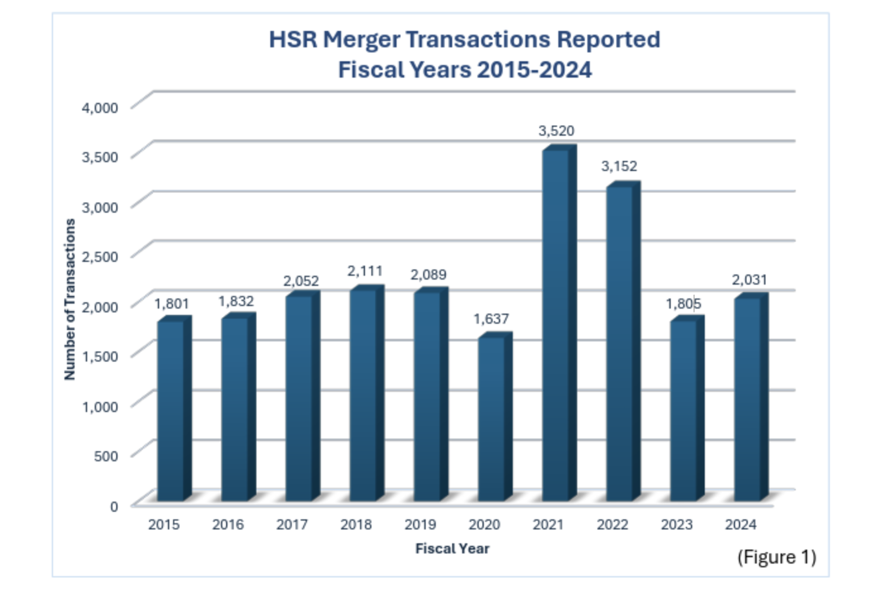
- Doesn’t appear to track the business cycle
- Ironic note on Biden: business leaders accused FTC/Khan of blocking transactions, but 2021 had more transaction than the previous 15 years
Mergers by industry:
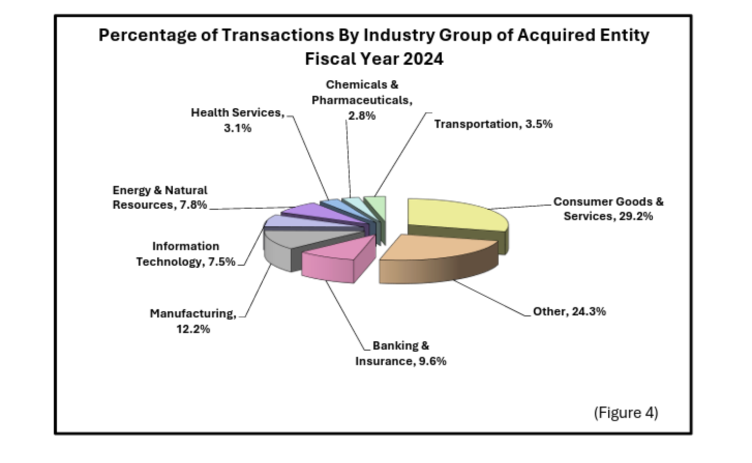
- No industry jumps out as being massively overrepresented relative to its size
Summary of transactions by fiscal year
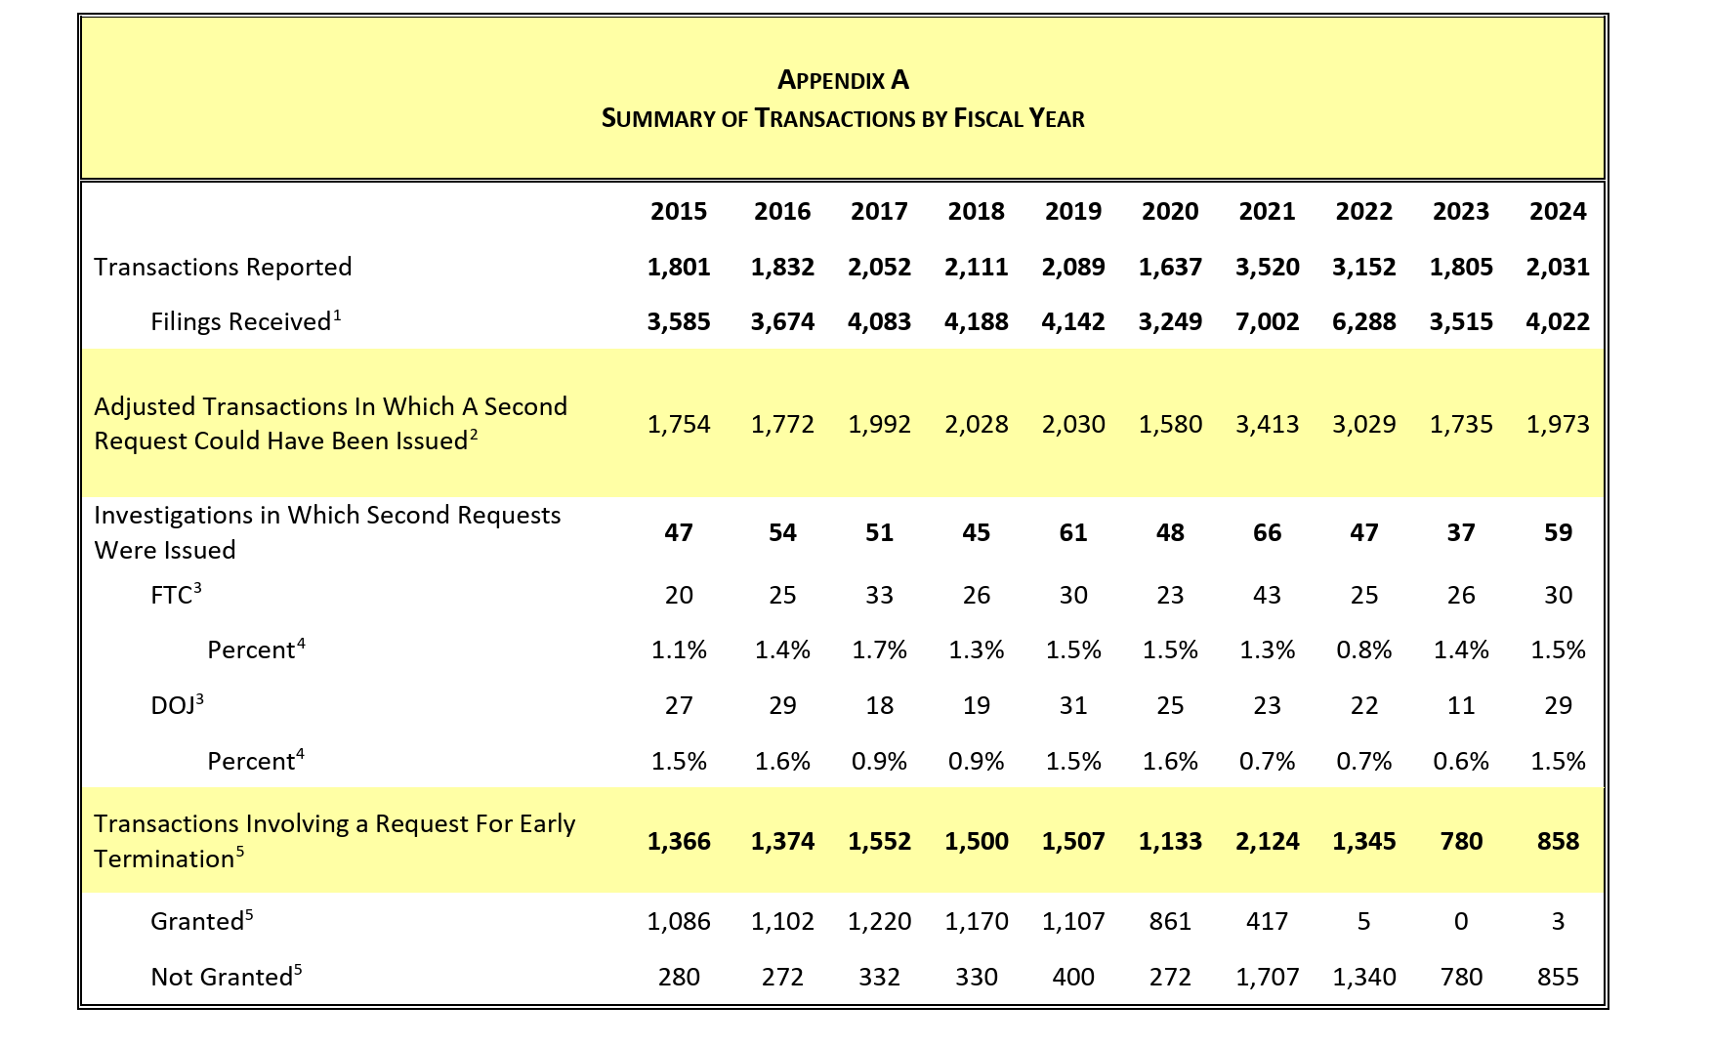
- There are severe resource constraints on agencies’ ability to investigate mergers: note the small percentage that goes to special request
- Don’t grant requests for early termination – just let requests expire to save administrative resources
- Main point: using antitrust law to protect “mom and pop” businesses just isn’t practical, the agencies don’t have enough resources to review all the relevant transactions

Acquisitions by size
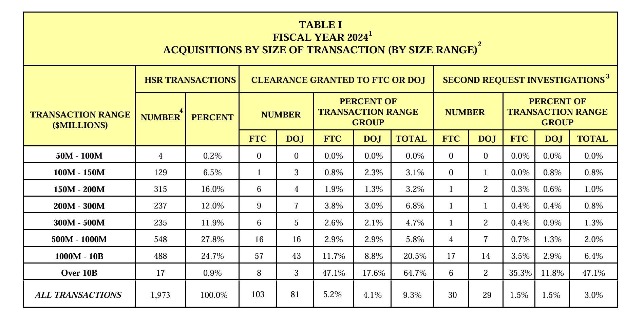
- Most transactions that reach second request are very large

Merger guidelines:
- Published by the FTC/DOJ: reflect what agencies think,
- Courts are not required to follow the merger guidelines (although many followed the last set of guidelines from 2010)
Intended to outline:
- Analytical techniques: analytical, economic, and evidentiary tools
  - Sources of evidence: what do agencies look at to determine whether there should be a second request or enforcement?
    - Merging parties; customers, workers, industry participants, observers; econometric analysis and economic modeling; transaction terms
  - Evaluating competition among firms: the particular data and conceptual frameworks agencies use to think about mergers
    - Strategic decisions; entry and exit; customer substitution; impact on rivals; effect of diminished competition
  - Market Definition
  - Calculating market shares and competition: influential in other areas of antitrust beyond mergers
- Practices
- Enforcement policy
Intended to assist:
  - Business community and the public
  - Antitrust bar
  - Courts
2023 Guidelines: 11 categories (structure is distinct from previous 2010 guidelines, which laid out principles rather than categories, although the content is very similar besides 7)
- (1) Concentration thresholds: how to map economics and data onto the law (PNB)
- (2) Competition between firms: unilateral competitive effects (major theory)
- (3) Risk of coordination: concentration decreases the incentive to compete, increases incentive to coordinate
- (4) Potential entrant: preventing a firm from entering prevents it from playing a competitive role in the market
- (5) Exclusion of rivals: merger can result in rivals being cut off from distribution, suppliers
- (6) Dominant position: concerns about monopolization
- (7) Trend toward consolidation: protect small business by preventing larger firms from consolidating (basically reviving Brown Shoe – see critiques of case below)
- (8) Series of acquisitions: the aggregate of a dominant firm buying lots of small rivals could be anticompetitive even when a single acquisition wouldn’t be
- (9) Platforms: specifically address the novelty of two-sided platforms
- (10) Competition between buyers:
- (11) Partial ownership: there are situations where it is unclear who controls a firm after merger, identifying the independent actors is tricky

Market Definition
Steps courts take to define market:
- (1) Identify commodities that are “reasonably interchangeable” by consumers “for the same purpose” (Cellophane)
  - Consider price, use, and qualities; cross-elasticities of demand
- (2) Identify a narrower “submarket” (Brown Shoe)
  - Consider a “grab bag” of “practical indicia”: (a) recognition of the submarket as a separate economic entity, (b) product’s characteristics and uses, (c) unique production facilities, (d) distinct customers, (e) distinct prices, (f) sensitivity to price chances, and (g) specialized vendors
- (3) Hypothetical monopolist test: a product market is the smallest product or group of products and narrowest geographic area such that a
  - (a) Hypothetical monopolist who is the
  - (b) only present and future seller of products in the market
  - (c) would be able to profitably impose a “small but significant and non-transitory increase in price" (SSNIP) (or decrease the transaction quality, meant to capture Google (SSNIPT))
    - Usually, a 5% increase starting from prices that would prevail absent the merger suffices
  - (d) Assuming the terms of sale of all other products are held constant
  - The analysis begins with the narrowest possible market and then adds the “next best substitute” until a SSNIP would be profitable (then stops)
General flow: P argues for a narrow market definition using Du Pont and Brown Shoe, D will argue that Brown Shoe distinctions are arbitrary, potentially ground the analysis in hypothetical monopolist test (although opposing experts will fight about this too)
- Benefit of hypothetical monopolist test: connects the analysis of product and geographic market to anticompetitive case (Cellophane + Brown Shoe doesn’t get at anticompetitive effects even though that is the whole point of the analysis)

2023 merger guidelines: the goal is to define a market to identify some anticompetitive effects from a merger – concentration alone isn’t dispositive
- Define a market to identify whether there is “any line of commerce” or “section of the country” in which the merger “may substantially lessen competition” or “tend to create a monopoly” (Clayton Act § 7)
- Agencies define “area of effective competition” in which competition may be lessened with reference to a product and geographic market
- Market definition also allows Agencies to identify market participants and measure market shares and market concentration
- Viewed as more controversial than prior guidelines (although prof. believes only number 7 is really different)
Evidence agencies use to identify relevant antitrust market:
- (1) Direct evidence of substantial competition between the merging parties
- (2) Direct evidence of the exercise of market power can demonstrate the existence of a relevant market in which that power exists
- (3) A relevant market can be identified from evidence on observed market characteristics (“practical indicia”)
- (4) The hypothetical monopolist test, which examines whether a proposed market is too narrow by asking whether a hypothetical monopolist over the market could profitably worsen terms significantly, for example, by raising price

Hypothetical monopolist test examples: the test is consistent with cellophane, more quantitatively grounded
Coke
- Suppose narrowest product definition is Coke: a hypothetical monopolist likely would not be able to profitably impose a SSNIP – consumers would just switch to other colas
- Suppose we add all other formulas of caramel-colored cola (Pepsi, Dr. Pepper, etc.): a hypothetical monopolist probably could profitably impose a SSNIP – people who want cola are likely to be willing to pay more rather than switch to another drink like Sprite
- Thus, the product market of caramel-colored cola would likely be a relevant market for antitrust purposes
- This could be revealed by Coke’s own documents (don’t need an economic expert) – marketing team has likely done thorough research on what consumers will do, how they will substitute Coke for other products as price rises
Organic grocery stores
- Suppose one firm owned all organic grocery stores in Berkeley – could they profitably raise prices by 5-10%?
- If yes, then that is a product market and would raise concern about a merger
- If not (i.e., consumers just turn to other grocers like Safeway), then organic grocery stores is not a market and the algorithm should be continued by expanding the set of stores
Math: 2 points:
- (1) For an economist to run hypothetical monopolist test, they need:
  - (a) Prices: observable
  - (b) Quantity sold: observable
  - (c) Marginal cost to produce another unit of good: this is the opportunity cost (not accounting cost), which experts can reasonably disagree on
  - (d) Demand elasticity: some sophisticated firms (e.g., Google) will have these data; otherwise, opposing economists will provide estimates and argue about which is better
- (2) Critical loss: how many units would a monopolist have to lose for monopolization to not be profitable?

Evidence for hypothetical monopolist test: answer the question “how will buyer respond to a price increase?”
- Buyer responses to prices in the past: cross elasticities
- Information from buyers on how they would respond to prices: survey evidence
- Conduct of sellers: past behavior of sellers
- Timing/cost of switching to buyers: is it easy or hard for buyers to switch
- Legal/regulatory requirements

Geographic markets: consumers’ willingness or ability to substitute products/suppliers’ willingness or ability to serve customers are often limited by distance
- Limiting factors: (a) transportation costs, (b) language, (c) regulation, (d) tariff and non-tariff trade barriers, (e) custom and familiarity, (f) reputation, and (g) local service availability
- The hypothetical monopolist test can be carried out for locations: start with downtown Berkeley, could a hypothetical monopolist have raised prices by 5-10%, if yes then expand to Berkeley more broadly, etc.

Caselaw:
U.S. v. H&R Block (D.D.C. 2011) (shows how courts define markets in merger cases)
- Holding: merger is enjoined
  - Product market:
    - Under Cellophane/Brown Shoe, P will argue for a narrow market definition and D will argue for a broad market definition, while the judge can justify anything
    - Under hypothetical monopolist test, (1) test is less arbitrary and more grounded; (2) you can get much narrower markets with the hypothetical monopolist test (but surrenders case to expert economist
    - Court’s hypothetical monopolist test: start with narrowest product market, DDIY
      - Use of D’s documents:
        - TA: analysis by investment bank for an actual market transaction identifies market as composed of digital providers
        - HRB: merger strategy documents say HRB is trying to maximize its digital footprint with the merger
      - Assisted tax preparation is not part of the market:
        - DDIY pricing: constraint on pricing is coming predominantly from digital providers
        - Price differentials: large difference between assisted tax prep and DDIY ($200 vs. $50) – a 5-10% increase in the price of DDIY software ($50 > $55) wouldn’t cause consumers to shift to assisted tax prep (think about demand elasticity)
        - Assisted services pricing: there are some lower priced assisted tax preparation services, but not enough to discipline price increase in the DDIY market
      - Manual tax preparation is not part of the market: if manual tax preparation was part of the market, then consumers would have not alternative but to not do their taxes, which is illegal and would be an absurd market definition
  - DDIY tax preparation is the product market
- Facts: Proposed merger of two providers of tax software products (H&R Block and TaxAct). Three methods of preparing a tax return: manual preparation, assisted preparation, and digital do-it-yourself tax preparation (DDIY). DDIY includes HRB (16%), TA (13%), and Intuit (TurboTax) (62%).
- Prof. Note: court uses Cellophane, Brown Shoe, and the hypothetical monopolist test to arrive at a market definition
  - Case shows that Cellophane and Brown Shoe are fairly indeterminate approaches to market definition
  - The evidence from real transactions by decisionmakers not thinking about litigation is the best kind of evidence (see TA investment bank analysis, merger strategy docs)

Market Participants
Market participants: firms that currently earn revenue in a market or have committed to enter a market soon
- Also includes “rapid entrants”: firms that would enter the market without incurring significant sunk costs in response to a price increase (SSNIP)
  - These entrants enter on the basis of the pre-entry price and don’t expect their entrance to affect the price
Excluded firms: entrants
- Most entrants enter in a timely and likely manner, but their entry is often insufficient
- Entrants enter on the basis of their expectations for the post-entry price. They must decide whether entering will be profitable given their entry will likely lead to a decrease in price.

Market shares: calculated for all market participants where possible
- Typically calculated using historical evidence: Agency also considers predictable effects of ongoing/recent changes
- Can be calculated using (a) revenues (typical), (b) unit sales, (c) capacity, (d) reserves (e.g., General Dynamics), or (e) use, whichever is most relevant

Market Concentration
Herfindahl-Hirschman Index (HHI): sum of squared market shares (can be between ~0 and 10,000)
- Projected market shares (from the merger) are used to estimate changes in concentration
- Concentration is given more weight when historically stable
- Rule of thumb: market with n equal-sized firms has an HHI of 10,000/n
- Increase in HHI equals the product of the merging firms’ market shares times 2
Thresholds for structural presumption:
- Using post-merger HHI: market HHI greater than 1,800 AND change in HHI greater than 100
- Using merged firm’s market share: share greater than 30% AND change in HHI greater than 100 (such a firm must buy a firm with a market share ≤ 50/30)
  - Math example: 2*30*x ≤ 100 → x ≤ 100/(2*30) → x ≤ 50/30)
Administrability concern: these thresholds include so many transactions that agencies can’t credibly evaluate them all

K-firm index: old approach, measures the market share of the k largest firms (used in PNB)

P’s theory of harm
Merger Guidelines 2-6 provide possible theories: 2, 3, and 5 receive the most attention from courts (although courts still aren’t very receptive to these theories) – P can bring multiple theories
- (2) Unilateral competitive effects: “eliminate substantial competition between firms” (horizontal)
- (3) Coordinated competitive effects: “increase risk of coordination” (horizontal or vertical)
  - E.g., merger makes policing a cartel easier
- (4) “Eliminate a potential entrant” (horizontal or vertical)
- (5) “Lead to exclusion of rivals” (main vertical theory, also horizontal): really any merger between complements that creates the possibility of exclusion
  - E.g., Time Warner merger created greater potential for exclusion of other distributors and content creators by merging TW’s content with AT&T’s distribution
- (6) “Entrench or extend a dominant position” (horizontal or vertical):
  - Vertical: typically involves something like a tie
    - Extend: use power in one market to buy into a complementary market, extending power into the complementary market (e.g., Microsoft tying browser to OS to preserve power in OS market)
    - Entrench: if Microsoft purchased all the browsers, that would entrench their position in the OS market
  - Purpose: stop monopoly in its incipiency

Merger Guidelines 7-11 provide evidence to support possible theories:
- (7) Trend toward consolidation
- (8) Series of acquisitions
- (9) Platforms
- (10) Competition between buyers
- (11) Partial ownership

Coordinated Competitive Effects
Coordinated competitive effects: merger facilitates collusion by the remaining firms in the market (post-merger market will be conducive to coordination)
- This is the typical type of anticompetitive harm in merger cases
2023 Merger Guidelines:
Guideline 3 (coordinated effects): mergers can violate the law when they increase the risk of coordination
- Particularly vulnerable markets: market that is highly concentrated OR has seen prior anticompetitive coordination – Agencies will infer, subject to D’s rebuttal, that the merger “may substantially lessen competition”
- In a market that is not highly concentrated, the Agencies investigate whether facts suggest a greater risk of coordination than market structure alone would suggest
- Coordination among rivals lessens competition whether it occurs explicitly or tacitly
  - Motivating theory of merger law: Agencies vigorously enforce Section 7 of Clayton Act because tacit coordination often cannot be addressed under Section 1 (or 2) of the Sherman Act (no CCC/ROT with tacit coordination/oligopolist behavior)
Primary factors:
- Highly concentrated market
- Prior actual or attempted attempts to coordinate
- Elimination of a maverick: play important role in disciplining the market
Secondary factors: when is coordinated conduct likely to take place?
- Market concentration
- Market observability
- Competitive responses
- Aligned incentives
- Profitability or other advantages from coordination
- Rebuttal based on structural barriers

Relevant factors are very similar to what was relevant under Section 1:
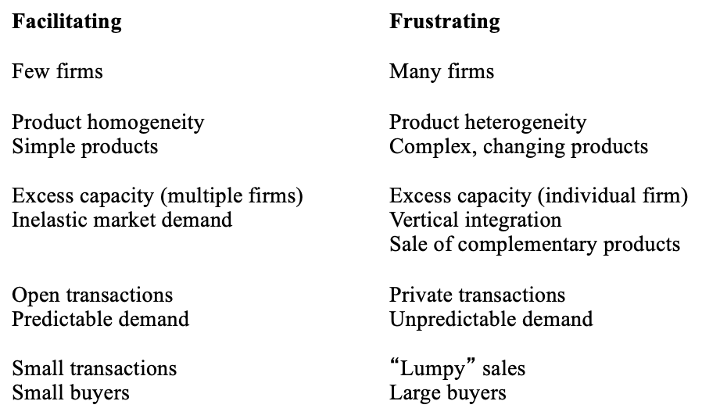
Facilitating factors are analogous to Type 2 factors used to infer agreement under S1 – the FTC’s classification of primary and secondary factors provides a general hierarchy of Type 2 factors (in the eyes of the agencies)

Interaction between S1 (agreements) and C7 (mergers):
- (1) S1 can’t police oligopolistic conduct (parallel conduct often does not involve an agreement). Because of this, C7 is used to prevent mergers in their incipiency that appear likely to lead to parallel conduct.
- (2) Competitors that want to make an agreement must find alternatives shaped by S1 and C7:
  - (a) Joint venture: competitors can convince agencies that their joint venture is procompetitive
  - (b) Merge: agreements between members of the same firm are not illegal, so S1 doesn’t apply – agencies and courts can address the behavior using C7
- (3) Under C7, enforcers are more concerned with market structures with facilitating attributes

Mavericks: firm that constrains effective collusion between other firms
- Disciplines price of rivals by (1) lower price/raising output and (2) refusing to follow price rises
- (1) If the merger involves a maverick:
  - Mavericks as a sword for P: P can argue that the merger eliminates a vigorous competitor from the market (HRB)
  - Mavericks as a shield for D: D can argue that the merger will make the company that merged with the maverick more aggressive than before (Heinz)
- (2) If the merger doesn’t involve a maverick:
  - D: merger could create a maverick
  - D: other maverick’s that aren’t part of the transaction will continue to discipline the market, preventing the merger from being anticompetitive
  - P: merger will prevent a firm from being a maverick by excluding them from distribution or supply

Lessons from cartel enforcement: gives an idea of what companies would like to do but can’t because of the law (or may attempt to do informally)
- Cartels can involve many firms
- Many effective cartels are not detected
- Shareholder governance isn’t guaranteed to shine a light on cartel behavior
- There can be cartel behavior even if there is a fair amount of entry

Caselaw:
Hospital Corp. of America v. FTC (7th Cir. 1986) (facilitating and frustrating factors in a merger case)
- Holding: merger violated Clayton Act S7
  - Market definition: hospitals compete with other hospitals, not difficult here
    - Here, HHI calculations would satisfy the prima facie case
  - Court turns to the question of whether the merger would lead to anticompetitive effects (here, coordinated effects)
  - Court identified factors that might facilitate collusion in the post-merger market:
    - Regulation: the state requires hospitals to file a certificate to show that a hospital is needed in the area, which is a barrier to entry
      - Under an oligopoly, facilities might be used less (more empty beds) because of higher prices, which the regulation misinterprets as there not being need in the area
    - Tradition of cooperation: management companies govern multiple hospitals (like if Ford appointed the manager of GM)
    - Elasticity of demand: in the short run, people get healthcare through insurance and are not price sensitive (inelastic demand)
  - D identified factors that might frustrate collusion in the post-merger market:
    - Services: hospital services are complex and heterogeneous (hundreds of different services)
      - Court says this is a bad argument, both sides of the market (hospitals and insurers) understand the market and behave with the behavior of other firms in mind
    - Composition of sellers: sellers are heterogeneous (some hospitals are non-profits)
      - Court: nonprofit status has no bearing on antitrust liability
      - Prof.: non-profit hospitals do tend to behave differently (attract doctors less motivated by profit, offer less profitable services that for-profit hospitals cut) – some tend to be mavericks, which could help D’s case
    - Technological change: industry is undergoing rapid technological and economic change
      - Court: this could go either way, so it doesn’t help D (offers an incentive to collude to avoid disruption of changes)
    - Buyers are large and sophisticated
    - Competitor complaint: FTC investigation was triggered by a competitor complaint
      - Court: only reason a competitor should file a complaint is to avoid exclusion, but that’s not the alleged harm here (concerned about coordinated effect)
  - These factors were not substantial enough to overturn the prima facie case of concentration and likelihood of harm
- Facts: Acquisition of two large hospitals in Chattanooga area by HCA. Acquisition raises HCA’s share from 14% to 26%. Raises C4 from 79% to 91% and reduces the number of firms from 11 to 7.
- Prof. Note:
  - D may have had a better chance in front of a different ALJ or district court (outcome was strongly affected by the posture of the case)
  - Court says demand curve is inelastic for individuals, but this is wrong: economics shows that when prices increase, people forgo the most important care
  - Unclear if other judges would block this merger: they might look through the other factors (especially potential additional services enabled by the merger) and let it through

U.S. v. H&R Block (D.D.C. 2011)
- Holding:
  - P made a prima facie case, so the burden is on D to show that structural barriers to collusion specific to this industry defeat the ordinary presumption of collusion in a highly concentrated market (Heinz)
    - Here, the court applied the hypothetical monopolist test, so the presumption against D is stronger than it would be otherwise
  - Arguments with respect to likelihood of collusion:
    - P:
      - Race to free: all of the parties are concerned about the race to free, and TA is the leader in offering free services, so the merger will make it easier for TT and HRB to coordinate and stop TA’s efforts
      - Past cooperation: firms have cooperated when it is in their interest (e.g., IRS program that allowed all three firms talk to each other without violating antitrust law led to a suppression of free services being offered)
        - Prof.: this is damning evidence – when they had a chance to collude, they did
      - Eliminating TA: TA is a maverick that disciplines the market
    - D:
      - TT incentives: TT doesn’t have incentive to not compete aggressively (TT’s own documents suggest the merger will intensify competition)
      - Differentiated product/low price transparency: the products are so complex that prices can’t be determined, so coordination would be very difficult
        - Court: ignores this
      - Maverick: by acquiring TA, HRB can become more of a maverick that can challenge TT (like Heinz)
    - Court: this does not rebut the presumption of anticompetitive effects, there is no argument that the industry is fundamentally different in a way that undermines P’s PF case
- Facts: same as before – HRB proposes merger with TA in DDIY tax software market.

Unilateral Competitive Effects
Unilateral competitive effects: merger facilitates unilateral exercise of market power by the merged firm (market becomes less competitive as a result of merger)
Guideline 2 (unilateral effects): mergers can violate the law when they eliminate substantial competition between firms (unilateral effects)
- The Agencies examine whether competition between the merging parties is substantial since their merger will necessarily eliminate any competition between them
  - Under Copperweld, merged firms are one decisionmaker and can’t agree with one another, so S1 doesn’t apply
- An analysis of the existing competition between the merging firms can demonstrate that a merger threatens competitive harm independent from an analysis of market shares
  - Intended to help P: P can prove the case without indirect evidence and discussion of market concentration under PNB
Guideline 4.2.A: generally applicable considerations to evaluate competition among firms (on an exam, go down this list)
- (1) Strategic deliberations or decisions: HRB, look at documents, did the companies think they were in competition with each other, did they price with the other companies in mind
- (2) Prior merger, entry, and exit events
- (3) Customer substitution
- (4) Impact of competitive actions (e.g., advertising, investment) on rivals
- (5) Impact of eliminating competition between firms
- (6) Additional evidence, tools, and metrics
Guideline 4.2.B: considerations when terms are set by firms
- (1) Diversion ration: fraction of unit sales lost by the first product that is diverted to the second product (higher ratio = more competition between products)
- (2) Aggregate diversion ration: the diversion ratio of the products of one firm to a group of products made by other firms
- (3) Value of diverted sales: diversion ratio times the change in quantity of product A times (price of B minus marginal cost of product B)
  - Intuition: number of A’s units diverted to B times the profit per unit of B
- (4) Gross Upward Price Pressure Index (GUPPI): value of diverted sales of product B divided by revenue lost of product A
  - Dividing by 2 gives a rough measure of how much agencies expect firms will raise prices: if this value is above 5% (a SSNIP), then it can be used to define the market
    - If a firm that got control of this one other product would raise prices by a SSNIP, then a firm that got control of the whole market would be even worse
  - Doesn’t account for how other firms might change prices or reposition products
  - Basically measures how much of A’s diverted sales will flow back into their pocket via B after the merger
  - Provides an analysis of existing competition that is independent from market shares (come up with estimate of how much
- (5) Critical loss: how much would you need to lose on a 5% increase in price (SSNIP) to exactly break even (measured as the difference between the units sold before and after the price increase divided by the units sold before the price increase)
- (6) Critical elasticity: what is the elasticity of demand at which rising the price 5% makes you break even
4.2.B. stats can be used in three places:
- When agencies screen:
- P’s prima facie case:
  - Market definition: use to show likelihood of competitive effect (just like hypothetical monopolist test)
  - Theory of harm: can help show unilateral competitive effects

Mathematical Exercise
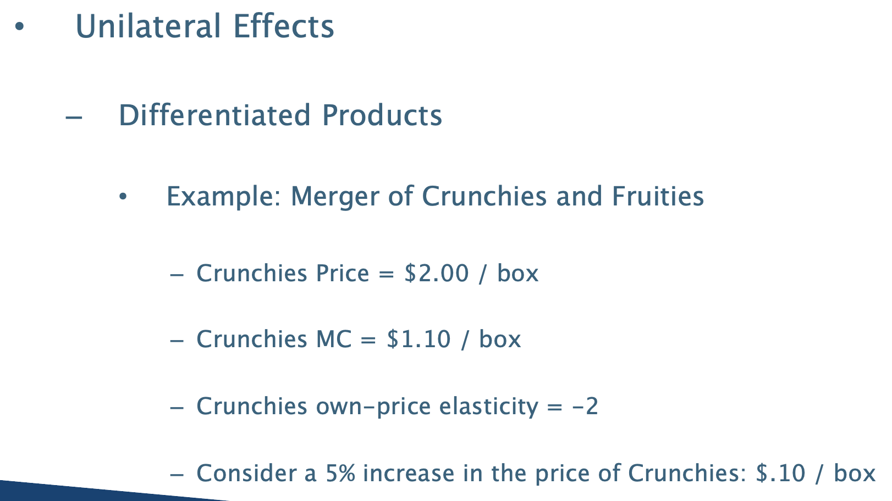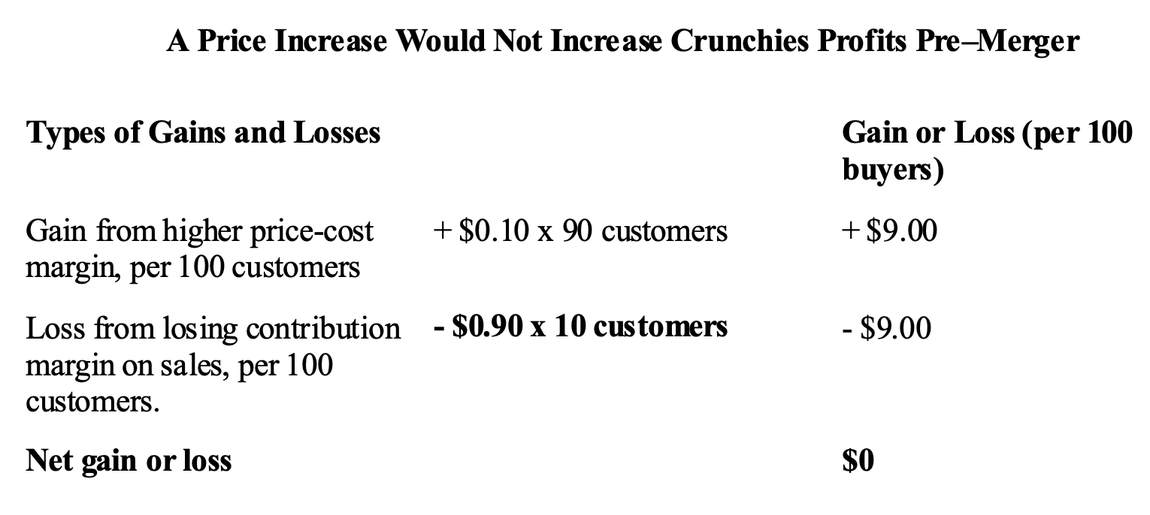

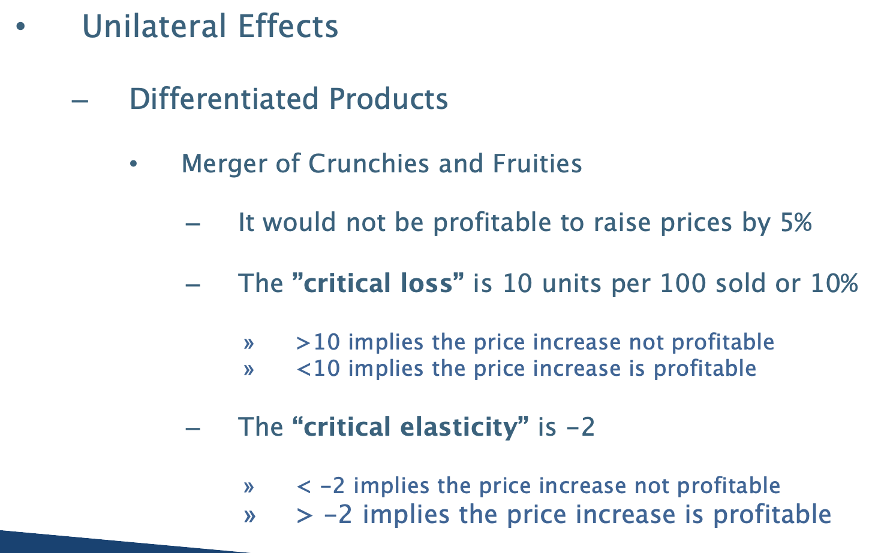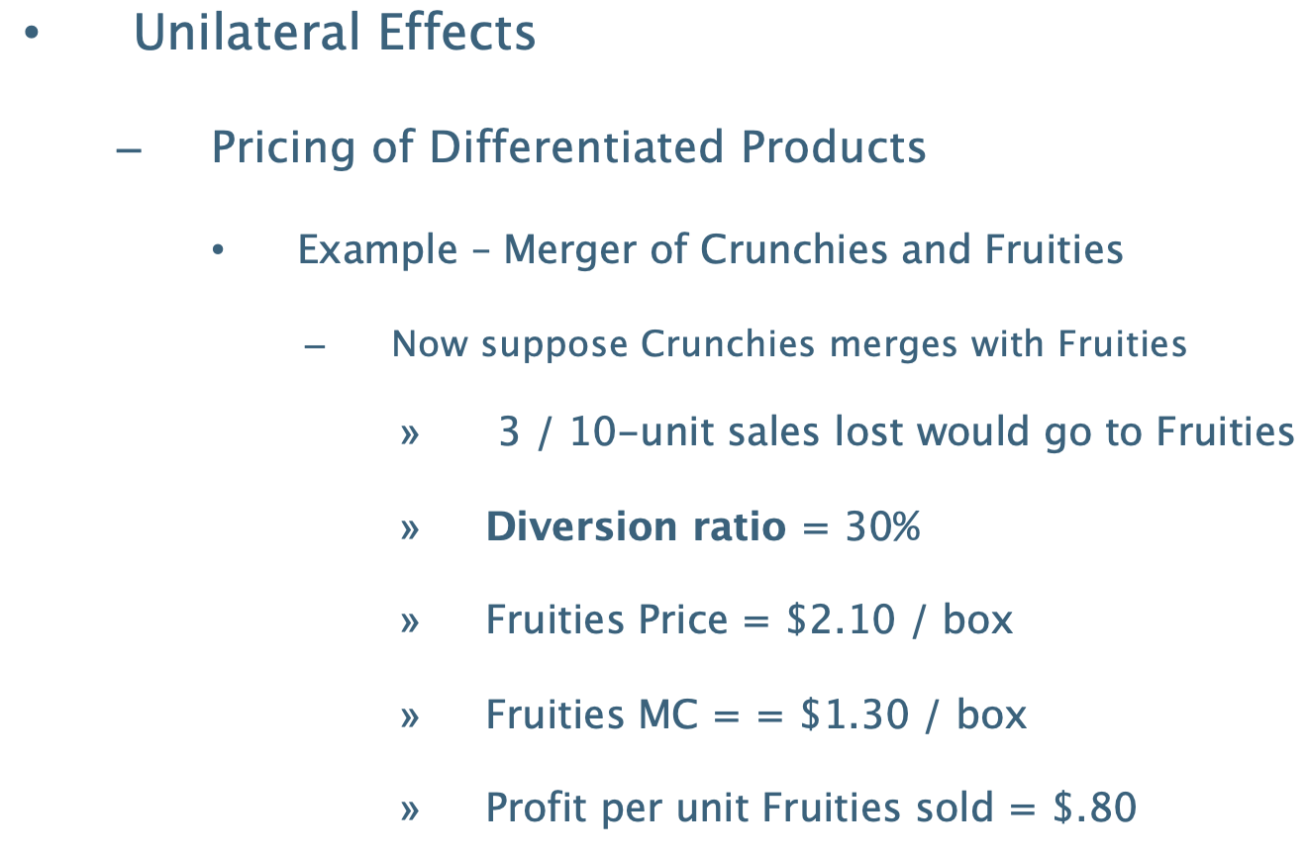
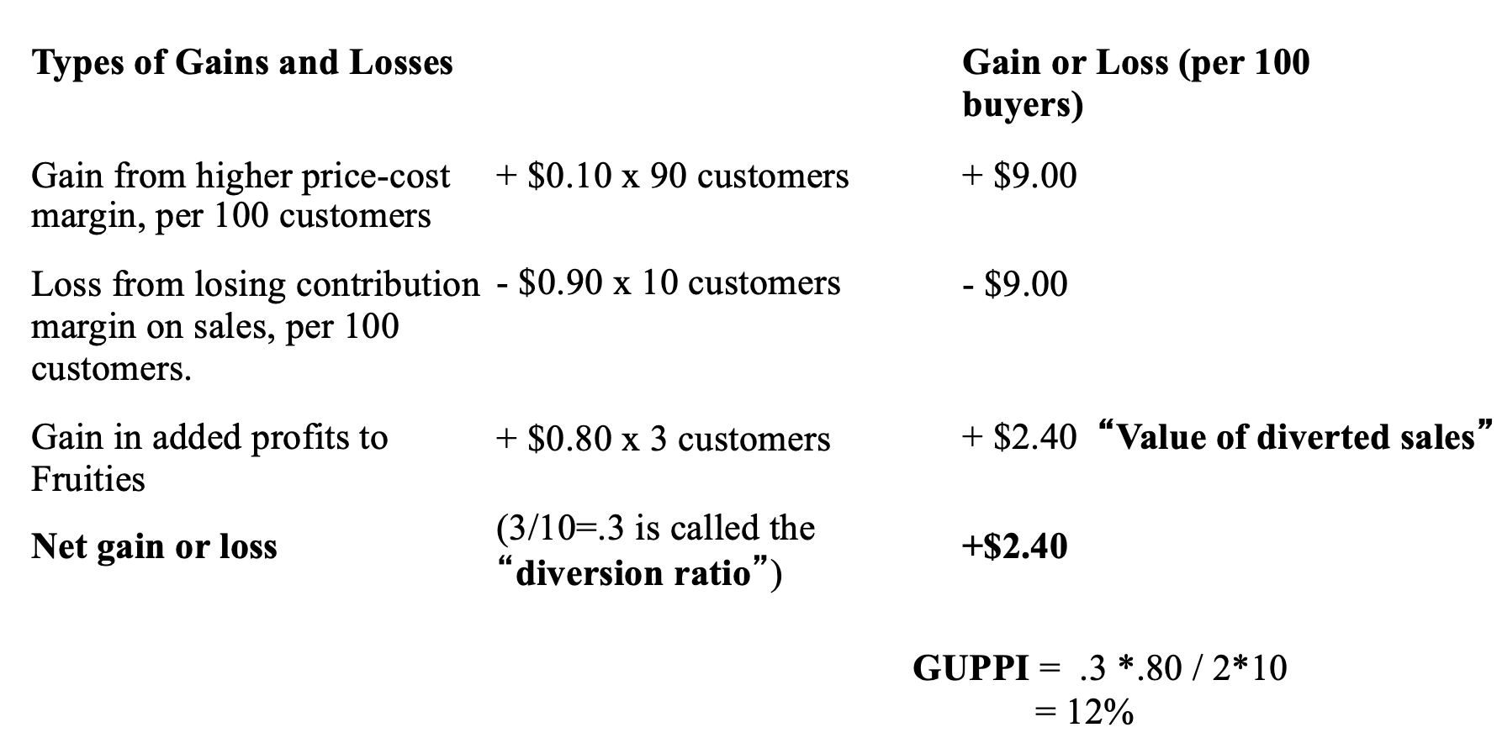
Other considerations:
- 4.2.C. Considerations when terms are set through bargaining or auctions
  - E.g., insurance company has less bargaining power after a hospital merges
- 4.2.D. Considerations when firms determine capacity and output
  - (1) High market shares
  - (2) Undifferentiated products
  - (3) Market elasticity of demand is low
  - (4) Margin on suppressed output is low
  - (5) The supply responses of rivals are small
- 4.2.E. Considerations for innovation and product variety and competition

Caselaw:
N.Y. v. Kraft General Foods (S.D.N.Y. 1995) (unilateral effects of merger not concerning)
- Holding:
  - Concern is the loss of competition between Post’s Grape Nuts and Nabisco’s Shredded Wheat (unilateral effects of the merger)
  - Court: not enough head-to-head competition to support a finding of unilateral competitive effects
    - (1) Physical similarity/image similarity: marketed as healthy, plain cereals with some distinguishing features
    - (2) Customer testimony on buyer substitution: Executives of grocery retailers set the prices of the two independently and didn’t consider them to be close competitors
    - (3) Marketing survey data on customer demographics: Grape Nuts higher income and younger; Nabisco Shredded Wheat less wealthy and older
    - (4) Extent to which firms monitor/respond to one another: Post documents – both brands near the top of each other’s list of competitors (but Post looked to Kellogg – no evidence that Post looked at Nabisco to price)
    - (5) Econometric evidence on buyer substitution: low cross elasticity of demand between the two
  - Court: it would not be profitable for Kraft to raise the price of Grape Nuts in the expectation that a substantial portion of its lost sales would go to Nabisco Shredded Wheat
- Facts: Merger of Kraft (owner of Post) (12%) and Nabisco (~3%) in the ready-to-eat (RTE) cereal market (large shares given there are hundreds of cereals). Kellogg and General Mills together have 60% of the RTE cereal market (>200 RTE cereal products). Post sells Grape Nuts, while Nabisco sells Shredded Wheat.
- Prof. Note:
  - Shares are low in absolute terms, so there wouldn’t be a strong prima facie case under PNB. This case is P’s attempt to get around PNB by showing there is substantial head-to-head competition between the merging parties (i.e., appeal to the unilateral competitive effects).
  - Today, the econometric evidence would include GUPPI, which would be run for every pairwise instance of competition (every

U.S. v. H&R Block (D.D.C. 2011)
- Holding:
  - Unilateral effects
    - (1) Elimination of Direct Competition (P): TA and HRB are direct competitors, merger will result in a loss of competition between the two
    - (2) Pledge to maintain current prices (D): not a legal basis for defending a merger, there are other ways to harm competition besides lowering prices (e.g., decreasing quality)
    - (3) Market segmentation (D): court rejects D’s argument that TA and HRB are not competitors because TA is sold for a lower price and HRB is sold for a higher price
      - Prof. Note: this is a plausible argument, but court rejects it here
    - (4) Combined market share (D): court rejects the idea that unilateral competitive effects should only be considered once the market size is above some threshold
      - The point of considering unilateral competitive effects is just to evaluate whether there was a loss of competition between the merging firms, regardless of market size
    - (5) Post-merger dual brand strategy (P): there was a plan to raise the price of HRB, the expensive product, post-merger because lost sales would flow to TA
      - The price differentiation of HRB and TA is actually anticompetitive
    - (6) Merger simulation (P): GUPPI suggested a price increase, there was an elaborate back and forth
    - (7) Repositioning (P): entry is tough in this market. There are only 3 firms and no evidence of entry or repositioning

Vertical Mergers and Conglomerate Mergers
Vertical mergers: merger of firms producing complementary units (not of competitors)
Guideline 5 (vertical mergers): mergers can violate the law when they create a firm that may limit access to products or services that its rivals use to compete (often through foreclosure) (AT&T)
- (A) Merged firm can limit access to products or services
- (B) Merged firm can gain or increase access to information that facilitates collusion
- (C) Threat of exclusion can deter rivals or potential rivals from investing or otherwise competing
Test under AT&T: burden shifting framework without required appeal to concentration statistics
- (1) P’s prima facie case
  - (a) P must establish a prima facie case that the merger is substantially likely to harm competition in the relevant market: show there is going to be some exclusion/foreclosure
  - (b) P cannot rely on concentration statistics but must make a “fact-specific” showing that the proposed merger is “likely to be anticompetitive”
- (2) Burden shifts to D to rebut P’s prima facie case
  - Baker Hughes: Once the prima facie case is established, the burden shifts to D to:
    - (a) Present evidence that the prima facie case “inaccurately predicts the relevant transaction’s probable effect on future competition,” or to
    - (b) “Sufficiently discredit” the evidence underlying the prima facie case
- (3) Burden shifts back to P to produce additional evidence
  - Upon such rebuttal, “the burden of producing additional evidence of anticompetitive effects shifts to the government, and merges with the ultimate burden of persuasion, which remains with the government at all times”

Guideline 4 (potential competition): mergers can violate the law when they eliminate a potential entrant in a concentrated market (Meta)
Basic idea: if a firm would enter the market but-for the merger, the merger should be blocked – otherwise, there is no anticompetitive effect from the merger (a la effects on potential competition) – apply this idea when in a nonstandard situation like Meta
- 2.4.A. Actual potential competition: eliminating reasonably probable future entry
  - Merging a current and potential market participant eliminates the possibility that the potential entrant would have entered on its own
  - Test: 2 elements – if either fails, don’t prevent the merger
    - (1) Potential entrant must have the “available feasible means” of entering the market other than by acquisition
      - If not, there are no competitive effects of merger
    - (2) Independent entry would produce de-concentration or other procompetitive effects
      - If entrance is trivial, then there won’t be any procompetitive effects, nothing lost from merger
- 2.4.B. Perceived potential competition: lessening of current competitive pressure
  - Acquisition of a firm that is perceived by market participants as a potential entrant
  - Test: 2 elements – if either fails, don’t prevent the merger
    - (1) Firm possessed the characteristics of a perceived (de novo) potential entrant
    - (2) Firm’s presence prevented anticompetitive behavior by market participants
Theory still needs to be proven in court, unclear what set of facts the theory can be proved on (these are more ambitious forms of competition)
- Unilateral competitive effect: elimination of potential competition
- Coordinated competitive effects are getting farther away
Standard case: incumbent is buying an entrant
- Observed world: incumbent buys entrant where entrant was very likely to enter the market
  - Merger eliminates reasonably probable future entry
- Counterfactual: Entrant enters the market, introducing head-to-head competition with the incumbent (unilateral competitive effect) and decreasing the chances of coordination given the larger number of firms
- Perceived potential competition case: basically analogous, just disciplining effects of the acquired firm were weaker because they were further from entering the market than the entrant

Nonstandard case (Meta): entrant is buying an incumbent

History of vertical mergers: not much recent activity outside of the telecom industry
- 1962: Brown Shoe v. U.S. (merger between a shoe manufacturer and a shoe retailer)
  - “Primary vice” of vertical mergers (or other arrangements tying a customer to a supplier): may “clog competition” by depriving rivals of a “fair opportunity” to compete.
    - This is still the theory of harm for vertical merger cases
  - Only vertical arrangements that may substantially lessen competition, or tend to create a monopoly, are prohibited by the Clayton Act (C7)
- 1972: Ford Motor Co. v. U.S. (last case on vertical mergers)
  - Holding: Court prohibited Ford’s acquisition of a leading spark plug manufacturer
    - Exclusion happening at two levels of the market:
      - Primary: independent automobile manufacturers are forced to deal with a single spark plug manufacturer, which harms competition in the car market
      - Secondary: a lack of buyers to operate at scale may lead the remaining independent sparkplug manufacturer to fail
  - Facts: There were only two independent sparkplug manufacturers. Ford purchased from independent manufacturers while GM owned its own manufacturer. Ford attempted to merge with one of the independent sparkplug manufacturers.
- 1978: Chicago School critique (Bork/Antitrust Paradox)
  - In structural era of merger enforcement, vertical mergers were condemned with fairly small foreclosure shares: Chicago School started asking “but what’s the harm?”
  - Foreclosure is never a threat to competition, only occasionally a threat to individual firms (suppliers and customers will find each other)
  - The structure of an industry will be whatever is the most efficient for that industry. The law should not interfere with the decision of whether to make oneself or buy from others, which must be based on the difference in cost and effectiveness of each option.
    - E.g., Sri Lankan delicacies offered at grocery stores despite the country being very small because people are willing to pay a lot for them
- 1996: Time Warner buys Turner Broadcasting (consent decree)
  - TW concerned that they wouldn’t be able to compete with online distributors
  - Three links to the industry’s chain: content creation, programming, and distribution
  - Horizontal merger dynamics (content/programming):
    - TW owns HBO, Cinemax, and Warner Brothers Studio
    - Turner owns CNN, Headline News, TNT, and WTBS
  - Vertical merger dynamics
    - TW operates cable systems
  - Consent decree: attempt to prevent exclusion at two levels of the market
    - (1) Turner cannot discriminate against other distributors (cable, satellite, etc.)
    - (2) TW cannot discriminate against other content creators/programmers
    - Prof. thinks this is reasonable: this is an older company’s attempt to compete with new, technologically savvy firms – not an attempt to acquire market power
    - Concern: court must oversee this process, which is costly and presents administrability issues
  - Merger ultimately unsuccessful: TW sold its cable, decided to exit the distribution business (but it’s ok, we need businesses to try new things for the market to work)
- 2011: Comcast buys NBC Universal (consent decree)
  - Horizontal merger dynamics: content and programs
    - Comcast owns E! and Golf Channel
    - NBC owns NBC, MSNBC, Syfy
  - Vertical merger dynamics:
    - Comcast owns cable systems
  - Consent decree:
    - NBC cannot discriminate against other distributors (cable, satellite, etc.)
    - Comcast cannot discriminate against other content creators/programmers
- 2018: AT&T buys Time-Warner (pure vertical merger challenged)
  - Raised First Amendment concerns: media companies merging
  - Vertical merger dynamics
    - AT&T owns distributors: Direct TV (satellite) and U-verse (cable)
    - Time-warner owns content/programming: Turner (including CNN, TBS, TNT, and WB) and HBO
  - Concern that merger would give too much leverage in bargaining: the merged company can extract better deal from distributors by credibly threatening to withhold content
  - Unclear why Trump challenged this merger and didn’t just pursue a consent decree (maybe because he hates CNN?)
    - Led to litigated case where we can see what the court thinks
  - U.S. v. AT&T (D.D.C. 2018)
    - Rejects 3 government assertions:
      - (1) TW (content/programming) will raise prices to other distributors (appealed)
      - (2) TW (content/programming) will limit content to online distributors
      - (3) TW (content/programming) will restrict use of HBO to other distributors
  - U.S. v. AT&T (D.C. Cir. 2019)
    - Adapts PNB and Baker Hughes to vertical mergers

Antitrust doesn’t reach size:
- As long as a company doesn’t harm competition, antitrust doesn’t have much to say about it (doesn’t concern itself with the size of merging firms)
- Good example of where size is regulated: financial sector, banks can only hold a portion of deposits in each state
Caselaw:
Early cases of vertical mergers
Brown Shoe v. U.S. (1962) (merger between a shoe manufacturer and a shoe retailer)
Ford Motor Co. v. U.S. (1972) (last SCOTUS case on vertical mergers)
- Holding: Court prohibited Ford’s acquisition of a leading spark plug manufacturer
  - Exclusion happening at two levels of the market:
    - Primary: independent automobile manufacturers are forced to deal with a single spark plug manufacturer, which harms competition in the car market
    - Secondary: a lack of buyers to operate at scale may lead the remaining independent sparkplug manufacturer to fail
- Facts: There were only two independent sparkplug manufacturers. Ford purchased from independent manufacturers while GM owned its own manufacturer. Ford attempted to merge with one of the independent sparkplug manufacturers.
Modern cases of vertical mergers
U.S. v. AT&T (D.C. 2019) (adapts PNB and Baker Hughes to vertical mergers, Guideline 5)
- Holding: merger upheld, P failed to establish its prima facie case
  - Court outlines the test for vertical mergers (new test needed because vertical mergers don’t result in an increase in concentration, concerned about exclusion):
    - Adapts PNB and Baker Hughes to vertical mergers:
      - (1) P must establish a prima facie case that the merger is substantially likely to harm competition in the relevant market: show there is going to be some exclusion
      - (2) P cannot rely on concentration statistics but must make a “fact-specific” showing that the proposed merger is “likely to be anticompetitive”
    - Baker Hughes: Once the prima facie case is established, the burden shifts to D to:
      - (1) Present evidence that the prima facie case “inaccurately predicts the relevant transaction’s probable effect on future competition,” or to
      - (2) “Sufficiently discredit” the evidence underlying the prima facie case
    - Upon such rebuttal, “the burden of producing additional evidence of anticompetitive effects shifts to the government, and merges with the ultimate burden of persuasion, which remains with the government at all times”
  - Court applies test:
    - Market definition: multichannel video distribution (still have to define the market to show exclusion)
      - Excludes distributors of solely on-demand content (Netflix/Hulu)
        - Contentious: likely justified under hypothetical monopolist test, but Cellophane would justify including Netflix/Hulu, they seem reasonably interchangeable
      - 1,100 local markets
    - Anticompetitive effects: two levels of possible exclusion that could lead to higher prices (rejected by Court)
      - Content: merged company could credibly threaten to withhold distribution of other firms’ content if they didn’t agree to terms (can just show TW content during blackout)
      - Distribution: merged company could credibly threaten to withhold TW content from being distributed by other firms if they didn’t agree to terms (can just distribute using AT&T)
    - Prima facie case: not an easy case one way or the other
      - Statements by Ds in prior FCC filings (P): other agencies are worried that the content providers will discriminate
      - Internal documents of Ds (P): Ds documents suggest they believe they will be in a better bargaining position with distributors as far as offering their content
      - Statements by other competitors (P): other market participants were concerned that the parties would discriminate
      - Bargaining model (P): much discussion, prof. thinks it isn’t good to rely on a model in this instance
      - Past instances of vertical integration (no price effect) (D): key piece of evidence for D, there was no evidence of a price effect after merger
        - Prof. counterargument: of course, they were stopped from raising prices by the consent decree
      - Firms need to join forces to compete with new threat of online providers (like Netflix) (D)
  - Court affirms the district court: P failed to establish its prima facie case
- Facts: AT&T (distribution) and TW (content and programming) merge.
- Prof. Note: because the case was litigated, enforcers lost everything, could have had at least a consent decree otherwise
  - Prof. thinks merger should have been blocked: government should have proceeded with structural presumption – there were substantial foreclosure shares, so anticompetitive effect should be presumed
    - Without a consent decree, block this, harmed parties would have no recourse for damages
    - With consent decree, let the merger through and see how the market responds
  - Takeaway: it’s typically hard to win vertical merger cases
  - Historical outcome of merger: known as a horrible merger, the merged firm faced a ton of competition from online providers and sold off the content piece of the business

2023 Merger Guidelines
FTC v. Meta Platforms (ND Cal. 2023) (example of agency litigating potential competition)
- Holding:
  - Nonstandard case of eliminating a potential or perceived competitor: rather than the incumbent purchasing an entrant, this is an entrant purchasing an incumbent
    - Here, the AT&T test is trivially satisfied: Meta is one of the best resourced tech companies in the world, they certainly have the means to make entry feasible
    - However, test doesn’t get to the core question: would Meta have entered the market but-for its acquisition of Supernatural? If yes, the merger should be blocked because having 2 competitors in the market is better than 1
  - Court adopts the FTC’s market definition: “VR dedicated fitness apps in the United States”
    - Pre-merger HHI: 6,917 (revenue shares), 6,307 based on total hours spent, 3,377 based on monthly active users (indicates one firm has ~80% share).
    - Prof. Note: the merger won’t change concentrations since Meta would be an entrant (would fail to satisfy the PNB test)
  - FTC’s first theory: merger deprives actual potential competition:
    - Acquisition deprives the market from the competition that would have arisen from Meta’s independent entry
    - Elements:
      - (1) Potential entrant must have the “available feasible means” of entering the market other than by acquisition
      - (2) Independent entry would produce de-concentration or other procompetitive effects
    - However, the court basically ignores this test (articulated more for the standard case)
    - Court concludes based on objective and subjective (what people are saying) evidence that it is not “reasonably probable” that Meta would enter the market for VR dedicated fitness apps if it could not consummate the acquisition
    - Basic idea: because Meta is unlikely to enter independently, you aren’t missing out on procompetitive benefits by allowing the merger, so it should be allowed
  - FTC’s second theory: perceived potential competition (harder to show than actual potential competition):
    - FTC must show
      - (1) Meta possessed the characteristics of a perceived (de novo) potential entrant
      - (2) Meta’s presence prevented anticompetitive behavior by market participants (disciplining gravity)
    - FTC is unable to make either showing
      - (1) Court doesn’t think Meta is going to enter on its own
      - (2) Court doesn’t think parties will change their behavior because of the outside presence of Meta
    - Again, basic idea: 2 firms is better than 1, threat of entry disciplines the firm in the market
- Facts: FTC challenges Meta’s purchase of Within, the maker of Supernatural, a virtual reality (VR) subscription fitness service. Acquisition would allow Meta to enter the market for VR subscription services. Meta manufactures VR devices and operates Quest Store, an app store for (Meta’s and third-parties) VR software applications.
- Prof. Note:
  - Court massages old doctrine: it seems like Meta would have reasonable means to enter the market, it has thousands of software engineers; if Meta entered, it would have decreased concentration in the market, so P would win if the court took the doctrine literally
  - Instead, court construes the standard as “reasonably probable”
  - How else might market participants react:
    - Meta’s presence as potential buyer could be good for consumers
    - Meta’s presence on the outside encourages market participants to compete to be acquired by Meta
      - If competitors don’t think they can be acquired, they won’t work hard to be acquired
  - Entry is too easy here, it’s easy to make an app and enter the market
  - Could argue that antitrust resources are not best spent here, Meta’s presence as potential buyer is incentivizing firms to compete

FTC v. Meta Platforms (D.D.C. 2025)
- Holding:
  - FTC alleged that Meta illegally maintained a monopoly by acquiring Instagram in 2012 and WhatsApp in 2014
  - Monopoly power:
    - The FTC’s proposed market definition of personal social networking (Facebook, Instagram, Snapchat, and MeWe) was too narrow
    - Court: under an expanded market that includes TikTok and YouTube, Meta did not hold monopoly power
      - Importance of remedy: FTC was seeking an injunction, so the court looked at Meta’s market power at the time of the suit (not the time of acquisition)
- Facts: Meta purchased Instagram and WhatsApp. FTC sues alleging monopolization.
- Prof. Note:
  - FTC could have brought the case as a merger case (Meta merged with Instagram and WhatsApp)
    - For challenging the merger:
      - Unilateral competitive effects: Meta competed with Instagram and WhatsApp, the merger eliminated the competition between the firms
        - But problem with P’s prima facie case: Instagram had very small revenue at the time of the transaction, concentration thresholds under PNB might not have been met – maybe Instagram only successful because of resources invested by Meta?
  - General policy concern: killer acquisitions, we want to make sure that acquisitions are intended to make the product better, not to kill it
  - FTC could have (but didn’t) also pursued an exclusion theory like the Meta and Supernatural merger: merger might enable Meta to exclude other apps from platform (like the Pepper case)

D’s rebuttals to P’s prima facie case
2023 Merger Guidelines 3: Rebuttal evidence showing that no substantial lessening of competition is threatened by the merger
- (1) Failing firms
- (2) Entry and repositioning (horizontal)
- (3) Procompetitive efficiencies

Entry and repositioning
Entry and repositioning (2023 Merger Guideline 3.2): one of the strongest ways for D to rebut P’s prima facie case in the case of a horizontal merger
- Entry considers whether a firm that is not part of the market at the start of the prima facie case will decide to enter given the conditions that would exist after it entered
- Repositioning: change in products offered
- Entry and repositioning can rebut the presumption that a merger will lessen competition
- Entry must be timely, likely, and sufficient
Timeliness: must be fast and durable
- Entry must counteract any loss in competition before it occurs: actual or threatened entry must deter anticompetitive effects
- Entry must be durable: firm is not merely entering to take advantage of a temporary price increase
Likelihood: must be certain
- Entry must be so likely that no substantial loss of competition occurs
- Market participants: those who are in or would enter the market based on the pre-entry price
  - Firms already in the market
  - Firms that would enter in response to a SSNIP (“hit and run” entrants)
- Entrants decide to enter based on post-entry conditions
  - Entrant must evaluate whether it is profitable for them to be in the market after they’ve entered and likely lowered the price relative to the pre-entry level
  - If entrant expects prices to fall as a result of entry, they are less likely to enter (and vice versa)
  - E.g.: Baker Hughes, firms from other countries didn’t enter, there must be some reason why – likely that price post-entry would be too low
- “The Agencies also assess whether the merger may increase entry barriers.”
Sufficiency: aggregate scale of entrants must be large enough to replace one of the merging firms
- Entry may not be sufficient to prevent a loss of competition
  - E.g.: entering firms might be a small fraction of the market
- “Entry must at least replicate the scale, strength, and durability of one of the merging parties to be considered sufficient”

Distinctions between the prongs:
- Timely and likely entry by a small number of small firms: likely not sufficient because it can’t replace the competition lost from the merger
- Sufficient entry by a large firm that is (1) several years in the future (not timely) or (2) not certain (not likely) would be not credited as a rebuttal to P’s prima facie case.
- Relevance of sunk costs to timing, likelihood, and sufficiency:
  - Sufficiency: if sunk costs are high, an entrant may not enter at scale
  - Likelihood/timing: if sunk costs are low, an firm may enter quickly with high certainty – may lead agencies to classify firm as a market participant rather than an entrant

Caselaw:
U.S. v. Waste Management
- Holding: Merger allowed
  - Ease of entry implies that the merger will not be anticompetitive
  - Test:
    - Prima facie case from PNB can be rebutted only by demonstrating that the merger will not have anticompetitive effects
    - A substantial market share is insufficient to void a merger where that share is misleading as to future competitive effects (General Dynamics)
      - Prof. Note: this is different than usual, not just that the market definition was wrong
    - Case law/merger guidelines suggest entry may be considered in appraising whether a merger will lessen competition.
  - Application of test: entry in the product and geographic market is so easy that it will negate any anticompetitive effect of the merger (as a matter of law)
    - Bidding on contracts and sunk cost: before entering the market and incurring sunk costs, a firm would first secure a contract
    - History of entry: firms outside Fort Worth have entered the Fort Worth market, indicating entry is easy
    - Incumbent reputation is not a barrier to entry: there doesn’t appear to be evidence that reputation has stopped firms in the past, and even if there is, why would that be a bad thing? The market should deliver benefits to those good at trash collection
    - Existing contracts are not barriers to entry: if it’s true that no one can compete in the market because people are locked in contracts, then no one can raise prices, so there is no anticompetitive effect – not a concern.
  - Successfully rebuts P’s prima facie case
- Facts: Merger of American Container Service (a subsidiary of WM) and Texas Industrial Disposal in Dallas. The market is defined as trash collection excluding single and multi-family residences and small apartment complexes in Dallas County (industrial waste disposal). Combined market share in Dallas area will be 48.8%.
- Prof. Notes:
  - Some judges rely on a broad interpretation of entry to permit mergers
  - This is one of the strongest statements by the court outlining how D can make a rebuttal
  - Note that ease of entry doesn’t defeat the prima facie case in every instance, but it does on these facts as a matter of law
  - Critiques:
    - Court seems to underestimate how hard it is to enter the market: not like a mom and pop shop can start an industrial waste disposal service
    - Reputation might matter: if certain waste, like industrial chemicals, aren’t disposed of correctly the waste generator might be on the hook for tort liability
  - Best argument: antitrust resources are scarce, leave it to the market to address the issue.

U.S. v. Baker Hughes
- Holding: evidence of entry and expansion
  - Combination of factors were sufficient to rebut P’s prima facie case:
    - Past entry by two firms in 1989: past entry is the best evidence that the market might not be competitive
    - Potential entry by Canadian and other foreign firms: evidence that anticompetitive conditions would be disciplined in a timely, likely, and sufficient manner
    - Failed entry by foreign firms: attempted entry credited as evidence of entry/expansion (but could have been credited the other way)
    - Growth (expansion of existing competitors): entry + the growth in the size of entrants are significant enough to rebut
- Facts: HHUDR case
- Prof. Note:
  - Sunk costs: low like in WM because firms wouldn’t enter without first getting a contract
    - Further lowered by the fact that entering companies aren’t starting from scratch, they have lower costs
  - Note that D argues that the Canadian and Finnish firms are participants (make the market look more competitive), P argues that they are entrants (make the market look less competitive)
    - General exam note: don’t think about what’s “correct,” think about what the D would argue and what the P would argue
  - Entry is one of the strongest cases that D can make in a merger case because it appeals directly to the anticompetitive effect of the merger

FTC v. Heinz: entry at scale into the baby food market is hard because it would require substantial advertising to overcome barriers from incumbents’ reputation and consumer perception of quality

Procompetitive efficiencies
Procompetitive efficiencies (2023 Merger Guidelines 3.3): not as strong of a defense as entry
- The Agencies will not credit vague or speculative claims, nor will they credit benefits outside the relevant market that would not prevent a lessening of competition in the relevant market
- Agencies examine whether the evidence presented by the merging parties shows each of the following (come directly from case law):
  - (1) Merger specificity: merger must create efficiencies that the parties would not have created on their own
  - (2) Verifiability: it is insufficient for parties to simply state that there will be efficiencies, they must provide reasons why efficiencies will take place
    - E.g.: manufacturing, easy to calculate efficiency of output based on combining two complementary facilities
  - (3) Prevents a reduction in competition: efficiencies must be passed to customers/transaction partners
    - This is one place where consumer welfare standard pops up: only efficiencies that provide benefits to consumers bolster D’s defense (insufficient to show that efficiencies benefit the merging firms)
  - (4) Not anticompetitive: efficiencies must not be the result of anticompetitive conduct

Court interpretations of efficiency: trend toward recognizing efficiency as a defense
- “Possible economies cannot be used as a defense to illegality in C7 merger cases.” (FTC v. Proctor & Gamble, 1967)
- “Efficiencies in the relevant market are an important consideration in predicting whether the acquisition would substantially lessen competition.” (FTC v. University Health, 1991)
- “The trend among lower courts is to recognize the efficiencies defense.” (FTC v. H.J. Heinz, 2001)
Caselaw:
U.S. v. H&R Block (2011) (how courts treat efficiency claims)
- Holding: court denies that there will be post-merger efficiencies
  - Claimed efficiencies are not demonstrably merger specific, they all exist separate from the merger
    - TaxACT’s low labor costs
    - TaxACT’s cost consciousness
    - In-sourcing functions
  - IT related efficiencies are not entirely merger specific: TA having a good IT department is not an excuse for HRB not having a good IT department
  - TaxACT’s cost estimates are based on judgment (not verifiable, look speculative)
  - HRB’s prior merger did not achieve its projected savings, so court notes that HRB’s efficiency claims are highly suspect
- Facts: DDIY tax software.

Failing Firms
Failing firms (2023 Merger Guidelines 3.1): “This defense applies when the assets to be acquired would imminently cease playing a competitive role in the market even absent the merger.” 3 requirements:
- (1) Grave probability of a business failure (very stringent standard)
- (2) Prospect of reorganization is dim or nonexistent
- (3) Acquiring is the only available purchaser

Not raised often, nor is it accepted often: if a firm satisfies all three requirements, it is likely a very weak firm anyways, so purchasing is not going to be a reduction in competition

Remedies
Remedies: mergers are largely an administrative process rather than judicial, reflected in remedies
- Prohibition: court imposes a preliminary injunction, leading the parties to abandon the deal
- Negotiated settlement: After getting to second request, merging firms will start negotiating with the agency (settlement is the usual outcome)

Designing a remedy:
- Identify assets for divestiture
- Determine the capability of a buyer
- Timing of remedy (“fix it first”): depends on whether merging parties are repeat players – if they are, agencies will tell the firm to fix the merger and return after to negotiate
  - Agents occasionally impose aggressive timelines: if fix isn’t implemented by some date, then the firm will have to sell off assets (like crown jewels)
- “Litigating the fix”: if consent decree negotiations fail, both parties will try to position what happened to help them win the case
  - D: we all agreed, so agency shouldn’t prevail in blocking the merger
  - Agency: will reframe the issue

Tunney Act review (DOJ settlements, not FTC): courts review settlements

The Structure of Enforcement

Private Rights of Action

Statute of limitations
Statute of limitations:
Clayton Act Section 4: statute of limitations in civil suits (tolls begin after injury stops)
- 4-year statute of limitations for private or public antitrust actions seeking damages
- Runs from the time the plaintiff suffers injury
- No explicit limitation for private actions seeking equitable relief, though courts often use 4 years as a benchmark
- No statute of limitations for government actions seeking equitable relief
18 U.S.C. § 3282: statute of limitation for criminal antitrust actions is 5 years
Clayton Act Section 5: statute of limitations for private suits are tolled while federal government antitrust suits are pending and for one year afterward

Judgments & Defenses
Judgments:
Clayton Act Section 5(a): a final judgment in a civil or criminal antitrust proceeding brought by the U.S. government against a defendant:
- Is prima facie evidence against that defendant in an antitrust action brought by other parties
  - This provides private P’s an enormous advantage in followup suits to successful government challenges
- This rule generally applies with respect to all matters to which estoppel would apply
  - This is distinct from claim/issue preclusion because it is a statutory right created for antitrust litigants

Defenses: not covered, not examinable

Antitrust injury
Antitrust injury: Plaintiff must show that (Brunswick):
- (1) P suffered an injury
  - P is a rival firm: exclusion
    - Harm P suffers because D has just made a better product is not cognizable: while the rival firm is harmed, the harm is unlikely to affect other downstream parties, so there is no harm to competition
  - P is a transaction partner: exclusion and collusion
- (2) Caused by D’s (unlawful) collusive or exclusive conduct
  - Exception: tying under the per se rule is neither exclusive nor collusive and does not require P to prove causation
- (3) Of the kind antitrust law is intended to prevent
  - Equivalent to an injury to competition (collusion or exclusion)
Examples:
- Brunswick: P cannot recover damages under Clayton Act S7 for D’s acquisition of P’s failing competitor
  - To recover, a consumer must show collusion, a competitor must show exclusion
- Cargill v. Monfort: P competitor must show a reasonable likelihood of exclusionary conduct to enjoin a merger under Clayton Act S7 (S16)
  - Nonprofit hospital doesn’t like that their patients are likely to be affected by a hospital merger. However, the nonprofit hospital can’t sue because they are not suffering from collusion or exclusion.
- Competitors cannot recover damages for a Section 1 price-fixing claim – only customers can
Exam note: for every fact pattern,
- Where is there potentially collusion or exclusion?
- If there is exclusion, can you bring a claim under S1 or S2?
  - If exclusion, competitors can bring the action
- If collusion, bring under S1
  - If collusion, consumers can bring the action
- In any instance, government can bring the case

Standing
Standing: counterparty that directly bore the increase in price can sue (even if they passed on the increase in price to the end customer) - prioritized the privity of contract
- 5-factor test for standing (AGC)
  - (1) Causal connection and intent
  - (2) Nature of injury including whether P is consumer or competitor
  - (3) Directness of injury and speculative nature of damages
  - (4) Potential for duplicative recovery and complexity of apportionment
  - (5) Existence of more direct victims

Policy:
- Preserve incentives: spreading the ability to sue across multiple parties would diminish the incentive to sue
- Avoid harm to D: duplicative recovery would hurt D; total damages shouldn’t exceed the total harm from the conduct
Caselaw:
Illinois Brick v. Illinois, U.S. (1977)
- Holding: Indirect purchasers may not assert a claim for damages under the Clayton Act
  - Only general contractor is allowed to sue, but they can’t be forced to sue: general contractor may have business relations with masonry contractors that they don’t want to disrupt
  - Reasons why indirect purchaser cannot sue:
    - No defensive passover: D (usually) cannot avoid liability by demonstrating that the P was not injured because the P passed on an illegal overcharge (Hanover Shoe)
      - For sake of symmetry, no offensive passover either: don’t let P sue on the basis that D raised prices higher up the chain that were passed on to P as an indirect purchaser
    - Complexity of tracing the effects of overcharge: it is difficult to tell how much of the higher price the subcontractor charged the contractor was passed to the state by the contractor
    - Concern with diluting incentives to sue: if court allows too many parties to sue, damages will need to be split between plaintiffs, so the incentive for any given P will decrease
      - If potential Ps are less likely to bring suit, the deterrent effect of the antitrust laws will decrease
- Facts: P (IL) alleges price fixing conspiracy by D concrete manufacturers (ultimately subcontractors in this context). D sold concrete to masonry contractors who submit bids to general contractors who submit bids to customers (P).
- Prof. Note: after Illinois Brick:
  - Illinois Brick exceptions:
    - Cost plus contract: if the amount of pass through is stated in the contract (general contractor tells the state how much they buy and sell the cement for), then there is no basis to sue
    - Conspiracy exception (direct purchaser)
    - Injunctive remedies
  - Many states have adopted statutes allowing recovery by indirect purchasers under state antitrust law
  - This area of law is a mess: Federal price fixing prosecutions often gives rise to multiple private state and federal claims
  - Class Action Fairness Act (2004) has facilitated removal, transfer, and consolidation of state indirect purchaser actions to federal court
Apple v. Pepper (U.S. 2019) (application of Illinois Brick)
- Holding: consumer has standing to sue Apple (more friendly to standing)
  - This is a platform market:
    - Apple offers the hardware, operating system, and store
    - Developers make apps and sell them on the store
    - Consumers buy apps from the store
  - Consumers purchase from (and are in contract with) Apple and are therefore direct purchasers under Illinois Brick
  - Where there is any ambiguity under Illinois Brick it should be resolved in the direction of statutory text (Clayton Act Section 4) and allow recovery
    - The statute is very broad: “any person” who is injured may sue, suggests consumer should be provided a remedy
  - Consumer standing does not preclude app developer standing
  - Apple’s “who set the price” rule would create legal distinctions among supplier/distributor arrangements that are economically identical and provide strategic opportunities to avoid suit
    - Regardless of who sets the price, if the revenue split is the same, then the benefits for Apple and the developer are the same.
  - Distinction from Illinois Brick: Apple is in contract with both the app developers and the consumer, whereas in Illinois Brick the state is only in contract with the general contractor, not the cement contractor
    - To be fully analogous with Illinois Brick, Apple would have to not be in contract with consumer, which isn’t the case here
- Dissent: consumer does not have standing to sue Apple (less friendly to standing)
  - Court has a precedent that applies on these facts, so it should use it
  - Case falls squarely within Illinois Brick in terms of law and policy: app developers set the price, Apple merely passed on the price to consumers
    - Illinois forbids offensive passover
    - Would require precisely the kind of pass-on tracing and risk of duplicative recovery that Illinois Brick forbids
  - Apple allegedly overcharged app developers who may or may not have passed the overcharge onto consumers
  - Rule that only developers can seek damages avoids complicated apportionment and duplicative awards
  - Majority elevates form (contractual privity) over substance
- Facts: Apple charges app developers a $99 annual fee and 30% of the price of an app. Consumers may only purchase apps through iPhone app store. Consumer purchasers of iPhones allege that Apple has monopolized the market for app sales. Apple responds that consumers are not direct purchasers of (app store access) under Illinois Brick, so they have no standing to sue.
- Prof. Note:
  - In reality, a lot of Apple’s contracts include limitations imposed on application developers that force pricing
  - Other ways the court could have distinguished Illinois Brick besides privity:
    - (1) Apple excluding app developers: exclusion occurs through price overcharge, some developers excluded from the market because they can’t afford the overcharge
    - (2) Apple provides a platform market, not the case in Illinois Brick: Apple intermediates between the app developer and the consumer (narrow)
    - (3) This situation is analogous to Amex: the App Store is a transaction platform market, so suit should be allowed (narrower)
  - Clash of formalistic rules, each side accuses the other of applying a rule that is too manipulable:
    - Majority: Apple shouldn’t be able to insulate themselves from class actions by saying app developers set prices (arbitrary)
      - Prof. support: contractural privity has legal consequences that arbitrary distinctions between who sets a price doesn’t have (see also the case of joint ventures) – contracts are also recognized in other parts of contract law (like the CCC requirement under S1), which suggests this construction is coherent
    - Dissent: Apple can avoid making a contract with the customer (and avoid liability) by forcing the app developer to enter a contract with the customer directly
      - Prof. critique: customer will be in contract with Apple no matter what because they purchased their phone, this is not very manipulable
  - Zooming out: even if P had standing, they don’t have a case, you can’t sue for high prices
    - At best, sue for unilateral action under S2 and a refusal to deal theory, which is very narrow under Aspen Skiing
    - Remedy would be to classify the app store as an essential facility that is necessary to compete in the app market (and demands that D set reasonable prices), but P is very unlikely to win this case

Associated General Contractors of CA v. CA State Council of Carpenters, U.S. (1983) (established test for antitrust standing)
- Holding: P union cannot recover damages where D general contractors conspired to limit contracts awarded to unionized subcontractors
  - Unionized subcontractors (not the union) were harmed by the agreement.
  - Provides a 5-factor test for standing:
    - (1) Causal connection and intent (P): D’s intent and effect of the agreement was to harm the union by harming the union’s members
    - (2) Nature of injury including whether P is consumer or competitor (D): direct injury was sustained by D’s competitors and customers, not the union.
    - (3) Directness of injury and speculative nature of damages (D): union was not the one directly injured
    - (4) Potential for duplicative recovery and complexity of apportionment (D): regardless, the unionized subcontractors can also sue, the damages would need to be apportioned between the unionized subcontractors and the union if the union sued and won
    - (5) Existence of more direct victims (D): relative to the union, the unionized subcontractors were more directly injured
- Facts: an association of general contractors contracts with businesses. Typically, a general contractor will take bids from all subcontractors. However, general contractors agreed to take bids from some subcontractors, effectively excluding unionized subcontractors from the market. Union (as distinct from the unionized subcontractor) tries to bring suit.

Damages
Clayton Act Section 4:
- Any person who shall be injured in his business or property by reason of anything forbidden in the antitrust laws
- May sue therefore in any district court in the United States in the district in which the D resides or is found or has an agent, without respect to the amount in controversy
- Treble damages: And shall recover threefold the damages by him sustained, and the cost of suit, including reasonable attorney’s fees.
- Ds are jointly and severally liable for damages resulting from conspiracy: P can sue a deep pocket D and recover the full amount without chasing down each D individually
- Ds have no right of contribution against fellow conspirators (Texas Industries v. Radcliff, 1981)
Why treble damages? ABA Antitrust Section provides 5 rationales (which collapse to 4)
- (1): Provide private relief or compensation (compensation)
- (2)/(3): Encourage private enforcement/deter violations (deterrence from public enforcement may be insufficient)
- (4): Deprive violators of the fruits of illegal acts (unjust enrichment/restitution)
- (5): Punish violators (punitive, like torts)
P’s burden to get damages: P must establish:
- (1) Antitrust violation (Sherman Act / Clayton Act)
- (2) Antitrust injury (includes causation): collusion or exclusion that harmed P
- (3) Amount of damages: evolution of the law
  - 60s/70s: if P prevailed on liability, then they got what they asked for on damages
  - Modern: 2 stage trial, first liabilities then damages, both are hotly contested

Measures of damages (typical):
- Collusion: overcharges, attempt to recover the difference in price between what P paid and what they would have paid if there wasn’t a cartel (e.g., Andreas and the lysine cartel)
- Exclusion:
  - Lost profits
  - Going concern value: show reduction in the value of the firm (shareholder or enterprise value)
- Methodologies:
  - Before and after: calculate difference between price before the price increase to the price before the price increase (within jurisdiction, across time)
  - Yardstick (comparison group): compare the price in the jurisdiction affected by the price increase to a jurisdiction not affected by the price increase (across jurisdiction, within time)
  - Both: economist can combine both measures
- Techniques:
  - Regression: provides a way tot compute the before and after prices with a standard error (measure of uncertainty)
  - Model-based simulation: often used in the context of mergers
  - Artificial intelligence / machine-learning models: damages are computed via prediction models

Caselaw:
Conwood v. U.S. Tobacco (6th Cir. 2002): shows how difficult it can be to show damages and how hard it can be to reconstruct the but-for world

Antitrust Federalism
Federalism: spectrum between a state saying that S1 can’t be applied (preempted by supremacy clause of Constitution) and state fixing prices (allowed under state-action immunity)
States: the Sherman Act does not extend to states acting in their sovereign capacity (state-action immunity, Parker)
- Acts of the legislature and court decisions are state action – edge cases handled by Midcal
- 2-prong test: to obtain state-action immunity, the challenged restraint must be (e.g., Midcal):
  - (1) Clearly articulated and affirmatively expressed as state policy
  - (2) “Actively supervised” by the state

Policy: private (as opposed to state) actors have a conflict of interest to use state institutions to increase their profit

Municipalities: a municipalities (e.g., county’s) conduct need not be supervised by the state to receive immunity because they do not present the same conflicts of interest as private actors (Hallie)
- Test for municipalities has a single element: the challenged restraint must be (1) clearly articulated and affirmatively expressed as state policy
- What is clear enough: a reasonable person would understand that they have the power to do things of this nature
Other creatures of state government (e.g., agencies): if the agency/professional association/board is made up primarily of private actors, it must meet both prongs of the Midcal test (NC SBDE)

Caselaw:
Parker v. Brown (U.S. 1943) (establishes state action immunity in antitrust)
- Holding: price fixing permitted because CA has state-action immunity
  - Established state-action immunity in antitrust: CA law is still preempted by federal law (e.g., CA can’t pass a law that says S1 doesn’t apply in the state), but it can set prices
- Facts: California set up a prorate board that governed the price of raisins by allocating different types of raisins and producers to different types of selling schemes. Since CA was the only producer of raisins in the U.S., the effect of the policy was to raise the price of raisins nationally
- Prof. Note:
  - Court could have held that the state law was preempted by federal law, but it decided to rely on federalism instead
  - State action immunity doesn’t allow states to do anything they want: states can’t say that S1 shouldn’t be applied, that would still be preempted by the supremacy clause of the Constitution

Cal. Liquor Dealers v. Midcal Aluminum, Inc. (U.S. 1980) (outlines 2-step test for state immunity)
- Holding: P’s suit not barred
  - D: price fixing was allowed under state authority
  - Court outlines 2 prong test:
    - (1) Clearly articulated and affirmatively expressed as state policy: D meets this condition, the policy was clearly articulated and affirmatively expressed
    - (2) Actively supervised by the state: the state was not actively supervising the price setting process, so the wine producers weren’t immune from liability
- Facts: California law allowed wine producers to set wholesale price of wine collectively through process approved by the state. Distributor sues, alleging that the producers were setting an illegal minimum resale price for wine.

FTC v. Phoebe Putney Health System, Inc. (U.S. 2013) (application of Midcal to county hospitals)
- Holding: State authorization does not immunize the municipalities from C7
  - When is state policy clear enough to allow a private party to act?
  - Here, the authorization was like a general incorporation statute: not saying that the hospital is not subject to C7
    - State could say the county hospitals are not subject to C7, but it didn’t
  - Default rule: to establish state-action immunity, it must be shown that the hospital authority was delegated the power to act or regulate anticompetitively (anticompetitive conduct must be reasonably foreseeable)
- Facts: State (GA) authorized municipalities to own and operate hospitals. There was no evidence that the State affirmatively contemplated that the municipal hospital authority would displace competition by consolidating hospital ownership.
- Prof. Note:
  - There is a strong policy reason to allow local governments to own and operate county hospitals: there are areas where it wouldn’t be profitable for a private hospital to provide healthcare. County hospitals can fill these gaps.

Hallie v. Eau Claire (U.S. 1985)
- Holding: municipality’s conduct need not be supervised by the state to receive immunity because they do not present the same conflicts of interest as private actors
- Facts:

North Carolina State Board of Dental Examiners v. FTC (U.S. 2015) (application of Midcal)
- Holding: dental board’s conduct was not shielded by state-action immunity, case can continue
  - Although the Board is a state agency, it is made up primarily of private actors who are conflicted, and so requires supervision under Midcal
  - The state did not adequately supervise the board’s conduct
- Dissent: state agencies are creatures of state government created to enact state policy and should not have a supervision requirement
  - Claire rule should apply: even if we think what the agency is doing is wrong, it is not an issue of state law
- Dissent: the Board is a state agency, it exercised clearly articulated state authority to regulate the practice of dentistry, and supervision is not required for a state agency (Hallie)
- Facts: state agency under NC state law. The agency’s members (dentists) are unhappy that teeth whitening is being practiced by non-dentists. The Board sends cease and desist orders to non-dentists, resulting in effective stoppage of teeth whitening by non-dentists.

The First Amendment
Petitioning: the Sherman Act does not extend to joint or individual efforts to obtain legislative, executive, or judicial action (unless it’s a sham, see below)
- Such an extension would jeopardize the First Amendment right to petition the government for redress
- Petitioning for legislative or executive action: Noerr
- Extending Noerr to petitioning an administrative agency: United Mine Workers
- Extending Noerr to initiating and conducting litigation: California Motor Transp.
Sham exception: the Sherman Act may apply (i.e., immunity does not apply) to petitioning activity that is a “mere sham”
- Sham conduct: activities that are “not genuinely aimed at procuring factorable government action” (Allied Tube & Conduit Corp.)
- Abuse of process: the sham exception encompasses situations in which persons use the governmental process – as opposed to the outcome of that process – as an anticompetitive weapon (Omni Outdoor Advertising)
- Severe standard: to be sham conduct, it appears that the actor must have a 0% interest in the outcome of their petitioning
  - Objectively baseless: no reasonable litigant can reasonably expect success

Federalism and the sham exception: litigation is not immune from antitrust prosecution under Noerr if (Columbia Pictures Industries):
- (1) The litigation is objectively baseless in the sense that no reasonable litigant could realistically expect success on the merits
  - If the litigant could reasonably expect a successful outcome, the litigation is immune from antitrust prosecution
- (2) The litigation attempts to interfere directly with the business relationships of a competitor through the use of government process, as opposed to the outcome of the process, as an anticompetitive weapon

Hospital lobbying hypo:
- Permitted under Noerr: group of competing hospitals pool resource to lobby the government to deny a hospital entry permit
  - Permitted because they are petitioning government for a particular end: to block the permit
- Not permitted under Noerr: group of competing hospitals pool resources to lobby the government to deny a hospital entry permit, but they don’t think they are going to block the permit because government hasn’t blocked a permit in 50 years
  - Not permitted because the goal of the litigation is to delay their competitor’s entry, not the stated goal of the litigation (blocking entry)

Caselaw:
SCTLA: while boycotting was not protected, petitioning to get better wages would have been protected

Eastern RR Presidents Conference v. Noerr Motor Freight (U.S. 1961) (petitioning for legislative or executive action)
- Holding:
  - Petitioning activity may be a “mere sham to cover what is actually nothing more than an attempt to interfere directly with the business relationships of a competitor”
- Facts: Joint efforts by 24 railroads and an association of railroad presidents to obtain legislative and executive action unfavorable to competing trucking firms.
- Prof. Note:
  - Questionable how useful this formulation is, it is a very difficult rule to enforce because D has to show that P has 0% interest in the outcome of their petitioning

United Mine Workers v. Pennington (1965): extending Noerr to petitioning an administrative agency

California Motor Transp. Co. v. Trucking Unlimited (1972): extend Noerr to initiating and conducting litigation

Allied Tube & Conduit Corp. v. Indian Head (U.S. 1988): Sham conduct involves activities that are “not genuinely aimed at procuring favorable government action”

City of Columbia v. Omni Outdoor Advertising (U.S. 1991): “The ‘sham’ exception to Noerr encompasses situations in which persons use the governmental process – as opposed to the outcome of that process – as an anticompetitive weapon”

Professional Real Estate Investors, Inc. v. Columbia Pictures Industries, Inc. (U.S. 1993) (rare example of a sham exception claim)
- Holding: Columbia’s suit is not a sham
  - Columbia: just filing a copyright infringement suit with the courts, we have Noerr immunity from antitrust laws given the court’s activity is state action
  - Litigation is not immune from antitrust prosecution under Noerr if:
    - (1) The litigation is objectively baseless in the sense that no reasonable litigant could realistically expect success on the merits
      - If the litigant could reasonably expect a successful outcome, the litigation is immune from antitrust protection
    - (2) The litigation attempts to interfere directly with the business relationships of a competitor thought the use of government process, as opposed to the outcome of the process, as an anticompetitive weapon
  - Here, Columbia could reasonably have thought that they would win the suit, so it is not objectively baseless
- Facts: hotel offers video services as a side business to other hotels. Columbia sues for copyright infringement. Hotel brings a counterclaim that Columbia is monopolizing in violation of the antitrust law.

Exemptions
Exemptions: there are many exemptions where the antitrust law doesn’t apply
- Those areas are organized in a different way (see, e.g., Capper-Volstead Act and the agricultural economy)
  - Left response: this is an effective use of industrial policy to organize agriculture
  - Right response: these are the areas where regulation is causing issues

Appendix

S1/S2/C3 Issue Spotter Structure
General approach:
P’s arguments
- Identify the provisions P can bring its claim under (S1/C3/S2)
- Identify each element of each provision: dispose of obvious elements immediately, flag elements that need explanation/overlap with other provisions
  - S1/C3: unreasonable restraint of trade
    - Agreement: express vs. inferred
    - Restraint of trade: collusion or exclusion
    - Harm or high likelihood of anticompetitive effects
  - S2: monopolization/attempted monopolization
    - Power: market definition
    - Conduct: exclusion
- Consider each ROT/conduct element in turn, noting which provisions apply and relevant authority
  - Consider each applicable type of analysis:
    - Per se
    - Abbreviated rule of reason
    - Full rule of reason: P’s PF case + harm or high likelihood of anticompetitive effects
    - Edge cases (e.g., Brooke Group for predatory pricing)
D’s arguments:
- Go category by category and provide D’s arguments, addressing only those points that D has nonfrivolous arguments against
- At the end of each response, state what the court would hold
Conduct List:
- (1) Price fixing: S1 (per se/ROR)
- (2) Market division: S1 (per se/ROR)
- (3) Concerted refusals to deal (exclusionary and collusive group boycotts): S1 (per se/ROR)
  - Per se: exclusionary conduct, market power (optional), no procompetitive justification
- (4) Joint ventures: S1 (typically ROR)
- (5) Information sharing: S1 (per se/ROR)
- (6) Unilateral facilitating practices: S2 (attempted monopolization)
- (7) Unilateral refusal to deal: S2
  - Gains market power, breaks from past practice, and sacrifices present profits
- (8) Predatory pricing: S2
  - Proof of monopoly power and conduct (pricing below cost and dangerous probability of recoupment)
- (9) Predatory bidding: S2
  - Proof of monopoly power and conduct (pricing below cost and dangerous probability of recoupment)
- (10) Attempted monopolization: S2
  - Exclusionary conduct, specific intent to monopolize (can infer), and dangerous probability of success (proof of likely harm)
- (11) Tying: per se/ROR under S1/C3, ROR under S2 (but carveouts common)
  - Per se: products are sold separate, market power in the tying product, coercion, more than minimum amount of commerce
  - ROR: P’s PF case of separate products + market/monopoly power in tying market + coherent economic theory of exclusion; D provide procomp. justifications
- (12) Exclusive dealing: S1/C3/S2 ROR (no per se)
  - ROR: P’s PF case of substantial foreclosure (~40%) (and sometimes harm); D shows procomp. benefits or P overstates anticompetitive potential
  - Monopoly power: S2 requires, S1/C3 doesn’t
- (13) Conditional pricing practices: S1/C3/S2 (predatory pricing or exclusive dealing)
  - Price-cost test (price driving force, apply predatory pricing); exclusive dealing if not
- (14) Anti-steering/most-favored nation clauses:
  - ROR: P’s PF case need indirect evidence of harm, show harm on both sides of two-sided transaction platform market; D show procompetitive rationale; procompetitive efficiencies could be achieved through less anticompetitive means
- (15) Minimum resale price: S1 (ROR, legal most of the time)
- (16) Maximum resale price: S1 (ROR, legal most of the time)
- (17) Non-price exclusions: S2 (ROR, legal most of the time)
- (18) Exclusive distributorships: (presumptively lawful, almost always legal)
- (19) Petitioning: SA doesn’t apply unless sham exception
  - Sham exception: sham conduct + abuse of process (severe standard)
- (20) Non-price exclusion

C7 Issue Spotter Structure
General approach
- Copy in merger skeleton (see below)
- Read hypo and place relevant facts into skeleton

TEMPLATE
C7 blocks mergers that may substantially lessen competition. In P’s PF case, they must show that the market after the merger will be unduly concentrated and that the merger will cause a significant increase in concentration (PNB). A successful PF case will shift creates a rebuttable presumption that D must respond to by showing that P calculated the wrong shares (General Dynamics) or that the merger is unlikely to harm competition (Baker Hughes).
P’s prima facie case
Product and geographic market
- Du Pont (reasonably interchangeable)/Brown Shoe (submarkets)
- Hypothetical monopolist
Market participants
- Entrants vs. non-entrants
Market shares
- What is the best measure?
Concentration and PNB elements
- Undue concentration: HHI > 1800 OR market share greater than 30% after merger
- Significant increase: change in HHI > 100
P’s theory of harm
Unilateral competitive effects
- Consider: strategic deliberations or decisions; prior merger, entry, and exit events; customer substitution; impact of competitive actions on rivals; impact of eliminating competition between firms; additional evidence, tools, and metrics
- Metrics: diversion ratio, value of diverted sales, GUPPI
Coordinated competitive effects
- Primary and secondary factors
  - Primary: highly concentrated market, prior actual or attempted attempts to coordinate, elimination of a maverick
  - Secondary: market concentration, market observability, competitive responses, aligned incentives, profitability or other advantages from coordination, rebuttal based on structural barriers
Vertical mergers (merger of complements)
- Substantial foreclosure: consider exclusion in each merged market
Eliminate a potential entrant
- Actual potential competition: available feasible means of entering other than by acquisition and independent entry would produce procompetitive effects (de-concentration)
- Perceived potential competition: characteristics of perceived potential entrant and prevented anticompetitive behavior by market participants
- For nonstandard case of entrant buying incumbent, generally try to answer the question of whether entry is “reasonably probable” (if not, no anticompetitive effect of merger)
Entrench or extend a dominant position: usually looks like a tie
- Extend: use power in one market to extend into a complementary market
- Entrench: reinforce power in one market by purchasing competitors from another market
D’s rebuttal
Basics
- P calculated the wrong shares (General Dynamics)
- The merger is unlikely to harm competition (Baker Hughes)
Entry and repositioning
- Timeliness (fast and durable), likelihood (certain), sufficiency (replace one of merging firms)
Procompetitive efficiencies
- Merger specificity, verifiability, prevents reduction in competition, not anticompetitive
Failing firms
- Grave probability of a business failure, prospect of reorganization is dim or nonexistent, acquiring is the only available purchaser

Doctrinal framework for horizontal mergers (shifting burden of production):
- (1) P must make a prima facie case that the merger will lead to (PNB, use HHI):
  - (a) Undue concentration (post-merger HHI > 1800) AND
  - (b) A substantial increase in concentration in a particular product and geographic market (change in post-merger HHI > 100)
  - (c) Theory of harm: explain why the merger is likely to lessen competition
    - Look at 2023 Merger Guidelines 2-6
      - Big three are unilateral competitive effects (2), coordinated competitive effects (3), and mergers between complements (vertical mergers) (5)
- (2) D can rebut the presumption that the merger is anticompetitive (hard to do) by showing that the prima facie case inaccurately predicts the transaction’s probable effect on future competition (between Baker Hughes, where the industry was special, and Heinz/HCA, where the industries weren’t special) – either
  - (a) P calculated the wrong shares (General Dynamics) OR
  - (b) even if the shares are correct, the merger is unlikely to harm competition (Baker Hughes) because the market is (i) easy to enter or (ii) there is some procompetitive justification for the merger (e.g., substantial efficiencies, failing firms)
- (3) P must then provide additional evidence of likely anticompetitive effects (Baker Hughes)
  - (a) Collusion: coordinated competitive effects
    - 2023 guidelines look to “primary” and “secondary” factors (analogous to Type 2 factors under S1) to how likelihood of competitive harm – identify factors that help P/D, weigh and decide
  - (b) Exclusion: unilateral competitive effects
Note that as a matter of practice, P presents a theory of anticompetitive harm alongside their PF case (even though it isn’t required by the black letter law)
Calculating concentrations (HHI) for (1):
- (1) Define a relevant product and geographic market
  - (a) Look at reasonably interchangeable by consumers for the same purposes (Du Pont) and submarkets (Brown Shoe), where factors for submarkets include:
    - (a) recognition of the submarket as a separate economic entity, (b) product’s characteristics and uses, (c) unique production facilities, (d) distinct customers, (e) distinct prices, (f) sensitivity to price chances, and (g) specialized vendors
  - (b) Alternatively (and preferably for most courts), look at a hypothetical monopolist test: starting narrow and expanding larger, could a hypothetical monopolist profitably raise prices by 5-10% (SSNIP or SSNIPT)?
- (2) Identify market participants: (i) currently earn revenue in a market, (ii) have committed to enter a market soon, (iii) “rapid entrants”
- (3) Calculate market shares: typically based on sales, but other metrics (e.g., quantity sold, capacity) may be used
- (4) Calculate HHIs: sum of squared market shares
- Note that P’s prima facie case requires indirect evidence in the form of market concentrations, which is different from other areas of antitrust

